FeedbackFruits Interactive Audio
Teacher tutorial
teachingsupport@uu.nl

Contents

Contents 2
1. Introduction 3
2. Starting with Interactive Audio 4
3. Setting up an assignment 5
3. Instructions and settings 6
4. Contact 12

Introduction

FeedbackFruits Interactive Audio is a tool in which audio fragments can be uploaded and comments and/or questions can be added. This way, you can see what the students have understood well and what could be improved. Because students have to give the most important arguments, they are better prepared for class and it will be easier to have discussions.

Starting with Interactive Audio

- Fill in the contact form on https://educate-it.uu.nl/en/contact-information-form-for-tools/ to notfiy us you would like to make use of Interactive Audio.

- Teaching Support will get in touch within one working day. They may ask for more specific data about the course.

- After receiving the additional data, a plugin will be activated within the course on Blackboard.

- In Blackboard, you add Peer Review to the section in the course according to your liking.

- Now you can set up the assignment in Peer Review, and specify your preferences.

- Optional: you can follow a seminar about FeedbackFruits or make an individual appointment with Educate-it to discuss the possibilities of FeedbackFruits for your teaching. Please send an E-mail to teachingsupport@uu.nl if you like to make an appointment or follow a seminar.

3. Setting up an assignment
To add FeedbackFruits Interactive Audio to Blackboard, go the page where you want to place the assignment. Often, this is under the section ’Assignments’, but you can choose another section. Next, you can click on ’Tools’ and choose FeedbackFruits Interactive Audio. Here, you can name the assignment. Once you click on submit, on the bottom right of the page, FeedbackFruits opens within Blackboard and you can start creating the assignment.

Copying an assignment
You can also copy an assignment. Click on ‘use copy of existing’ to select a previous made Interactive Audio assignment of yourself or your colleagues. A copy shall be made by copying everything of ‘teachings contributions’, like instructions, deadlines, criteria etc. Adjustments made by students will not be copied. You can change the settings after you’ve made a copy.

All Interactive audio assignments in the list are assignments on which you are added as a teacher. To add yourself to an assignment of your colleague, you have to open the assignment. After this, the assignment can be find back in the ‘use of copy existing’ list. When you use FeedbackFruits via the website or direct, this functionality cannot be used. Instead, you can copy the existing assignment. You can read more about this via: https://help.feedbackfruits.com/en/articles/2080621-setting-up-interactive-audio/

Instructions and settings

1. Instructions
At step 1, you can fill in the instructions of the assignments. Here, you can also choose to make the comments visible to everyone or not. Click on ‘change’ to indicate your preference.

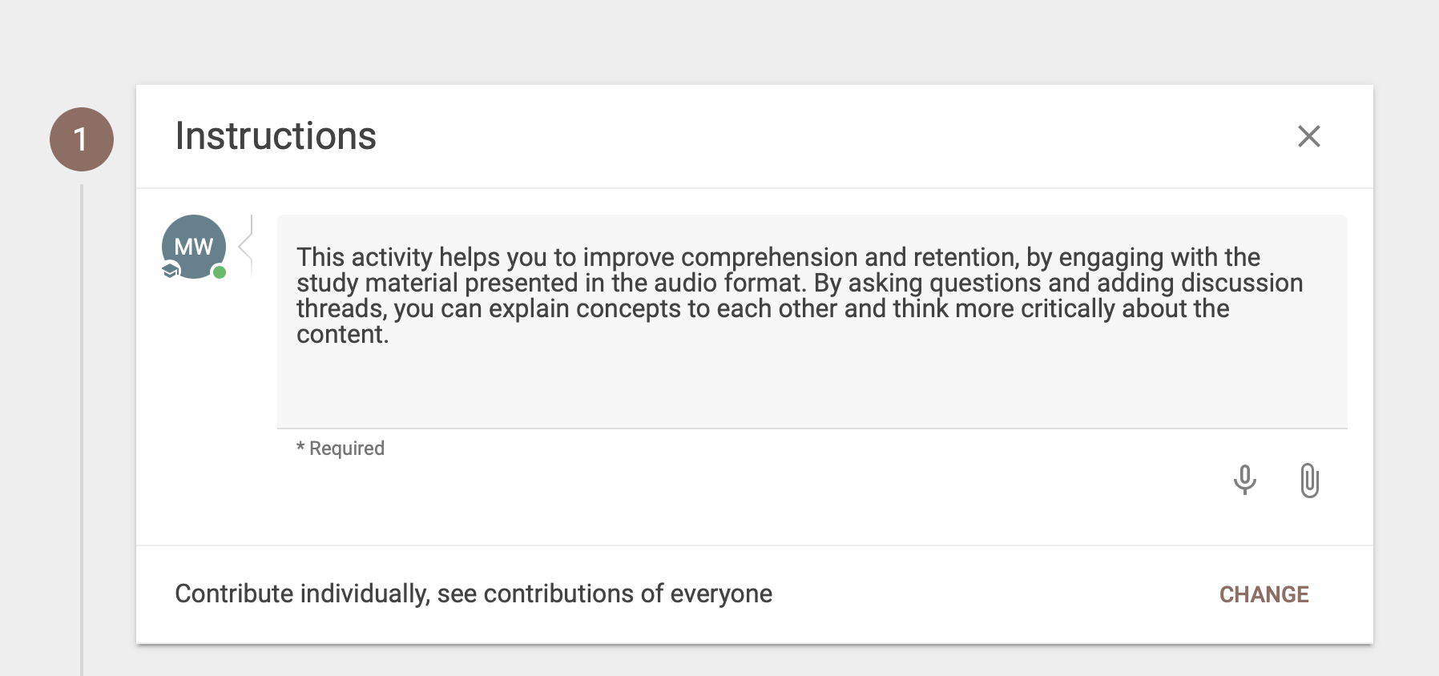

2. Uploading audiofile
At step 2, you can upload the audiofile on which the students have to comment on. You can drop the file in the square, or you can click on ‘choose audio’ to search for the file in your computer. It is also possible to share an online link. You then need to copy the link and paste it in the section ‘paste link’. Please not that the link needs to be public and that you cannot share a private link!

Click on ‘open audio’ to open the file and to add questions or comments. Click on ‘change file’ als u andere audio wil gebruiken.

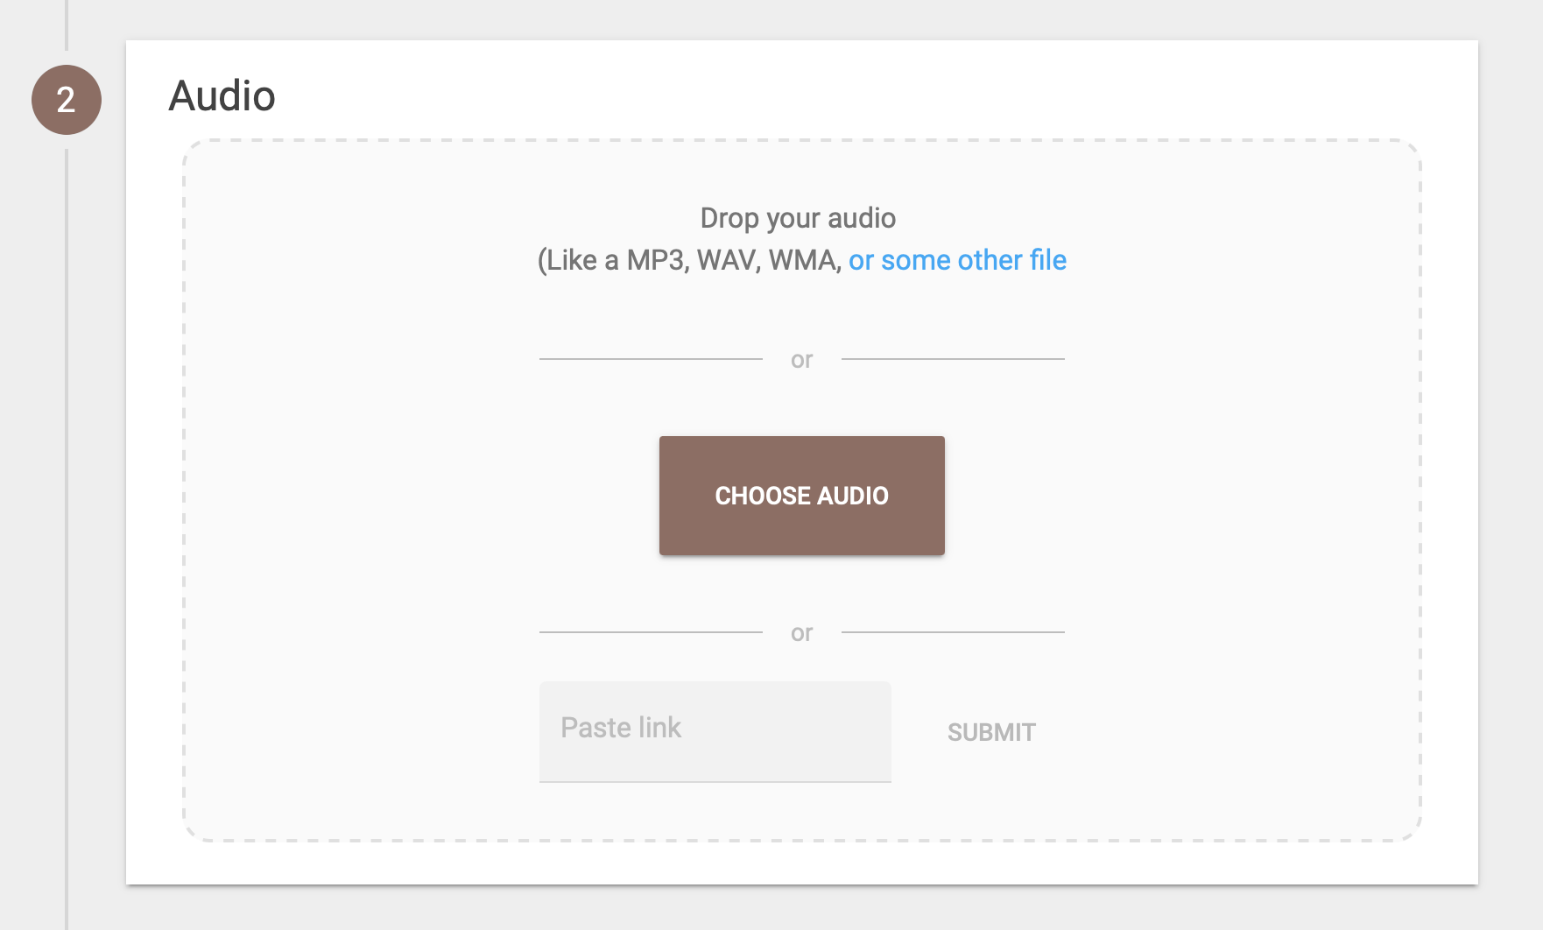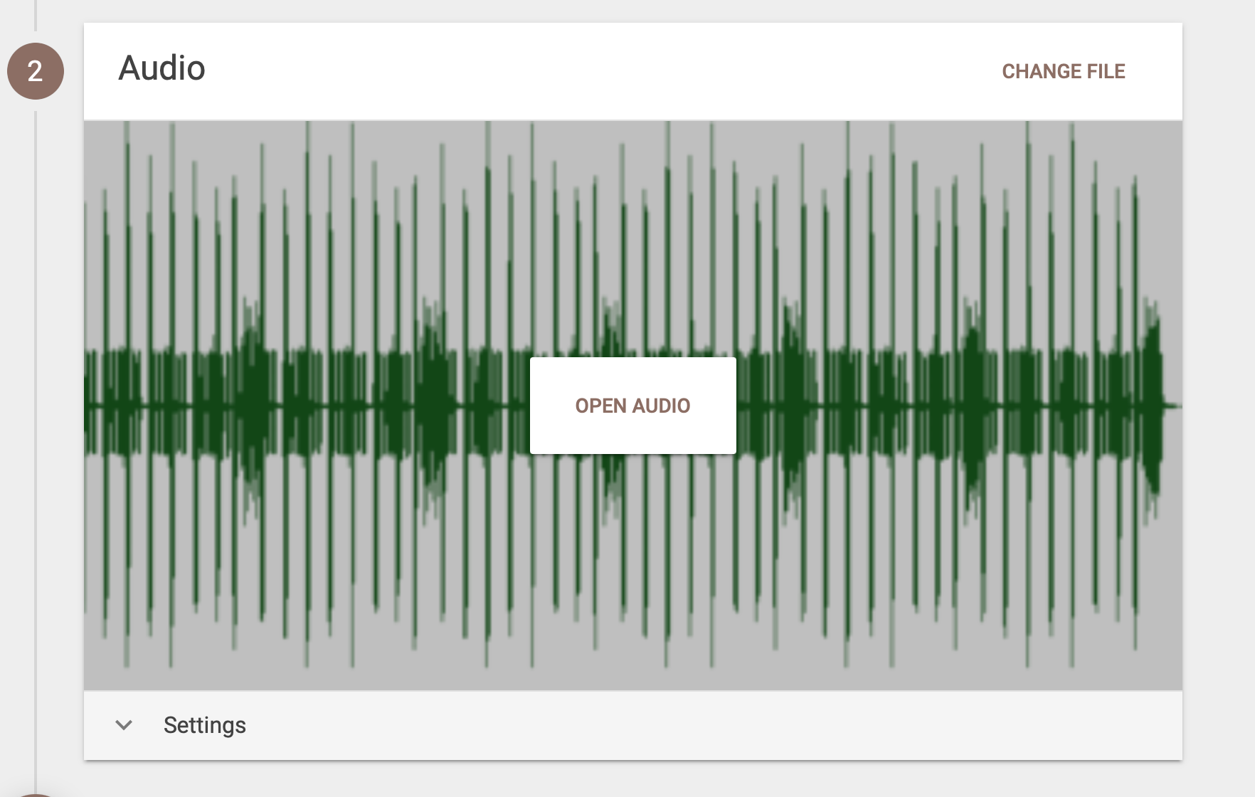

3. Settings
Once an audio file is added (as can be seen on the screenshot above), it is possible to change the following settings:

1. Students can download the audiofiles
2. Students can add comments (discussion threads)
3. Students can ask questions (question cards)
4. Students can ask questions or give comments anonymously
5. Subtitles: you have to add these yourself!

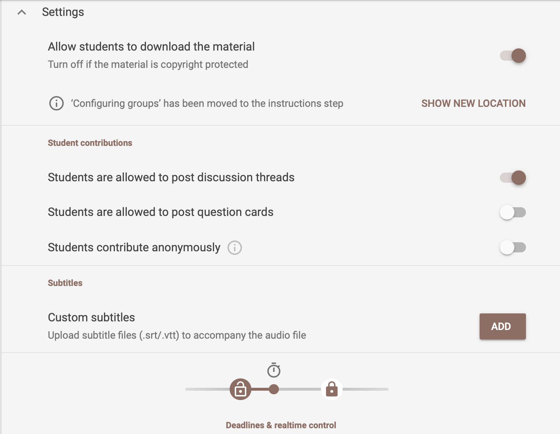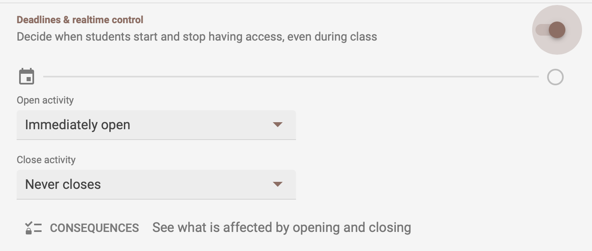

When you have have turned on the setting ‘deadlines & realtime control’, you can regulate the access to the audiofile. You can choose when students can listen to the audiofile (‘open activity’), and when not (‘close activity’).

Questions and comments
To the audiofile, you can add questions and comments by clicking on the file. You can do this by clicking on the file (‘open audio’). Then, select the time where you would like to add your question or comment.

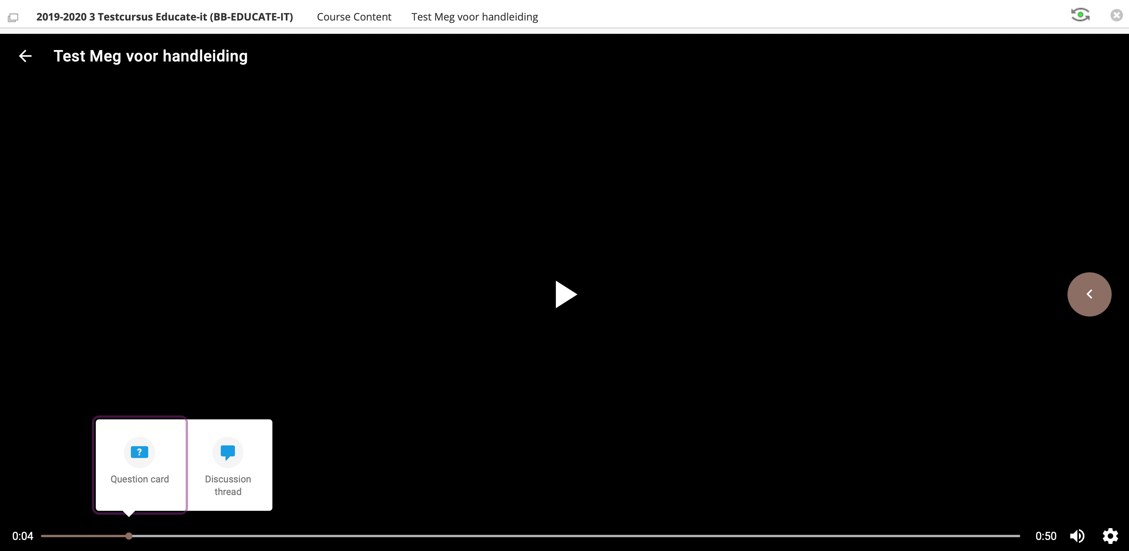

You can choose between a question card or a discussion thread. When you click question card, you can choose between a multiple choice or an open question. Click on publish to add the question or comment.

Multiple-choice
When you click on ‘multiple choice question’, you can formulate the question and answers to it. By clicking on the paperclip, you can add an extra file to the question. You can also add a file to the answers. Below, you can indicate if the students have to answer before continuing or not. It is also possible to check multiple answers as correct by clicking on them.

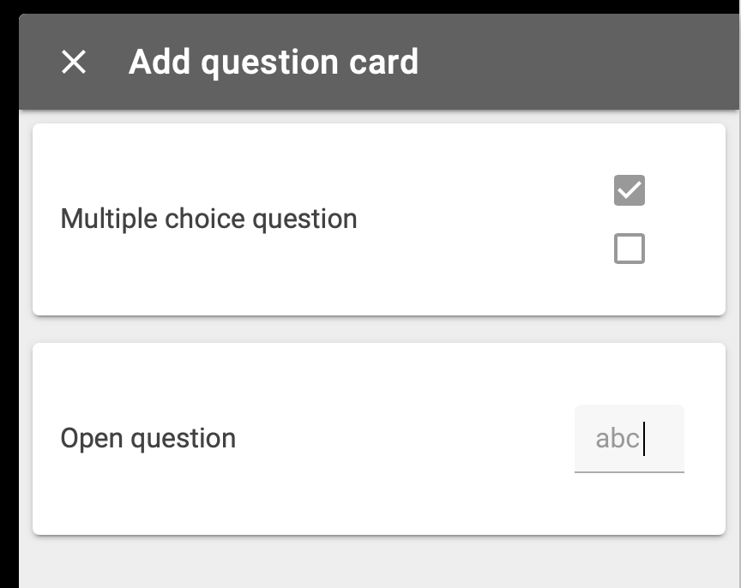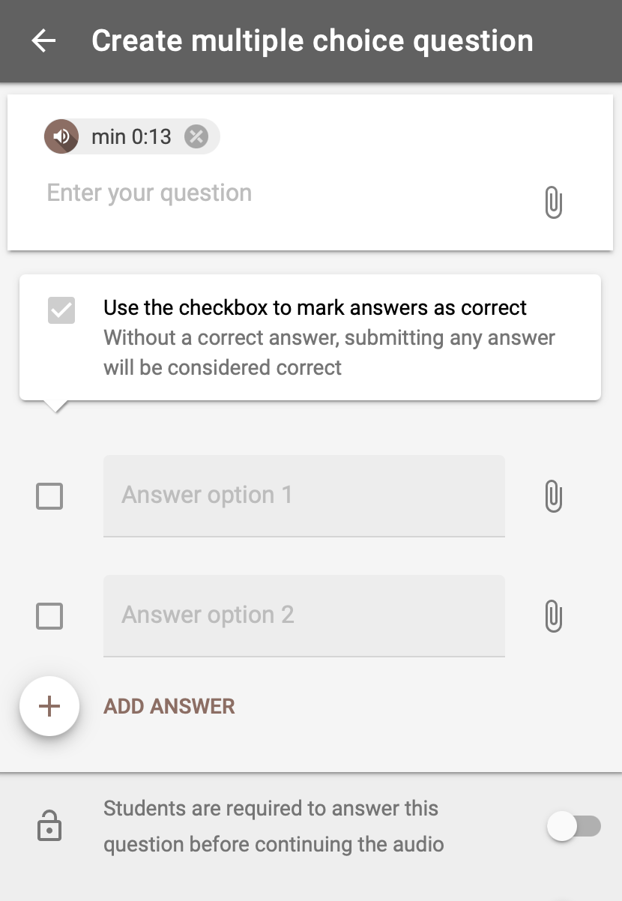

Open question
When you click on an open question, you can formulate the question and also indicate what the right answer is (this is optional).

Just as the multiple-choice question, it is possible to add a file to the question and student and indicate if answering is required to continue. You can also turn on the possibility to let students answer anonymously.

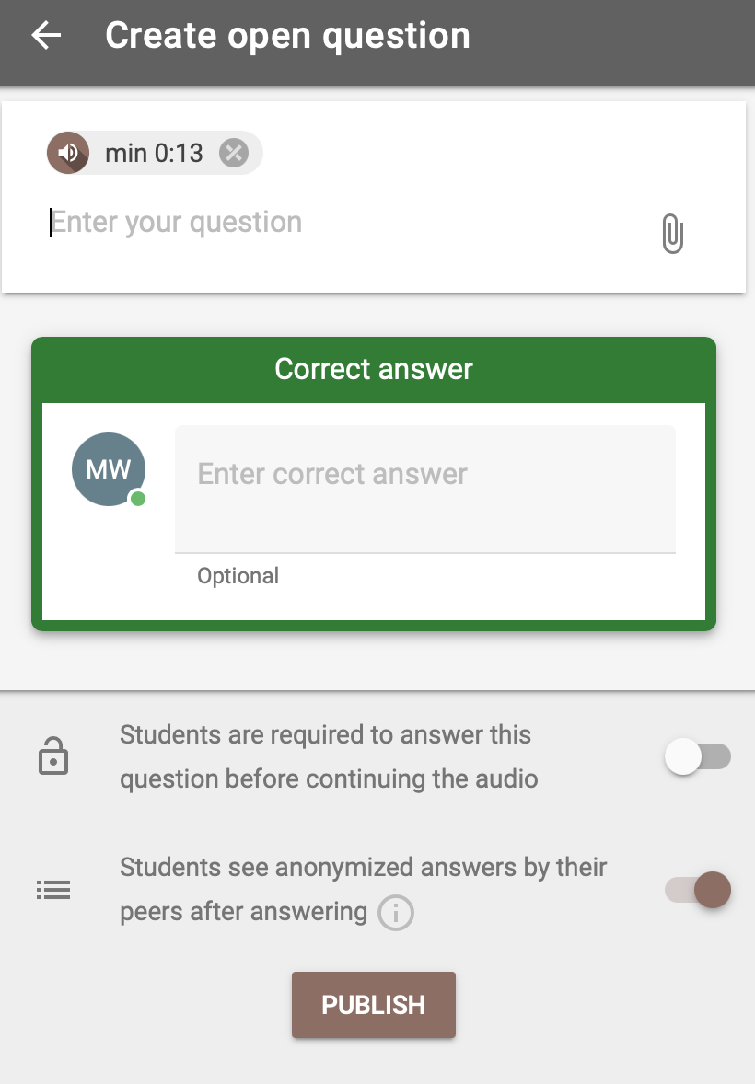

Discussion thread
With a discussion thread, you can write your own comments, add a file or record your comment.

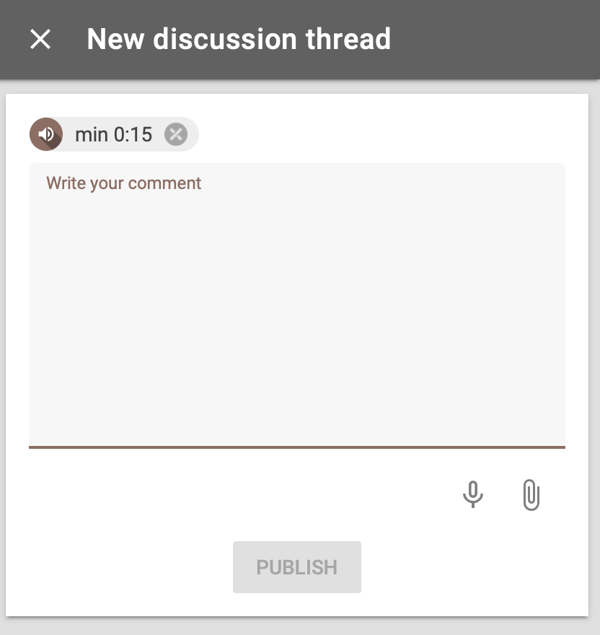

4. Add module
Below the audiofile, you can click on a brown circle with a ‘+’ on it. This way, you can add an extra module. There are three modules that you can add:

1. Configurable grading, you can make a division between parts of the assignment and what is being grader higher/lower.
2. Participation grading assignment, the students have to select their own comments on which they will be assessed on.

Below the audiofile, you can find a brown circle with a ‘+’ on it. You can add an extra module by clicking on it. You can choose between ‘Configurable grading’, where you make can weigh the parts of the assignment differently, ‘Participation grading assignment’, where the students have to select their best comments on which they will be graded, and ‘Reflect on the activity’, where students have to write their own reflection.

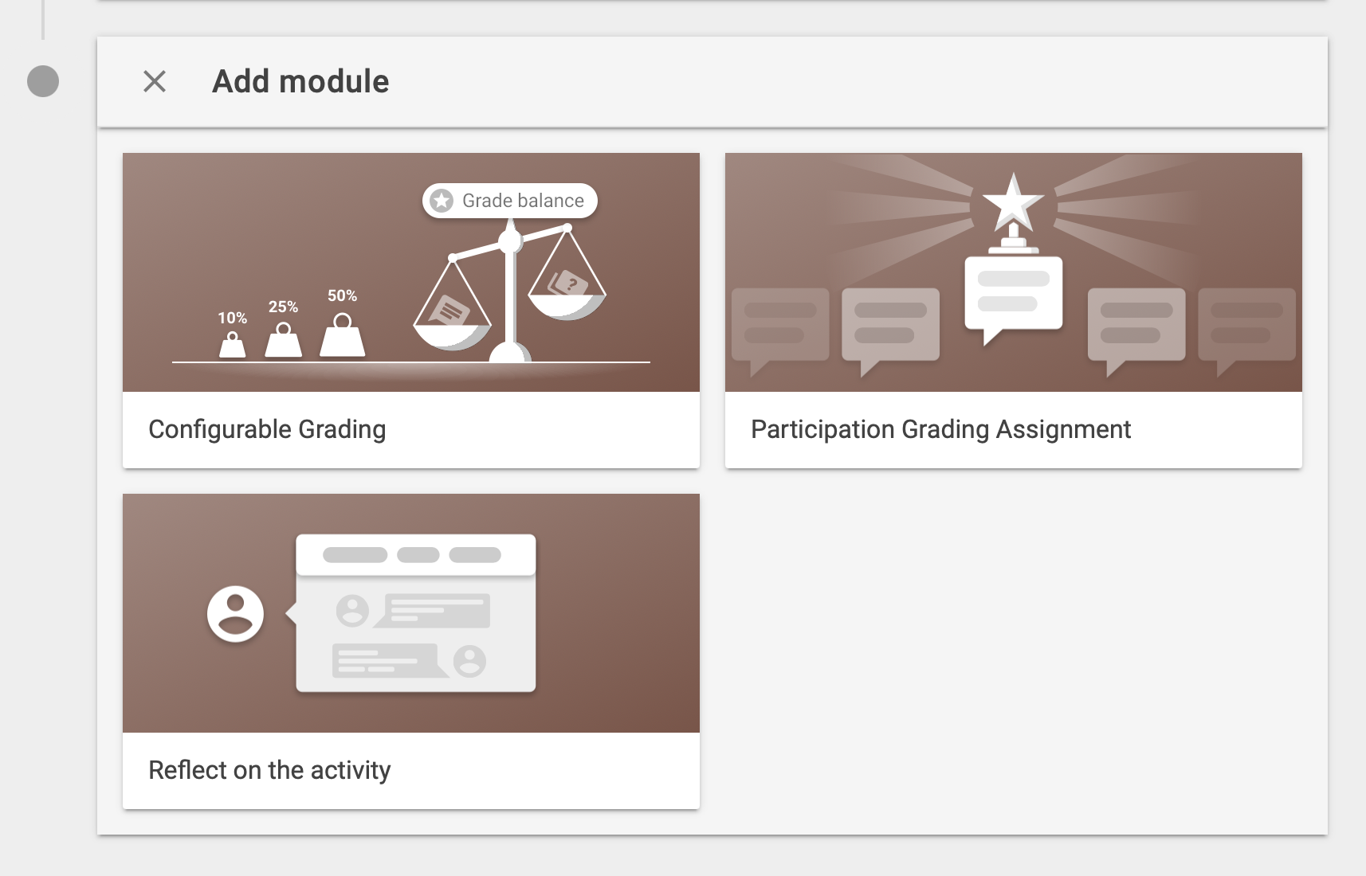

5. Overall student progress
Once you clicked on ‘Save’, the section ‘overal student progress’ will appear, as can be seen below. Here, you can see the progress of the group in general. You can also see the individual progress of a student by clicking on ‘statistics per active student’.

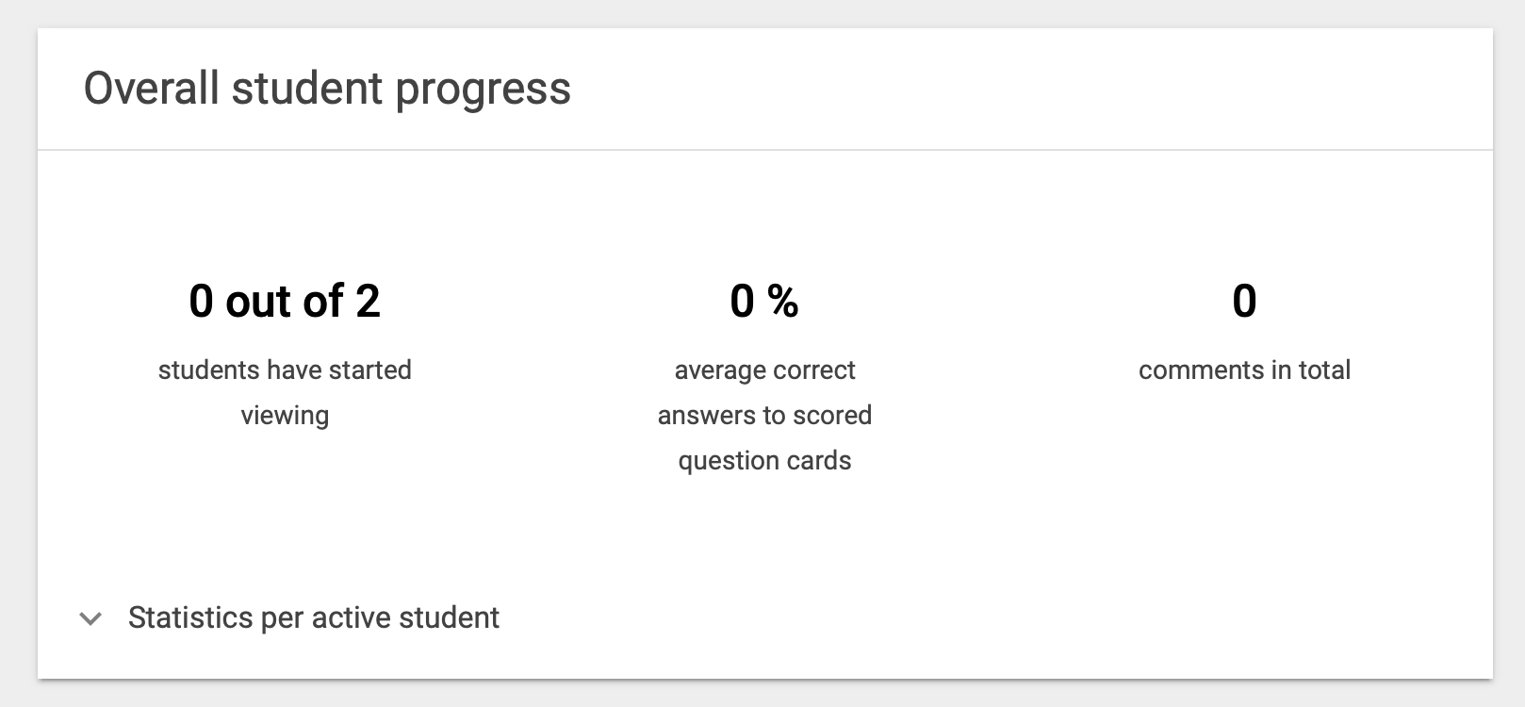

Contact
Do you have questions or would you like support when using FeedbackFruits 2.0 Peer Review? Let us know! We also like to hear if you have any complaints, suggestions or questions about this manual.

If you’re looking for didactical support, you can also contact us:

Teaching support
Opening times: Monday till Friday 8.30u - 17.00u
Telephone: 030 253 2197
E-mail: teachingsupport@uu.nl
Website: https://educate-it-uu.sites.uu.nl

