Interactive Audio
Student handout
teachingsupport@uu.nl

Inhoud

￼
￼
￼
￼
￼
￼
￼
￼
￼
￼
￼
￼

Introduction
FeedbackFruits Interactive Audio is a tool in which you answer questions or give comments based on an audio fragment. In this way you process the content of the fragment in an active way, and you are well prepared for, for example, a study group or a lecture. Depending on the assignment, the teacher may grade your comments or answer the questions.
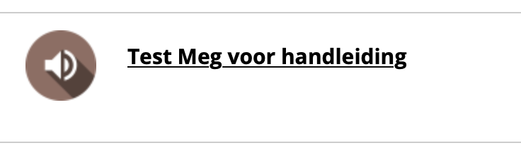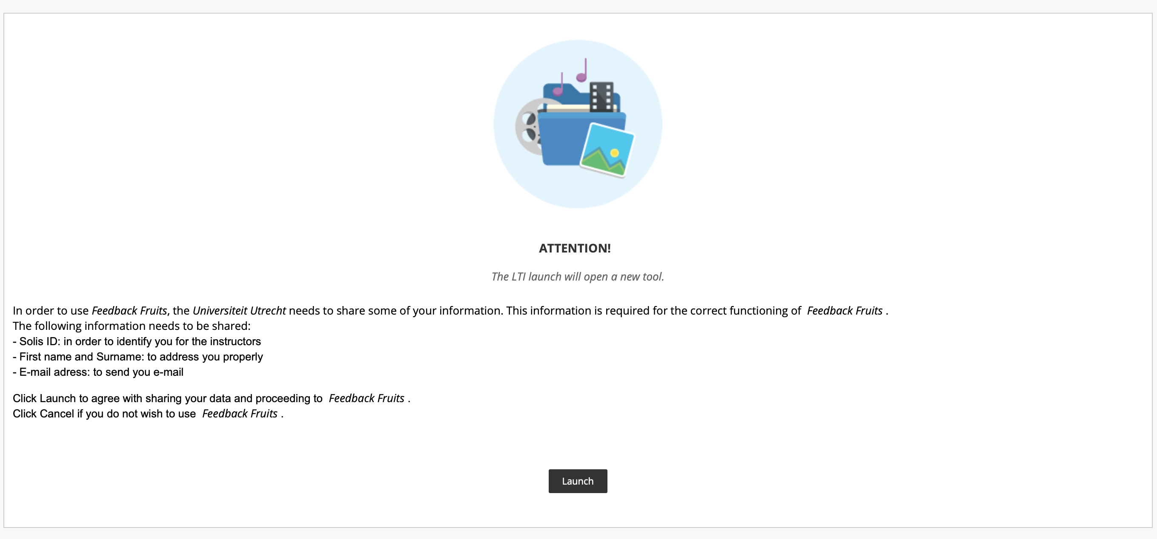

Start
Go to the appropriate page on Blackboard where the assignment is located. There is a FeedbackFruits logo next to the title. Once you click on it, it will say "LTI will open a new tool", then click on "Launch" to open FeedbackFruits. At step 1 there are instructions given by the instructor. At step 2 you can find the audio clip.

The audio file
The audio on which you answer questions (open or multiple choice) or find comments can be found in step 2. Click on 'Open audio' to do so. On the timeline you can see where a teacher asks for answers or comments. Depending on the settings you may be required to do this before you can continue in the clip. You can also add your own comments or ask questions by standing on the timeline yourself with your mouse and clicking on 'discussion thread' and the brown/white plus sign at the desired moment. A window will appear where you can add your comment or question. You can also add an attachment (paperclip) or record your voice (microphone). After clicking on 'publish' the teacher can see and answer your question or comment. You will also be able to see the answers from other students who preceded you. Depending on the type of question, you may also be shown the correct answer and asked whether you think your answer is right, wrong or somewhere in the middle.

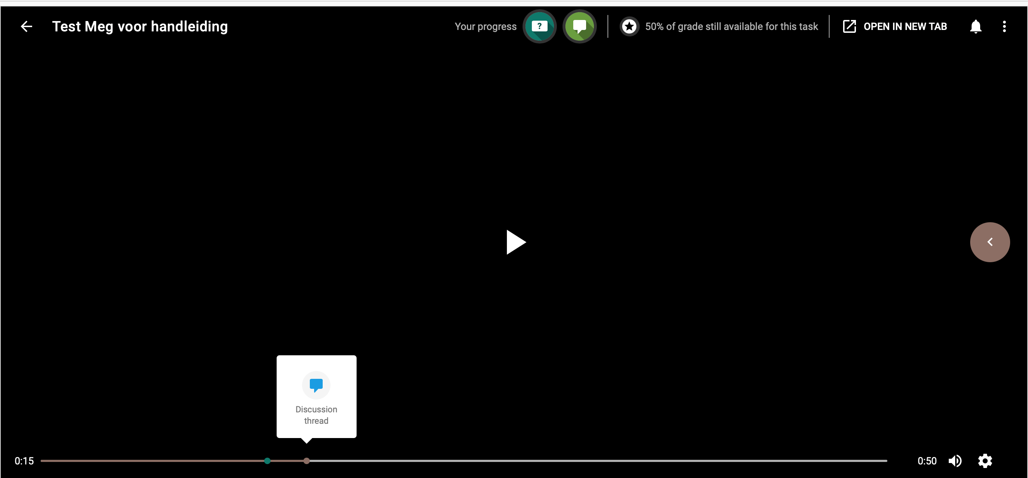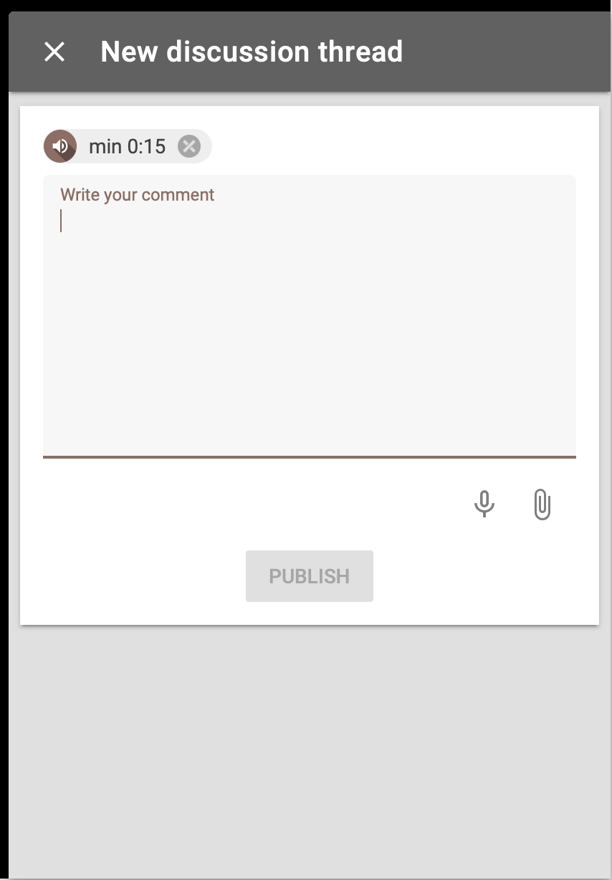

3.1 The sidebar
On the right side of the screen, you will see a drop-down menu bar. Here you can see all annotations and questions in chronological order, or you can sort them yourself. In this bar you can also add or upvote questions or comments and see which answers you have already answered. You can also delete your own questions or comments here.

3.2. viewing your process
In the bar at the top, you can see how far you have progressed with the assignment and, in case there is a grade linked to it, you can see how many percentages you still need for a full grade. Click on the icons for more detailed information.

Other components
In addition to the audiofile, the teacher can add two more components: 'Select your best contributions' and 'Reflect on the audiofile'. In 'Select your best contributions', you can choose your own comments to be graded. In 'Reflect on the audio file', you can reflect on the audio clip. This can also be linked to a grade.

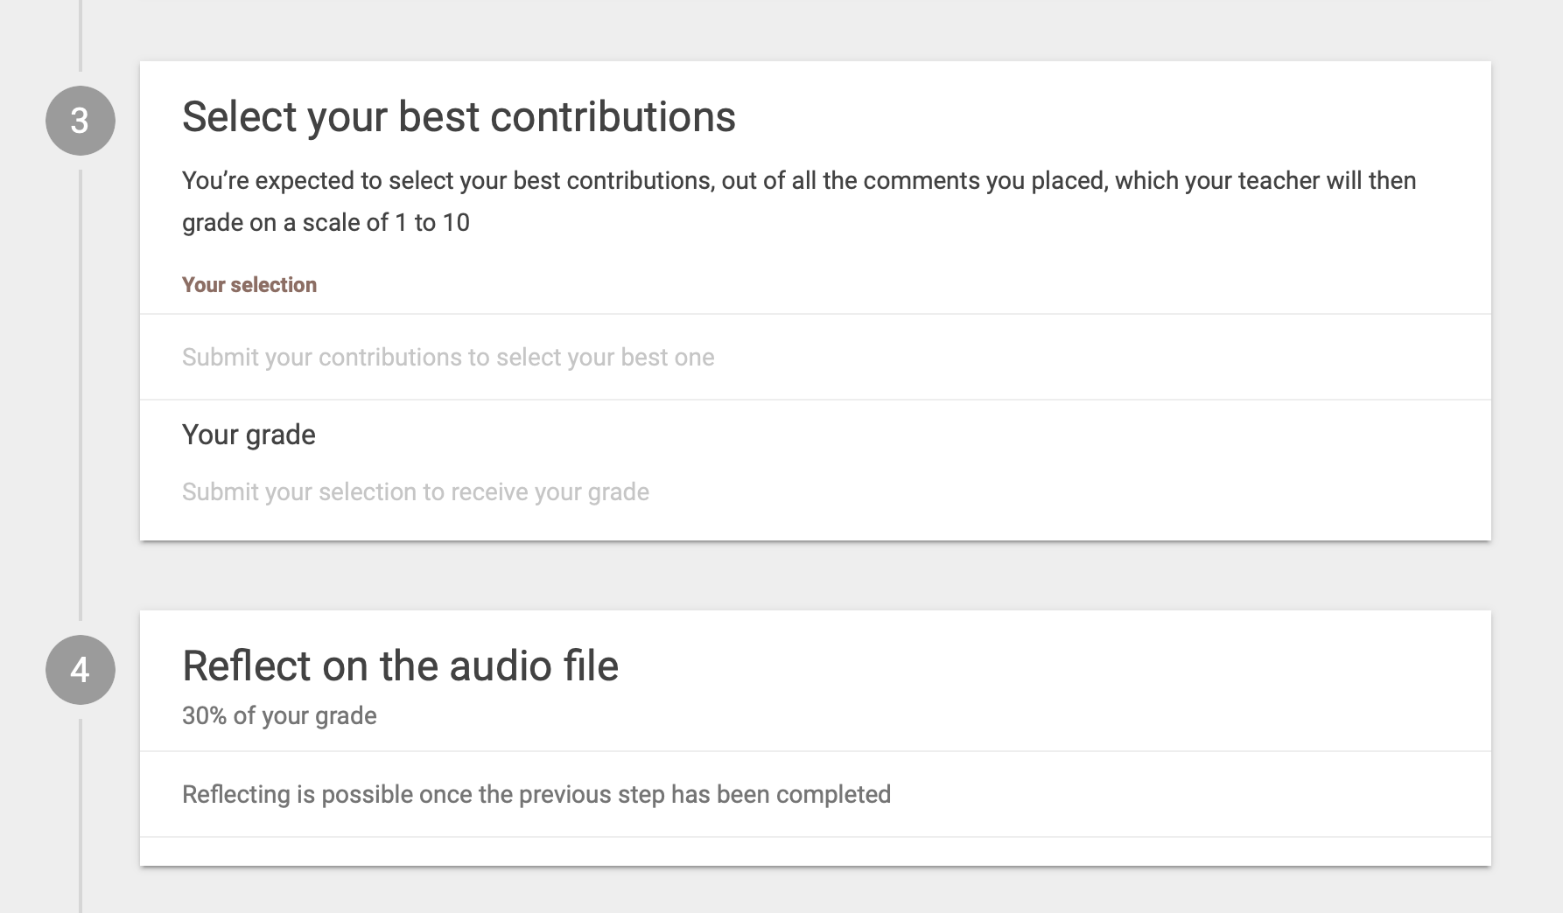

Contact
Do you have questions or need support in using Interactive Audio? Please feel free to contact us. Also, if you have any comments or questions about this manual we would love to hear from you.

Practical support

Teaching support ondersteuningsbalie
Adres: University Library Science Park, second floor, red desk. Opening hours: Every working day from 8:30 a.m. 17:00 pm.
Telephone: 030 253 2197
E-mail: teachingsupport@uu.nl
Website: https://educate-it-uu.sites.uu.nl

