FeedbackFruits – Group Member Evaluation
Student Hand-out
teachingsupport@uu.nl

1. Logging in
Your teacher has usually already activated this tool in the BlackBoard course environment. You just need to go to the Group Member Evaluation link and click on it. You will then end up in the tool.

When you don’t make use of blackboard, you can log into: https://feedbackfruits.com/
Go to log in and select Utrecht University. You will be redirected to a page where you can log in with your SOLIS-ID. This way, you can enter FeedbackFruits.
After you’ve been logged in, you will be see a homescreen. Here, you can see all the courses that you’re in and all the activities that you participate in.
Select the course or go directly to the assignment. Click on the assignment.
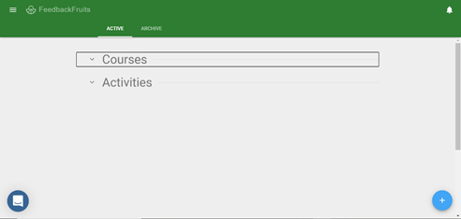

2. Instructions
In step 1, you can find the instructions that the teacher has set up. You can also see an overview of all the students in your group.
3. Feedback
In step 2, you can give feedback on your peers. The teacher has set up certain criteria on how to review your peers. In this following example you can see how Liz has to evaluate two group members. When you click on ’start reviewing’, you can begin with evaulating your group members.
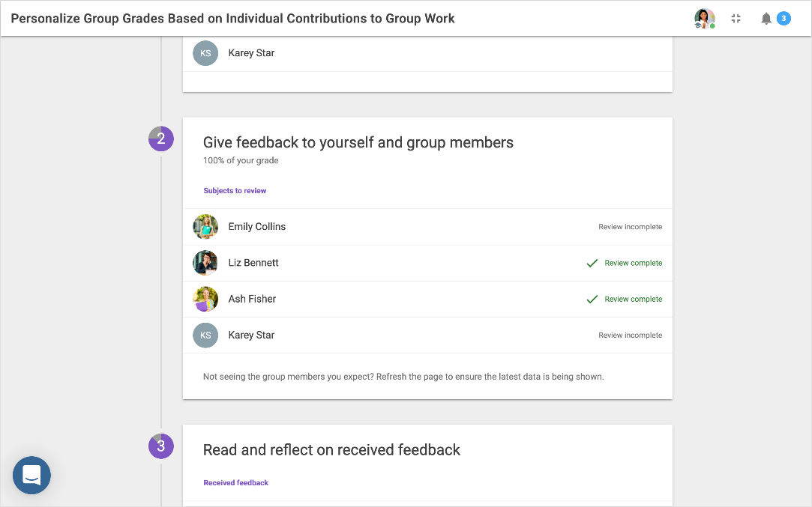
A new window will appear:
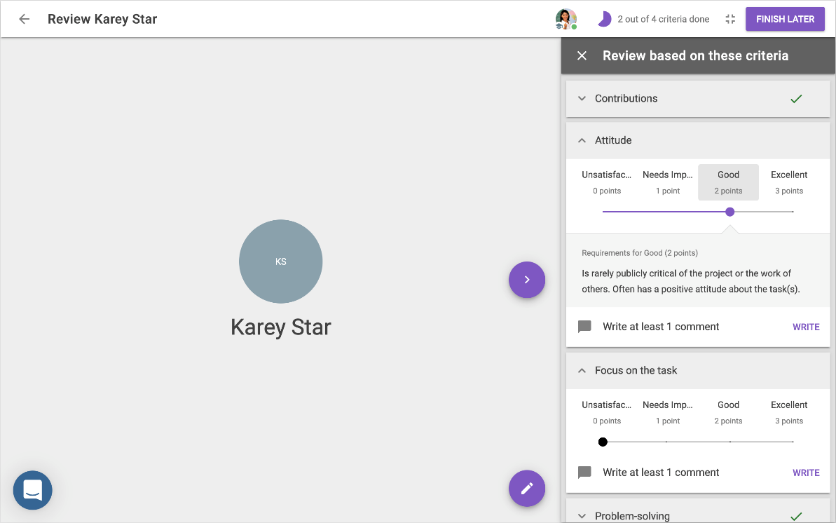
In the middle, you can see a student who is assessing their fellow students. On the right side, you can see the criteria that has been set by the teacher. You can slide the dot on the bar to choose how you want to rate your peer. In this case, Olivia rated Karey with a 2 out of 3 on the attitude criterion.

Like Olivia, you can also write a comment by clicking on write. She complimented Karey by clicking on the ‘compliment’-button before posting her comment. At sufficient comments you write the comment at the criterium.
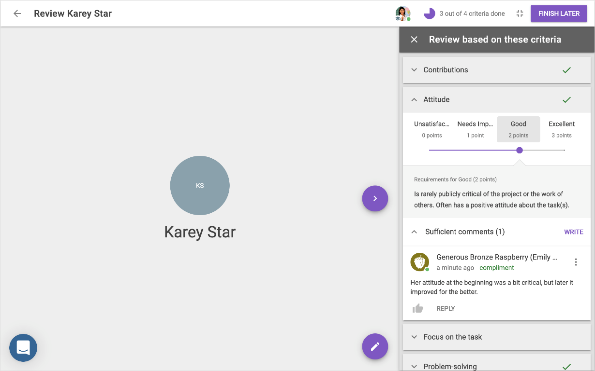
If you want to change or delete comments, you can click on the three dots next to the comment. This is only possible till the deadline is expired. You can also add an attachment.
You can also reuse feedback comments by scrolling down in the comment section where you can click on reuse. These can be divided into compliment or suggestion.
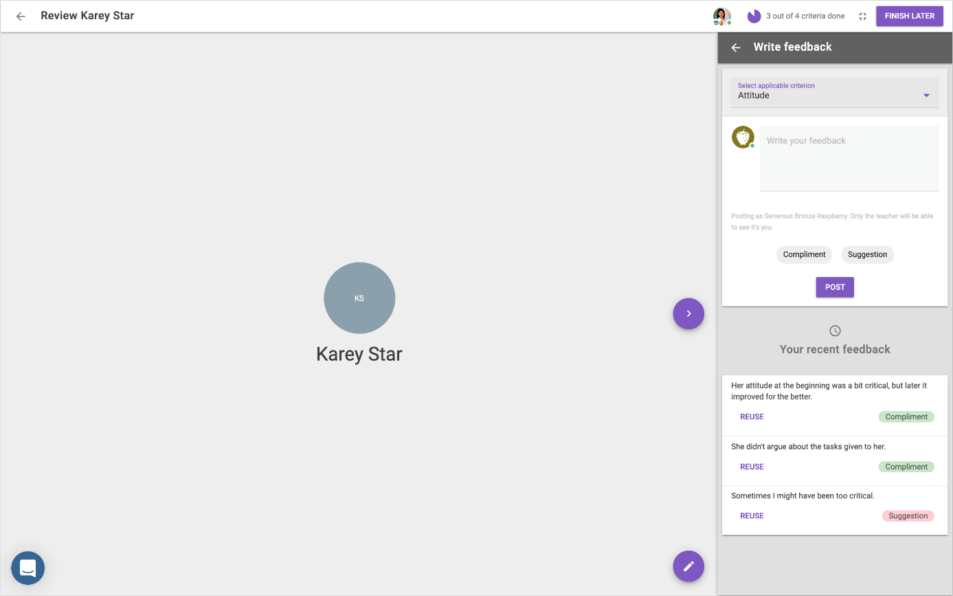
After you’ve finished reviewing, the purple button in the right corner will change to finish later to submit. This way you know you have done all the required steps and you’re finished with reviewing.
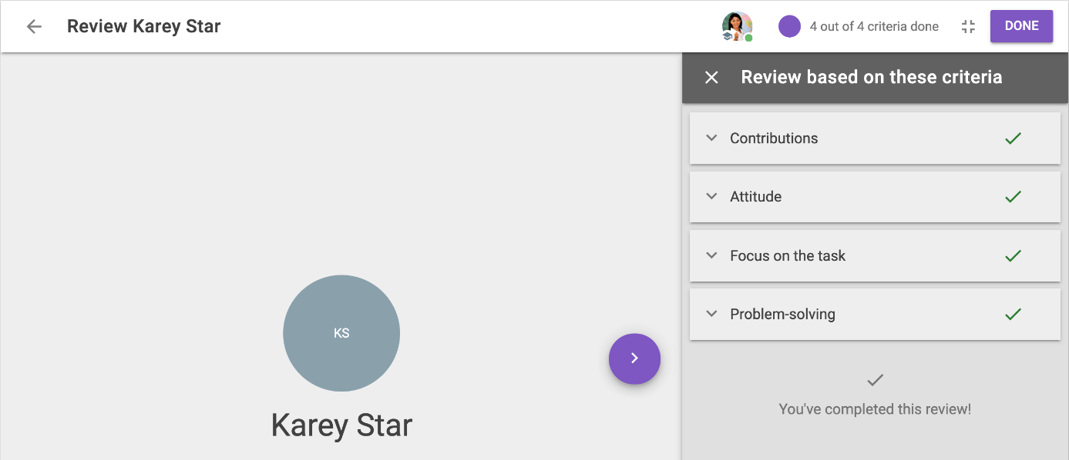
4. Reflection
If all group members handed in their review, you can see their comments in step 3. The option for reflection needs to be turned on by the teacher. If the teacher didn’t turn it on, you cannot see the part write a reflection on the received feedback.
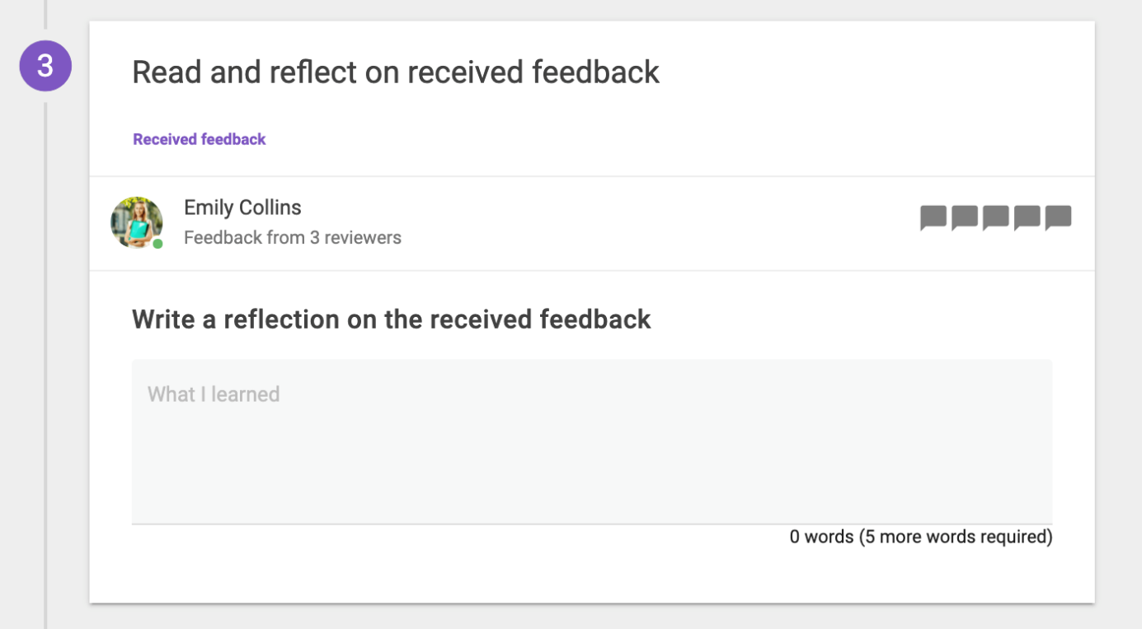
When you click on your own name, you can see the comments of your peers. You can see the average of how your peers have evaluated you in the right corner. When the teacher has indicated that you need to review yourself as well, you can see your own evaluation in this section as well.
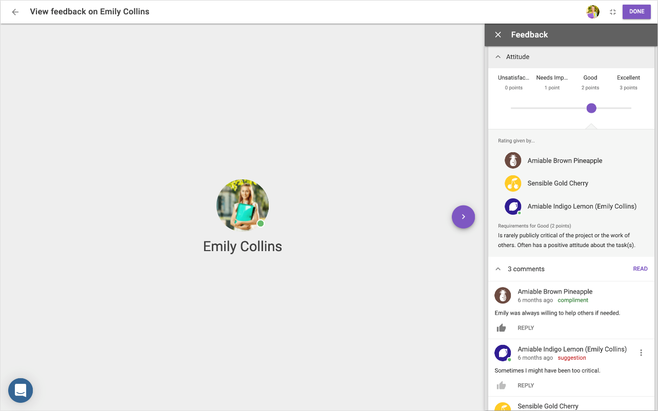
When you’ve opened the comments and read them, you can write a reflection about the received feedback. When you’re ready, click on submit to finish the assignment. You can change your submission until the deadline expires.
