FeedbackFruits – Group Member Evaluation
Teacher's Guide
teachingsupport@uu.nl

Contents

Contents 2
1. Privacy 3
2. Introduction Feedback Fruits – Group Member Evaluation 3
3. Request a tool 4
4. Via Blackboard or via Feedback Fruits 4
5. Get started 6
Step 1: Fill in general instructions 6
Step 2: Leave feedback 8
Step 3: Read & Reflect 10
Step 4: Add grades 10
6. Contact 11

Privacy

When using this innovation tool, you have to deal with personal data. Utrecht University strives to handle personal data of employees and students with care. Personal data is all data that can be traced back to an identifiable or identified natural person. Special personal data are data that are sensitive and therefore need to be protected. These include, for example, political views, religious expressions, ethnicity or sexuality. In principle, the processing of this data is not permitted.

When using this tool, we ask you to consider the processing of personal data in accordance with the General Data Protection Regulation (GDPR). This means that you only collect data for a predetermined purpose. This objective must be well defined and justified. Try to minimize the amount of personal data. So do not request unnecessary information from the students and do not keep this information longer than strictly necessary. In addition, it is important to communicate to the data subjects how long data is stored or based on which criteria this is determined.

Introduction Feedback Fruits – Group Member Evaluation
Feedback fruits 2.0 consists of several plugins, which are available separately and can be used as stand-alone Blackboard plugins. In this way, as a teacher, you choose a specific work form that you want to apply in your education. This guide discusses one of these plugins: Group Member Evaluation. With this plugin you can evaluate the collaboration of group assignments by letting students give feedback on their groupmates. Based on predetermined criteria, students provide feedback on the contribution of their fellow students to a group assignment. In addition to a textual explanation, they can also assess each other. After this process, students write a reflection on the feedback they have obtained. By carrying out the Group Member Evaluation, as a teacher you gain more insight into the individual contribution that students have made within a group.
This guide introduces the use of the Feedback Fruits tool with the Group Member Evaluation plugin and functions as a reference work for the further use of the tool. In addition, Educate-it also likes to offer didactic and practical support when using FeedbackFruits. Please feel free to contact educate-it's desk via teachingsupport@uu.nl.

Request a tool
Please contact the Educate-it counter when you want to use FeedbackFruits. This can be done by emailing teachingsupport@uu.nl or by filling in the following contact form: https://educate-it.uu.nl/contact-informatie-formulier-tools/. The feedbackfruits tool coordinator will contact you as soon as possible to discuss the information.

Via Blackboard or via Feedback Fruits
If we have received your request for the use of Feedbackfruits 2.0 in your education, FeedbackFruits will then be turned on for your course. The FeedbackFruits tool and its plugins can be used in various ways: via Blackboard or via My University. You can choose which way you like the most. Below is explained how it works per way.
Blackboard
Go to the page where the course is where you would like to add FbF. Click on the 'Content' tab and click on 'Tools'. Then choose the tool you would like to use. You can then use the tool under , for example, 'Assignments'. Students can go to the assignment via Blackboard.
FeedbackFruits (outside Blackboard)
Go to https://feedbackfruits.com/. Click on the tab 'Log in' and click on Utrecht University (see figure 1). Then sign in with your solis ID and password.
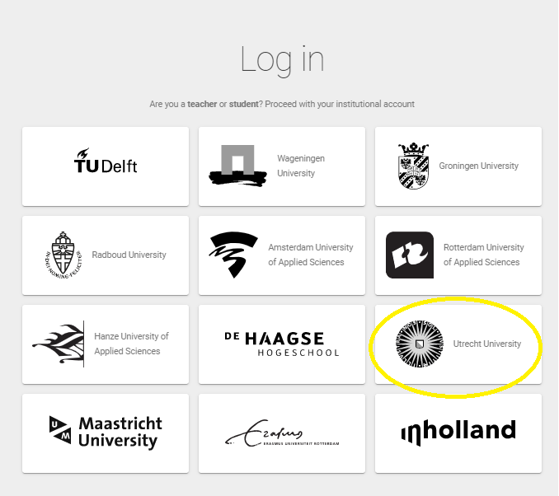
Figure 1. Choose the right university

You will now end up on your personal page. If you haven't used it before, you'll need to apply for teacher rights through teachingsupport@uu.nl. This can take 2 days.
If you have teacher rights, you will see the blue '+ sign' at the bottom right. Click to create a new assignment (see Figure 2). Then choose Group Member Evaluation (see Figure 3).

Figure 2. Create a new assignment
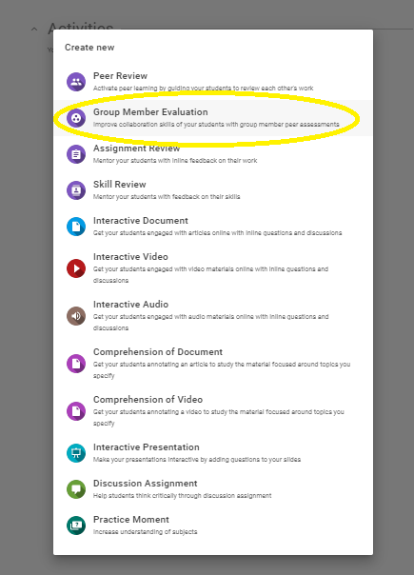
Figure 3. Choose the rightplugin.
Students can be invited via their student email or via a link after creating the assignment. The link can be sent by e-mail or put on Blackboard.

Get started

You are now in the home screen to create the assignment. In order to do this correctly, three steps must first be completed. In step 1, you draw up the general instructions. In step 2, you set the feedback deadline, the criteria and the required number of evaluations inthecase each student must submit. In step 3, the students read the feedback they have received and write a reflection on that feedback (if necessary).
First fill in a title and then proceed to the steps explained below.

Step 1: Fill in general instructions

Enter your general instructions for the assignment here (see figure 4 for an example). It is important that this field is filled in, otherwise the assignment cannot be published or saved.
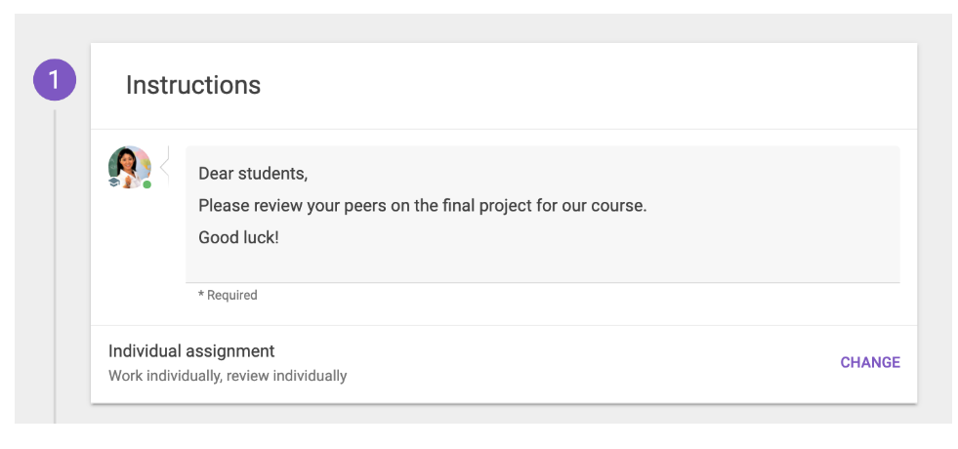
Figure 4. Example general instructions

The assignment can be an individual or a group assignment. Click on 'change' in the bottom right to choose between one of the following three options:

- Work individually, review individually.
Students are randomly and automatically assigned another student to provide feedback.
Use this option if, for example, you want students to give their peers feedback about an individual presentation.
- Work individually, review within groups.
Students are randomly and automatically assigned a peer from their own group. Use this option if you want students to evaluate their groupmates’ contribution to the group assignment.
- Work as group, review work by other groups individually.
Students are randomly and automatically assigned a different group to rate. Use this option if, for example, you want students to provide feedback on group presentations.

Important if you have chosen option 2 or 3
If you choose option 2 or 3 in step 1, you need to select or configure the groups. Note that you can only configure groups if students have been added to the assignment. If the students have been added to the course in, for example, Blackboard, they have also been added to the assignment associated with FeedbackFruits.
If you're using FeedbackFruits within Blackboard, you can select the groups from your LMS to use them in your assignment. If you want to change the composition of the groups (such as moving a student from group 1 to group 2), you have to make these changes in the LMS. In the FeedbackFruits assignment you can only choose which groups you want to include in the assignment, not which student is in which group. Note: If you change the groups to Blackboard, you will need to save the assignment to Feedback Fruits again.
First, make sure that you turn your assignment into a group assignment by choosing one of the group assignments options in step 1. Then click configure groups (see Figure 5).
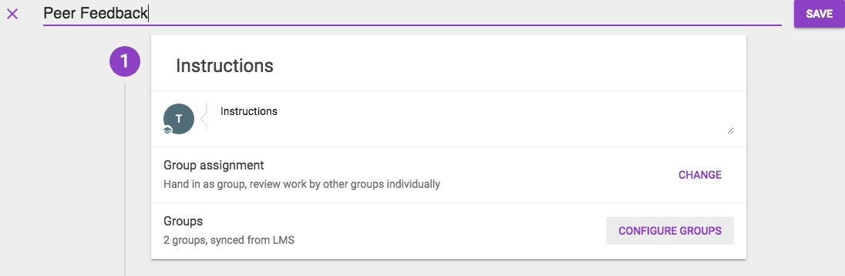
Figure 5. Configuring groups
In the next screen you will see an overview of the different groupand in your LMS. Click on the downward-facing arrow to see which groups there are and which students are in the group.
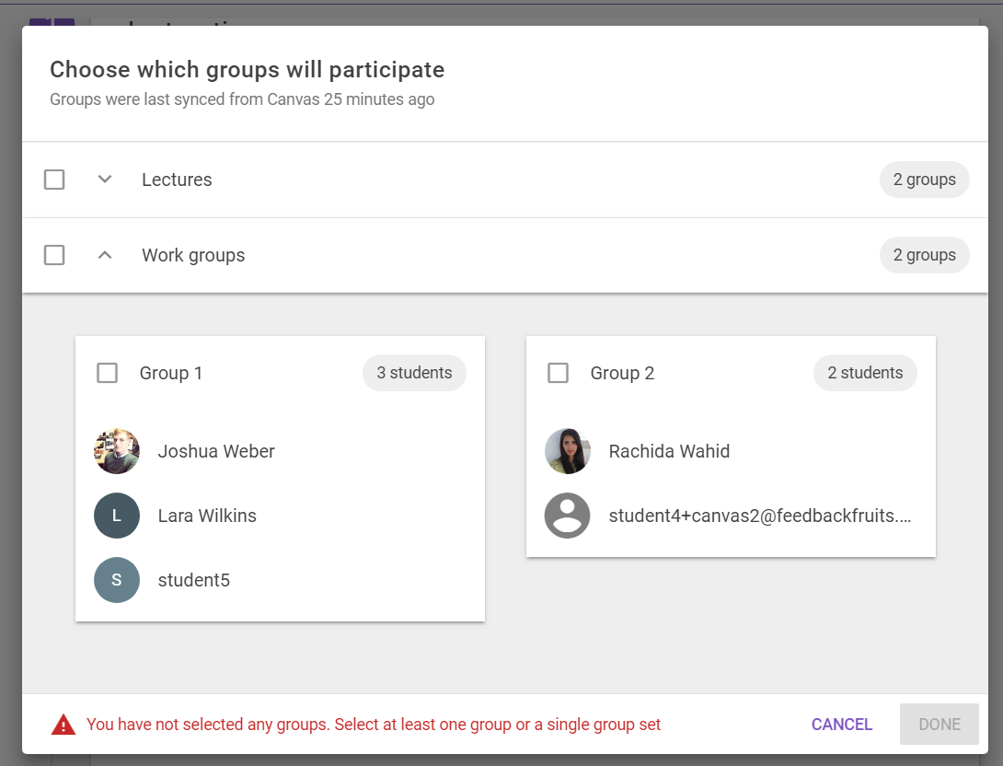
Figure 6. Groups and group members

Check the box next to the name of the group(s) to select all students from that group (see Figure 7). You will get an error message if certain students are in more than one of the groups you selected. Deselect groups that you want to exclude from the assignment.
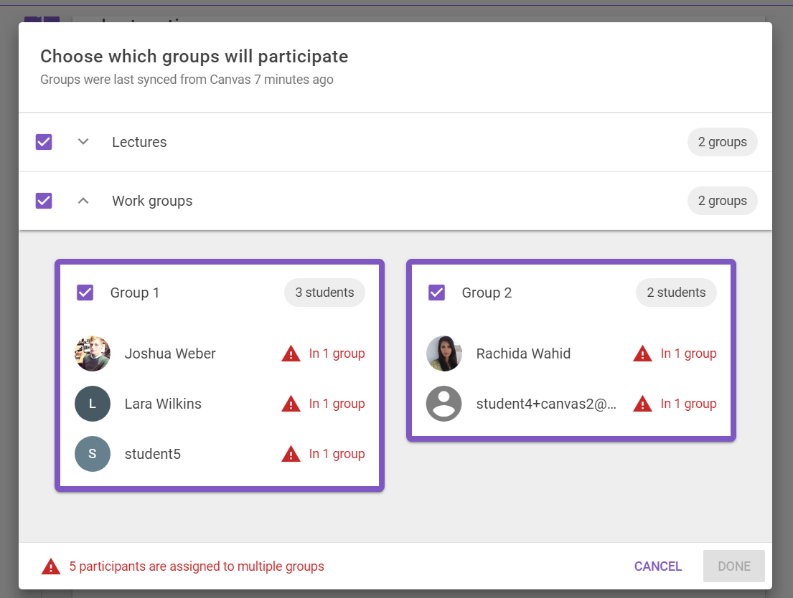
Figure 7. (de)selecting groups

Step 2: Leave feedback
In this step, students are assigned other groups to provide feedback. In this step, add specify criteria to help students provide feedback. Click on 'change' at the top right to edit, add or delete criteria. The other sections are explained in Figure 8.
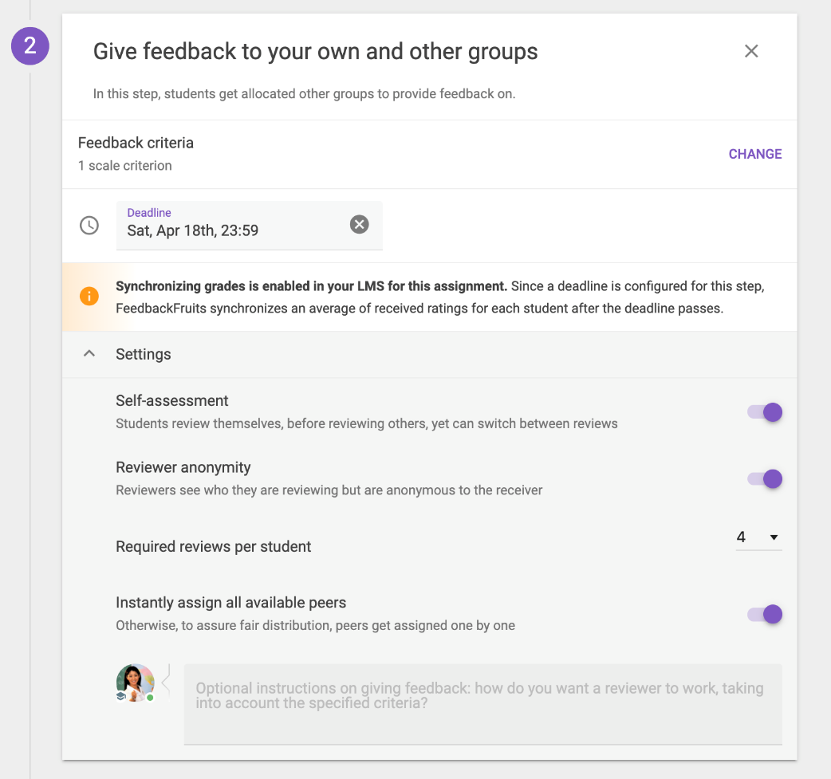
Figure 8. Settings for giving feedback

- Deadline Here
you set the deadline for giving feedback. Please note that reviewers will not be able to view or edit their reviews after this deadline has passed. Leave the box blank if you want the reviewer to have indefinite time to view/edit the feedback.
Institutions:

- Self-assessment
Students assess their own work before reviewing other students.
- Reviewer anonymity
If you enable this option, reviewers become anonymous. Reviewers still see the name of the person they're reviewing. Teachers can also see the reviewer's name.
- Required reviews per student
Specify how many peers/group members/groups each student will rate. If your group option ebt 2 hebt chosen at step 1 from this guide and you want all peers to rate each other, select "all". If
you want more than one review from each student, you can choose to turn on all available peers instantly assign. This way, the students immediately see all the peers they're going to review instead of having to complete the first review before proceeding with the second.
The following settings are only available if you set the required number of reviews to more than 1:

- Instantly assign all available peers
If this option is enabled, students are assigned all reviews to complete at once. The advantage of this is that students see all their peers at once. The downside is that it offers less flexibility, i.e., if students complete only 1 review, the others can no longer be assigned to someone else who completes all the reviews.
Finally, you can also set (optional) instructions that students can keep in mind when giving feedback. You can fill this in at the very bottom in the grey text box (see figure 5).
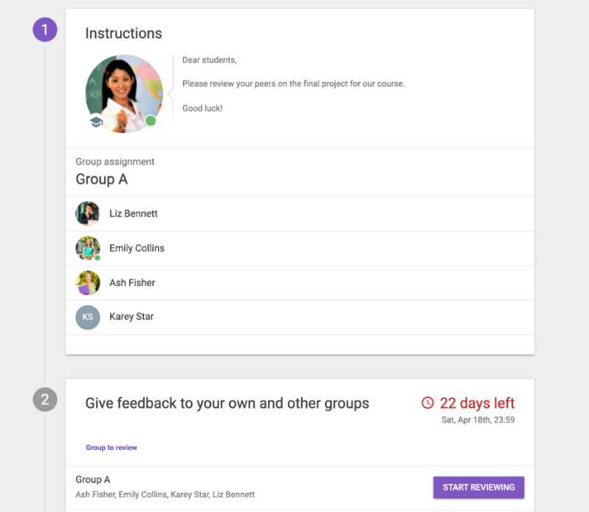
Figure 9. Overview for students

Figure 9 is an overview of what the student already sees within the program z. At step 1, the student sees his teammates (including himself) and at step 2 the student sees the group he needs to review. When the student finishes the review, the student will see "reviews received” in green with a check mark.

Step 3: Read & Reflect
In this step, the students read the feedback they have received and reflect on this feedback. The different parts that emerge in this step are explained under Figure 10.
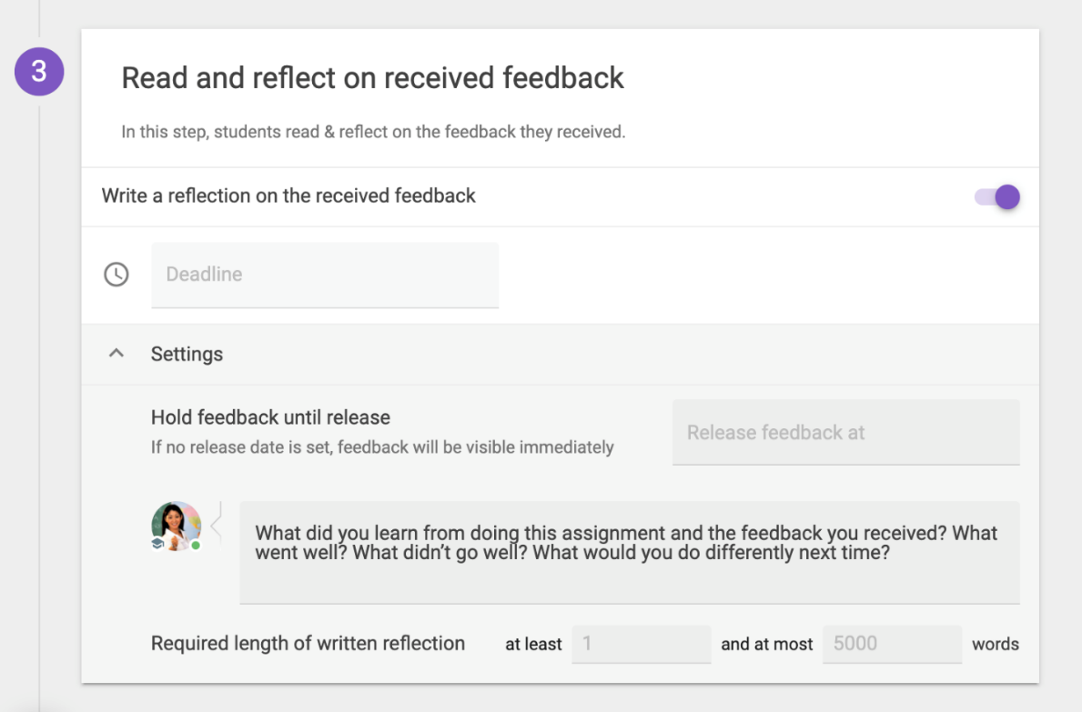
Figure 10. Step 3 settings

- Written reflection (optional)
The written reflection of the student who has received feedback is only visible to the student himself and to the teacher.
- Deadline
Students cannot write reflection after the deadline has passed. Students can still view the feedback and their reflection after the deadline. If you don’t set a deadline, students can write and/or edit their reflection indefinitely.
- Settings
Under 'settings' you can adjust the instructions for the written reflection. See Figure 7 for the standard instructions. You can also set a minimum required length of the written reflection.
If you want to add grades to the assignment, go to step 4 of this guide. If you don’t want to add grades, press Publish in the top right corner.

Step 4: Add grades
It is possible to add grades to the assignment. You can do this by clicking on the purple plus button at the bottom left (see figure 11).
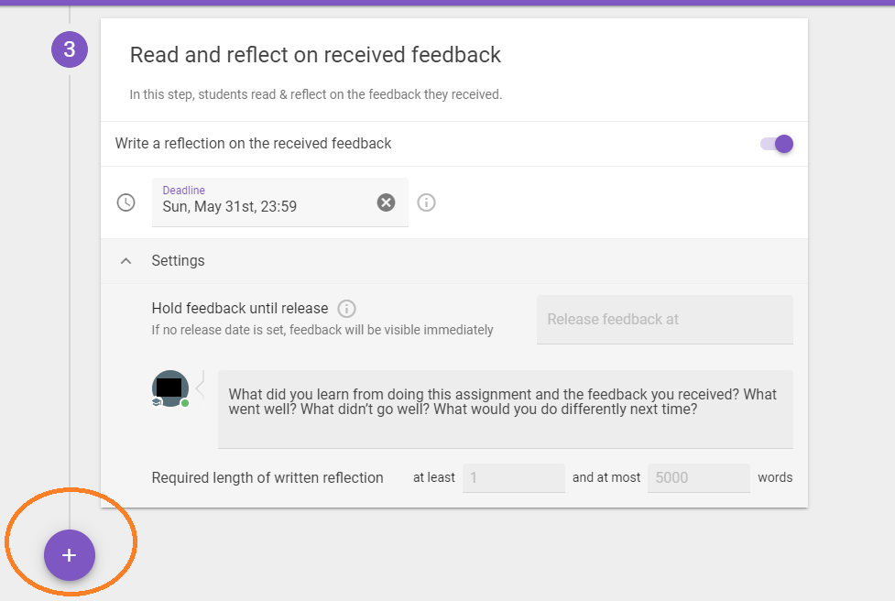
Figure 11. Add extra element
You can configure how many points you want to give to each process of the assignment, as shown in the screenshot below (Figure 12).
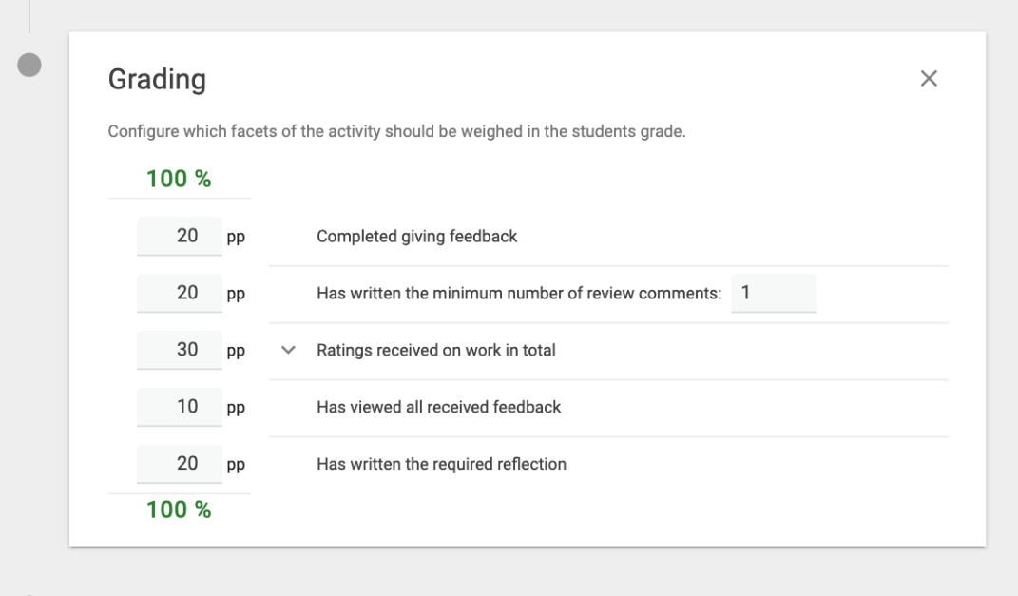
Figure 12. Add grades

When you’re done with this step, press "Publish" on the top of the screen.

Contact
Do you need questions or support when using one of the Feedback Fruits plugins? Please contact us. We would also like to hear from you if you have any comments or questions about this manual.
Teachingsupport@uu.nl

