Pitch2Peer
Teacher’s manual
teachingsupport@uu.nl

Introduction Pitch2Peer

Pitch2Peer (short demo in Dutch) is a review tool that allows students to learn from each other’s work and feedback. It is embedded in Blackboard and can therefore be used within the context of a course. Following an assignment, such as a presentation of personal research or a review of literature, students submit their ‘pitches’ to Pitch2Peer. The program supports different types of ‘pitches’, such as videos, photos, posters, slideshows, animations and (blog) texts. It is also possible to embed external media, such as YouTube or Prezi-presentations. The students can then be asked to reflect on their own work, as well as review (anonymously if necessary) one, two or more of their peer’s pitches. You can ask them to reflect or review with specific criteria and/or questions in mind. Also, the students can be motivated by using ‘likes’ and ‘medals’ to reward the best pitches. And as an instructor you can of course also give feedback yourself.

There are several advantages to using Pitch2Peer. You can set up the entire assignment, and the program will take over from then on. It will switch automatically from the ‘pitch’-period to the ‘review’-period and so on, according to the dates you set. It will also show students exactly what their tasks are in each period. The competitive and creative aspects of the program and the open nature of the pitches will motivate students to hand in their best work, while the focused and specified feedback from their peers and their self-reflections will help to improve their skills. Giving specified feedback will improve their critical thinking and communication skills. Finally, moving all presentations to an online platform will give you a lot more time during classes.

Besides all the advantages, it is important to keep in mind that there are some restrictions and disadvantages to using Pitch2Peer. It might take some time for the instructor to set up and monitor their assignments and the reviews. Students will also need to be instructed on how to use the program if they have not used it before. Creating the video and reviewing each other’s videos will also take more time for them than a normal presentation might have taken. Furthermore, students will notice if you are not actively involved in the process. It can therefore be necessary to give comments yourself and/or discuss the best pitches in class.

This manual provides an introduction to the use of Pitch2Peer and serves as a reference for further use of the tool. In addition, Educate-it also offers didactical and practical support in the use of Pitch2Peer. Please feel free to contact the desk of Educate-it via teachingsupport@uu.nl.

Pitch2Peer can be used within your personal Blackboard course(s), so there are no downloads or installations required. If you experience any problems with Pitch2Peer or Blackboard in general, it may be useful to try using another browser. We recommend:
- Google Chrome
- Safari 6 or higher
- Firefox

Before You Start

When you are getting started with Pitch2Peer, there are a few things you will need to consider in advance. In this chapter you can find some general remarks that could be useful before you start using Pitch2Peer.

Please note: If this is the first time that you want to use Pitch2Peer and if you’re not sure whether this is the right tool or not, please contact the desk of Educate-it via teachingsupportdesk@uu.nl. When you are sure you want to use this tool, please fill in this registration form (if you haven’t already done so). Otherwise, you won't have the correct rights to work with Pitch2Peer.

2.1 Pitch2Peer Module

To create a Pitch2Peer assignment, you'll need to go to ‘Tools’ within your Blackboard environment (for example within the ‘Course Content'. Two options for P2P appear: ‘Pitch2Peer’ and ‘Pitch2Peer by Groups'. It is only necessary to use the last option if there are separate groups of students within one Blackboard course. You can then use it to create separate Pitch2Peer modules for separate groups.

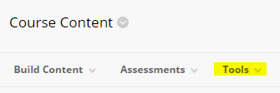

Furthermore, choosing ‘Pitch2Peer’ in the ‘Tools’ section will not directly create an assignment. It will create an entrance to a Pitch2Peer module, in which you can create several separate assignments. This means that, in contrast to common Blackboard practice, there is only one Pitch2Peer item in your Blackboard course, holding all your Pitch2Peer assignments, rather than having an item per Pitch2Peer assignment. Both the instructor and the students can use the same ‘entrance’ to the module but will see different aspects of it. The instructor will of course have a lot more options.

When you've clicked on ‘Pitch2Peer’ via ‘Tools’, a new tab wil appear. You can fill in the name and description of the module under ‘information’.

Attention: The usage of diacritical symbols (like arrows, stripes and dashes) in the description field may lead to an error when accessing Pitch2Peer through Blackboard. When the error ‘Not acceptable An appropriate representation of the requested resource could not be found on this server’ appears, try to delete these diacritical symbols from the description field and try launching again.

Furthermore, you can attach files under ‘attachments’. You will need to ‘enable evaluation’ under ‘Grading', to be able to send grades from Pitch2Peer to the Grade Centre. You can do so by clicking ‘Yes’ and then entering the ‘Points Possible’ (usually 10 points is the maximum a student can get). If you forgot to do this, you can always change this option later on. Lastly, you can choose several options under the menu ‘Options', such as whether or not you want to be able to track the number of views.

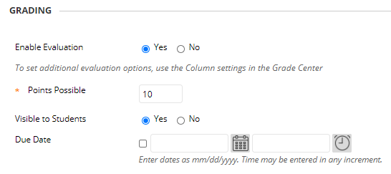

When you have filled in everything you needed, click ‘Submit’ to create the Pitch2Peer module within your Blackboard course.

Once the Pitch2Peer module has been created within the Blackboard course, you can click it to enter it. On the menu bar (which appears when clicking the grey arrow), you can choose the button ‘Edit’ to change the name or the description of the module in the Blackboard folder. We recommend keeping the description of the module short and we recommend placing an announcement in your Blackboard course to notify your students of the assignment(s).

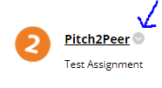
After clicking on the ‘Pitch2Peer’ module, you will see the following attention:

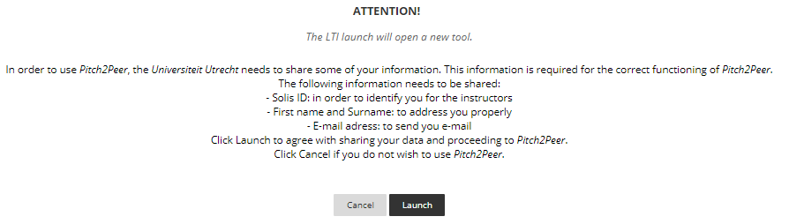
Click ‘Launch’ to be able to use Pitch2Peer.

2.2 Terms and definitions

Pitch2Peer sometimes uses terms that might be different than what you are used to. Here you can find an overview of the main terms for Pitch2Peer, which can be found in the menu bar.
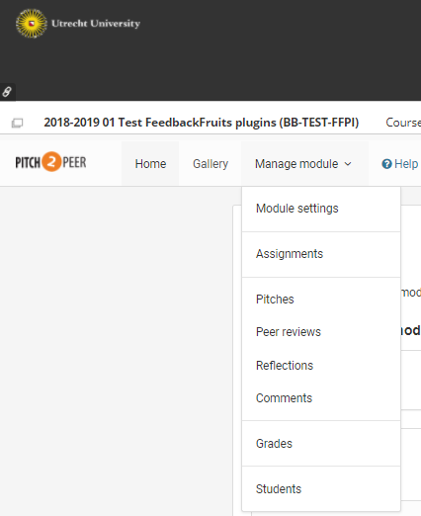

- Gallery = the gallery within Pitch2Peer is the place where you can find an overview of all the pitches for all assignments, in the module of a specific Blackboard course.
- Module = the module is the Pitch2Peer section of your Blackboard course in which you can add and manage all assignments. The module is the entrance to Pitch2Peer within a specific Blackboard course, which can be used by both the instructor and the students.
- Assignment = the assignments are the separate tasks or projects that students must complete. Within a module, you can create several assignments.
- Pitches = these are the results that the students submit for all the assignments within the module of a specific course. These could be videos, photoshoots, posters, slideshows, animations or blog texts. You can filter, manage and download the pitches here.
- Peer reviews = this will take you to the reviews that students have made of each other’s pitches.
- Reflections = here you find the reflections that have been made by students on their own pitches (if you have enabled this option in your assignment).
- Comments = here you can find all comments left below each of the pitches.
- Grades = this is where you can enter and find the grades of the students, as well as synchronize them with the Grade Center of Blackboard.
- Students = these are the students that have clicked on the Pitch2Peer module and which are thus ‘known by the system’ (not necessarily all students enrolled in your Blackboard course).

2.3 Your Profile
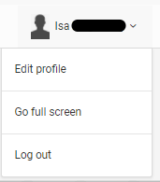

Both the instructor and the students can manage their profile by clicking the grey arrow next to your name on the homepage. After going to ‘Edit profile’, you can set your first and last name as will be shown in the assignments. It is also possible to upload a picture here, which will be shown when you leave comments or ‘likes’ for pitches. We recommend having your students also upload their pictures, so they will know who reviewed them or liked their pitches, which increases social cohesion. This picture will be used for all Pitch2Peer modules in all your Blackboard courses. Finally, there is the option to set an email address and a password. This will not be necessary because you will be using Pitch2Peer through Blackboard.

2.4 Plan Ahead

Before you create an assignment within a Pitch2Peer module, you will need to determine certain things, such as the deadlines, the nature of the assignment and the way it should be reviewed. There are a lot of options in setting up a Pitch2Peer assignment and determining these in advance helps you with the creation of the assignment. It also makes things clearer to students, as you can give them more precise instructions. You will also need to determine how involved you will be in the process yourself and at what stages. Students are more motivated if you are involved, but it will also take more time.

Furthermore, you will need to consider how you fit the Pitch2Peer assignment in the rest of your class and, more specifically, in the ‘Course objectives’ and ‘Course load’. Creating a pitch and reviewing other students’ pitches will take some time for the students and it could feel unfair, or it could be demotivating, if they are not graded on it. It is also important to make clear what things the grade will be based on. For instance, do you reward their creativity as well as their accuracy? Let them know if the focus is more on the form and/or on the content, for example by using a rubric. Finally, you can decide to grade their pitches only, or split the grade between their pitches and their written reviews. This might encourage them to be more honest, but it will take you more time.

2.4.1 Creating Videos in a Studio or Do It yourself

Another important part of the preparation for the Pitch2Peer assignment is deciding on the pitch type. If you wish to use a video, you will need to determine if you want your students to make professional videos in a (DIY) studio, or if you want them to make the videos themselves. An advantage of using a studio is that you will have more professional looking videos and you can ask the help of someone from Teaching Support (for the DIY studios at the university library at Utrecht Science Park and the library at KNG). A disadvantage is that every student needs to make an appointment and arrange it, which they can't do with their own account and SolisID (because they don’t have the rights needed to make a reservation). Thus, this can take quite some time.

It is also possible to have the students record their own presentations. Almost everyone has a smartphone with camera nowadays, and if you fear that they do not you could always decide to make them work in couples or small groups. The students could use a classroom if necessary, so they can record their presentation along with their PowerPoint slides. Another option to be able to see the both the student and the slides, is to let the students record themselves while presenting the slides in Microsoft Teams (in a meeting with only themselves or the group). Both these options will take a lot less time and are easy; they will not require professional help. The quality of the videos is of course not as good, so if you want to focus more on the form than on content that is something to keep in mind.

2.4.2 Uploading Videos to a Safe Environment

Students who upload their own personal videos must be sure that their pitches will only be used for educational purposes and will not go viral. Pitches are stored on one of the Pitch2Peer servers in The Netherlands. Safe access (https) is only provided to students and staff of Utrecht University who are in the same Blackboard module. In the Pitch2Peer environment it is not possible for students to download (and edit) each other’s pitches without special software.

Creating and Copying Assignments

When you create an assignment within a Pitch2Peer module, there are a lot of options to choose from. Each option in the assignment menu already has a little description next to it. In this chapter we will describe and discuss these options more extensively.

If you wish to create an assignment in Pitch2Peer, you will need to go to the module you have created within your Blackboard course. In this module, you can navigate to ‘Manage module’ in the menu bar and then click ‘Assignments'. Here you can find all the existing assignments in the module.
Choose the button ‘Add new assignment’ to start creating a new assignment (if you have created assignments before, this button can be found at the bottom of the page). This will bring you to a screen with several tabs, the first of which is the Overview. It summarizes the 6 steps to help you set up the assignment: Instructions, Timeline, Pitch, Criteria and Questions, Peer review, and Reflection. We will go through them step by step.

Before you start it is important to realize that you will have to enter something in the mandatory fields, marked with an orange star *, or you will not be able to ‘Save’ the assignment.

Further, an existing assignment can be easily copied including all settings (see 3.7).

3.1 Pitch Submission
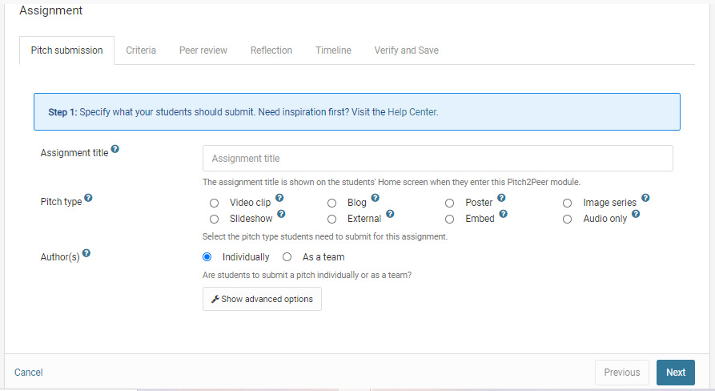
- Assignment title: this will be the title of this specific assignment within the module.
- Pitch types: here you can choose what kind of pitch your students will have to submit. The options are: video, blog (for texts), poster, image series, slideshow, external and embed (this last option can be used to embed content from other websites, such as Prezi and YouTube).
  - Please note that Microsoft Office files are not accepted, e.g. Word for the ‘Blog’ type. They cannot be viewed online and must be downloaded first, which hinders the user experience. However, Office files can be added to the pitch as attachment. To avoid all this, use PDF.
  - In general, the following file extensions can be used: mp3, mp4, mov, wmv, wma, wav, aac, ac3, mts, avi, pdf, gif, jpg, and png.
  - When uploading, students are informed about the maximum size of their files. For video this is 2 GB, for a slide show 200 MB, and for all other pitch types, including posters, images, and attachments, it is 100 MB. Further, the maximum duration of a video clip cannot be more than 8 minutes.
  - Finally, if you want students to be able to submit more than one pitch type, click on ‘Show advanced options’ and go to ‘Multiple pitch types’.
- Author(s): here you can indicate whether all students need to submit their own project, or whether the students should work as a group or team. You cannot indicate the team-members here, so you will need to let the students know what team they are in in a different way. When submitting their pitches, students will need to indicate their team-members themselves.
  - Please note that all students will need to be available in the module by then (see chapter 7.1).
  - Reviewing is always done individually.

3.1.1 Advanced Options
When you click on the button ‘Show advanced options’, several extra options will appear, as can be seen on the screenshot below:

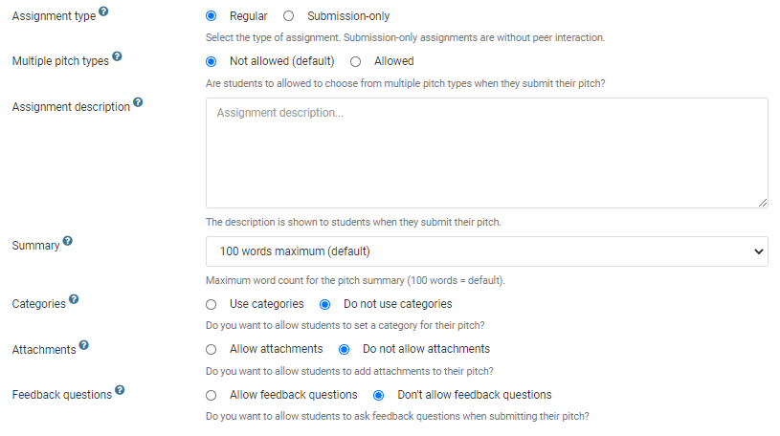
- Assignment type: here you can choose whether you want to have a regular Pitch2Peer assignment (‘Regular’), or whether you want it to just be a collection point for your students’ work (‘Submission-only’) without any of the peer-review or reflection options.
- Multiple pitch types: if you choose ‘Single pitch type’, you can check only one of the boxes in the row below, choosing only one type of pitch. All students will need to use that type. If you choose ‘Multiple pitch types’, you can check multiple boxes, allowing students to choose one of multiple options for their pitch.
- Assignment description: this will be the description of this specific assignment within the module. Please note that you can add other instructions later, for specific parts of the assignment, such as the reviews. This is only the general description.
Here is the place to advise students to upload their videos using the fast University network and not to rely on their network at home. When uploading takes too long, Blackboard does not see any activity, and will log them out.
- Summary: choose how many words students can use to give a summary of their project (with a minimum of 50 and a maximum of 400 words). You can only choose one of the options; you cannot enter your own number.
- Categories: you can use this option to set up several categories for your students. Categories can be regarded as metadata which can be used to filter the gallery on. This is useful when you have various broader general subjects in your class. Please note that only if you check the box for ‘Use categories’ more options will show up. Using the blue button ‘Add new category’ will allow you to add all the categories. Furthermore, you can include a short description or instruction. If you use categories, we recommend making them ‘required’ instead of ‘optional’, as you can use the categories to filter the gallery later.
- Attachments: you can use this option to allow students to add attachments (for instance if they have to hand in a video, along with a written script or a list of literature). Please note that only if you check the box for ‘Use attachments’ more options will show up. Furthermore, you can include a short description or instruction for the students, and you can choose whether the attachments should be visible to everyone or just to the instructor. Again, you can choose whether the attachment should be required or optional.
- Feedback questions: here you can choose whether you want to allow your students to submit questions along with their pitch that their reviewers can answer. Again, you can choose whether it’s required or optional to add these questions for the submitters, as well as whether it’s required or optional to answer the questions for the reviewers.

3.2 Criteria

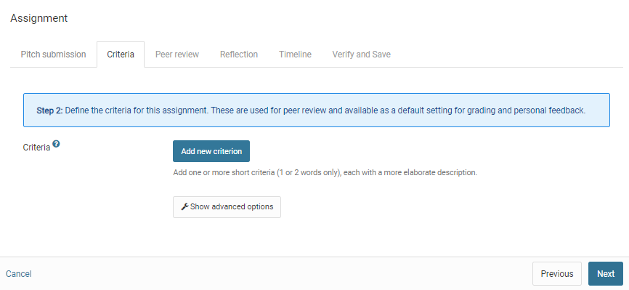

Criteria: by clicking the blue ‘Add new criterion’ button, you can add criteria that the students need to keep in mind when making their pitches. You can also click and drag the criteria to change their order. The criteria will be shown in advance, together with the assignment description in Pitch2Peer so students know what is expected of them. They will also be shown during the review session(s), allowing the students to review all pitches according to the same criteria. When reviewing, students will be asked to rate each pitch on a scale of 1 to 5 based on these criteria. Therefore, it is recommended to keep the criteria short and clear, if necessary with a short description.

Please note that it will be possible later on to add questions and review instructions that students have to answer while reviewing pitches (see step 12 and 18).

3.2.1 Advanced Options
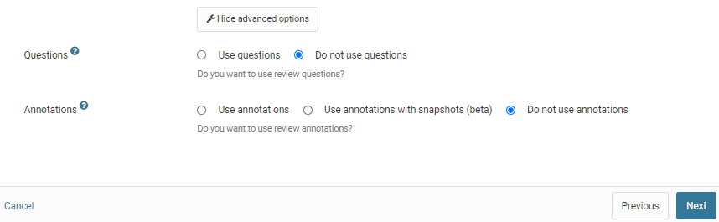
- Questions: here you can add questions the students have to answer when they review each other’s pitches. Please note that you will need to check ‘Use review questions’ before the rest of the options show. Use the button ‘Add new question’ to add as many questions as you'd like. If necessary, you can include explanations for the questions. You can also decide whether answering the questions is ‘Required’ or ‘Optional’.
- Annotations: these are comments that students can add at specific moments in the video pitch, making it clearer what they are referencing to. Please note that you will need to check ‘Use review annotations’ before the rest of the options show. If necessary, you can include an explanation. You can also decide whether these annotations are ‘Required’ or ‘Optional’. We recommend making them optional as it will not always be necessary to point to specific points to make a comment.

3.3 Peer Review

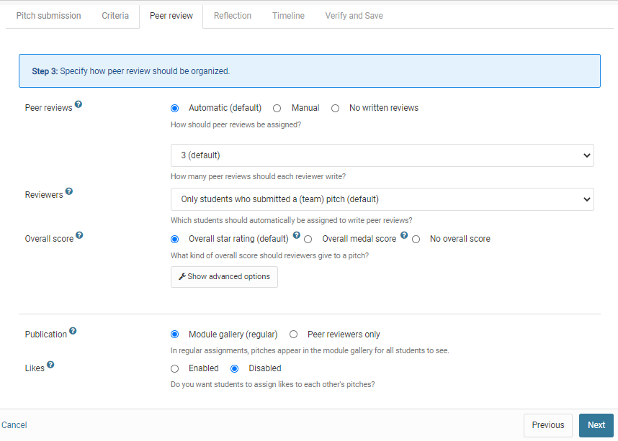
- Peer Reviews: here you can indicate whether the students should submit peer reviews. You can let Pitch2Peer choose who reviews who (by checking the ‘Automatic’ box) or pick the pairs yourself (by checking the ‘Manual’ box). Please note that you will have to make the pairs before the review period starts, by going to the tab ‘Reviews’ and clicking on the ‘Add review manually’ button on the bottom-left. You will then have to manually add all review pairs one by one, so it is recommended to make sure that you have a list of them before you start. If you let Pitch2Peer make the pairs you can indicate how many reviews each student should write. We recommend choosing no more than three reviews per student, as it will take them some time to watch and review each pitch and you do not want them to hurry to finish them. Also, the students can watch all pitches in the gallery if they want to. Finally, it is also possible to not let the students review each other by choosing ‘No written reviews’.
- Reviewers: there are three options when choosing who should make the reviews. In most cases you will want to let the students who submitted a pitch also make reviews. In that case choose ‘Only students that submitted a pitch’ (which includes the teams). However, in some cases you will want to let one half of your group of students make pitches and the other half review them (and maybe later switch the groups). In that case choose ‘Only students that did not submit a pitch’. The final option is to let all students make reviews, independently from whether they made a pitch or not. In that case choose ‘All student users in the module’.
  - Please note that this only means the students in the Pitch2Peer module, not the students in your Blackboard course. To include all students in the course, you will need to make sure all students have been added to the module (see chapter 7.1).
- Overall score: in addition to the review questions (see step 12) you can let the student assign stars and medals to the pitches of their peers. If you choose ‘Overall star rating’ the students can assign one to five stars to all pitches they have to review. If you choose ‘Overall medal score’, they can rank three pitches by assigning three medals (gold, silver and bronze). Besides these medals, they will need to assign stars as well. If you choose ‘No overall score’, students must do neither; they only must rate the pitch on the criteria and questions.
- Likes: when enabled, students can give ‘likes’ to all pitches in the gallery. This could stimulate them to watch other pitches than just the ones they had to review. On the other hand, they might not always use them in the way you intended (for instance, liking only their friends or liking pitches that have no likes yet). It could be viewed as childish or too competitive. You can choose what number of likes the student should be able to give (5, 10, 15, 20, 25 or unlimited).

3.3.1 Advanced Options
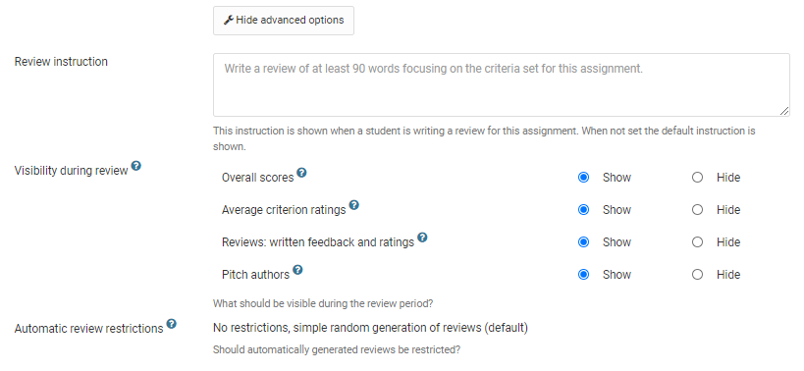
- Review instruction: here you can add instructions for the reviews the students have to give. Please note that the ‘Criteria’ you added earlier on will also be shown here, along with the instructions you gave with them. The ‘Review instructions’ should be specific to the ‘Review questions’ (specific open questions) you can enter after this, complementing the ‘Criteria’ (general criteria that can be rated on a scale of 1 to 5). These review instructions will be shown at the top of the review page.
- Visibility during review: here you can choose what students should be able to see during the review period. Check the box ‘Hide’ for ‘Overall scores’ if you wish to hide the overall scores, such as the medals and likes. Check the box ‘Hide’ for ‘Average criterion ratings’ if you wish to hide the average ratings based on the criterions you set (which will be rated on a scale of 1 to 5). Check the box ‘Hide’ for ‘Reviews: written feedback and ratings’ if you do not want the students to read each other’s reviews (specific feedback and ratings per student) yet.
All of these will of course become available in the conclusion period. We recommend making them hidden until that moment to make sure early reviews do not influence reviews that will be written later. Finally, you can also decide to hide the names of your students during the review period by checking the box ‘Hide’ for ‘Pitch authors’. This can be useful if you do not want your students to be influenced when they review pitches. However, please note that in the case of videos disabling the name might not make a difference as the student could be visible in the video. You will also need to let students exclude their names from their pitches beforehand.
- Automatic review restrictions: here, you can set up some restrictions for the distribution of the reviews among students. For example, you can restrict the distribution so that students only review pitches from the same category as their own. Please note that this option only applies when you enable ‘automatic reviews’ and categories are both used and required.

3.4 Reflection
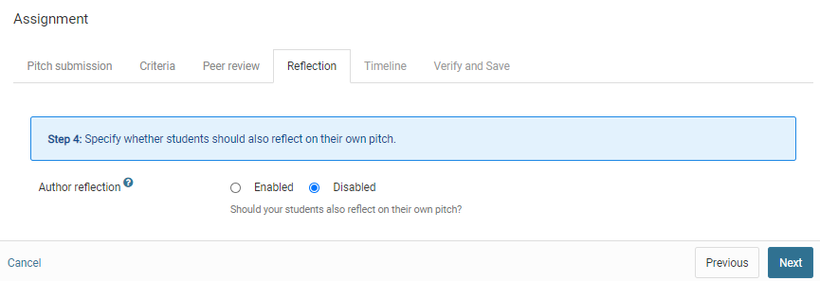
- Author reflection: if you enable author reflection, students will also have to reflect on their own pitches during the review period. Clicking ‘Enabled’ will give you the option to include a short instruction for the reflection. The criteria and questions the students will have to answer are the same as with peer review. Author reflections are private; their videos are always public to the whole group.

3.5 Timeline
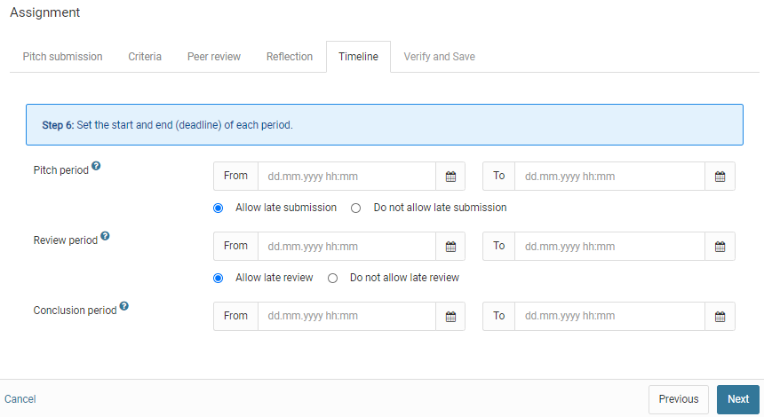
- Pitch period: this is the period in which students can submit their pitches through the assignment. On the ‘open’-date the students can start submitting their pitches and after the ‘close’-date (‘due date’, or deadline) this will no longer be possible. You can allow students to submit their pitches if they have missed the deadline by checking the ‘Allow late submission’ box, but please note that these pitches will not be included in the reviewing sessions if the review period has already started! If you want to also include pitches that were submitted late, add a few days between the deadline of the pitch period and the start of the review period.
- Review period: during this period the students can review each other’s pitches. The ‘open’-date must be set at least one hour after the deadline of the pitch period, to make sure all submitted pitches are included. The closing-date of the review period will mark the deadline before which students will have to make all their reviews. Again, you can allow students to review pitches if they have missed the deadline by checking the ‘Allow late reviewing’ box. Finally, you are free to change the dates of the review period after saving the assignment, if the review period has not yet started. Students will be assigned to pitches they have to review once this period starts and this distribution is final.
- Conclusion period: during the conclusion period everything (including all reviews, remarks etc.) will be made available to all students. This period is therefore only useful if you decide to not show the feedback during the review period (see step 19). This period also does not require any actions from the students. Please note that if you wish to check the reviews for yourself before making them public, it is best to make sure there are a few days between the deadline of the review period and the ‘open’-date of the conclusion period. After the ‘close’-date of the conclusion period, the assignment will be archived but remain available.

3.6 Verify and Save

With this final step you can review the choices you have made for your assignment. If necessary, you can use the ‘Previous’ button to go back to a step and change some of the options. You can also go back by clicking on the tab for that subject. Finally, click the ‘Save’ button to save and start your assignment. If all went well, you will get a pop-up window that confirms your assignment has successfully been saved.
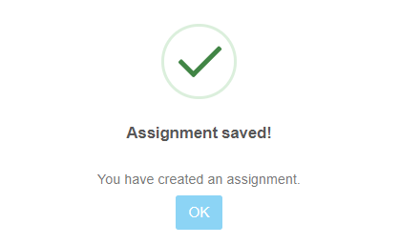

3.6 Verify and Save

Because of the many features of Pitch2Peer, setting up an assignment may be quite some work. However, it is very easy to copy an existing assignment. In the Pitch2Peer menu bar, click the button ‘Assignments’, and then the button ‘Copy existing assignments’.
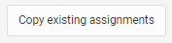
Select an existing assignment from your current or another Pitch2Peer module you have access to, adapt the title (see the tab Instructions in section 3.1) and dates (see the tab Timeline in section 3.5).

Managing Assignments

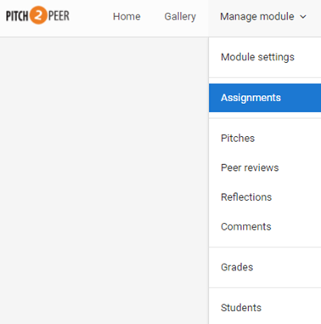
Once you have created one or more assignments, these will show up on the ‘Assignments’ tab, which can be found under ‘Manage module’. They will be listed from oldest to newest.

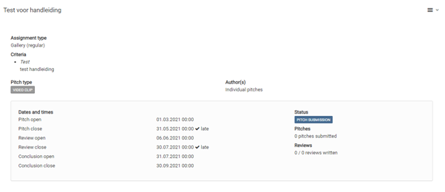

Two new buttons for each assignment are the ‘Edit’ button and the ‘Manage’ button:

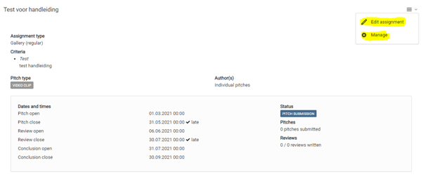

With the ‘Edit’ button you can go back to the settings of the assignment. Most of these can still be changed when the students have already started the assignment. Please note, however, that you cannot change the dates of any of the periods if they have already started (especially the review period). Pitch2Peer will let you know if you can still safely adjust the period dates.

When clicking on the ‘Manage’ button, you can delete the entire assignment. Deleting the assignment cannot be undone and is therefore not possible if students have already submitted pitches to this specific assignment. If the assignment must be deleted, you will have to confirm this through typing ‘delete’ in a textbox. In this way you cannot delete the assignment by mistake.

Managing Pitches

Viewing and managing pitches can be done in both the tab ‘Gallery’ and the tab ‘Pitches’ (via ‘Manage module’). The ‘Gallery’ tab functions as an overview: it shows you all the pitches of all the assignments that have a status beyond ‘pitch period’. It is here that you can easily view all pitches, as well as see their average ratings, likes, reflections, review and comments.

The ‘Pitches’ tab is the place to manage all of your pitches. You can also view pitches by clicking on the ‘View’-button (). But the ‘Pitches’-tab is primarily used to manage the pitches. This second tab will therefore be discussed more extensively.

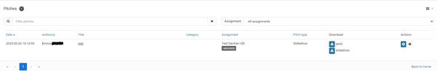

5.1 Filtering and Sorting

The pitches tab (as shown above) will give you an overview of all of the pitches in your entire module. You can sort these pitches by clicking on the blue headers (‘Submitted’, ‘Author(s)’, ‘Title’, ‘Assignment’ and ‘Status’). If you click on them once all pitches will be sorted based on that header, if you click them twice it will switch the order of the pitches. Viewing everything at once might be useful at first, but as soon as there is more than one assignment, you will want to filter them. You can filter the pitches to view only one assignment at a time. To do so, you can use the drop-down-menu at the top-right and choose the specific assignment you want to view. If you are looking for a specific pitch, or all the pitches of a specific student or subject, you can search for them by using the search-bar at the top-left.

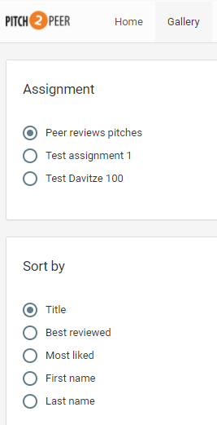

Pitches can also be viewed and sorted/filtered in the ‘Gallery’. Only the pitches from the assignments that have reached (at least) the review period will be available here. You can sort the pitches per assignment by choosing an assignment at the top-left. You can also choose how you want to sort your pitches by choosing one of the options from the menu on the bottom-left. Options are: ‘Title’ (which is chosen by the student), ‘Best reviewed’ (based on peer-review), ‘Most liked’ (based on peer-review), ‘First name’ or ‘Last name’ of your students, and ‘Category’.

5.2 Downloading

Each pitch can be downloaded by the instructor. This can be useful when you want to work offline and can be done by using the ‘Download’ button in the row of each specific pitch: (). You can choose whether you want to download the pitch as a PDF file (choose ‘pitch’) or as a video (choose ‘video’). This last option will result in separate .mp4 files.

In some cases, however, you might want to download multiple (or all) pitches at once. This is also possible, by using the button ‘Download multiple pitches’. Please note that in this way all downloaded pitches will result in a PDF file, no matter the pitch type.

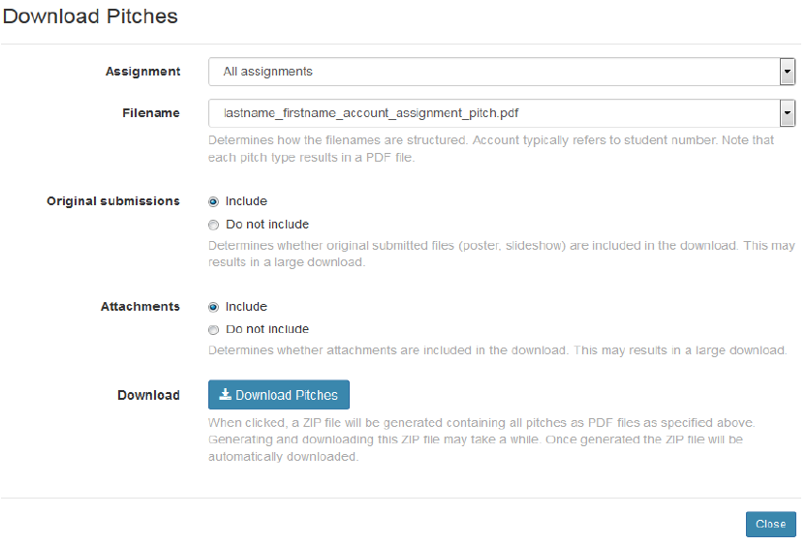
Clicking on the ‘Download multiple pitches’ button will give you a pop-up-window (see above). When downloading the pitches from your Pitch2Peer module, you will need to indicate whether you want to download pitches from all assignments, or from one specific assignment. Then, you can choose how you want your files to be named. There are five options, and all five of them have the same components but they are ordered differently. You can choose to have the file names start with students’ last names, first names, accounts (which are their student-numbers), or with the name of the assignment or of the pitches. We recommend using either last names or accounts/student-numbers, as those are most used.
Next, you can choose to include or exclude the original submissions by the students, and even the attachments if they have added any. Finally, clicking the ‘Download pitches’ button will give you your files. They will be generated in a ZIP-file. Please note that this may take a while before it is processed. Downloading should start automatically.

5.3 Hiding and Deleting

Sometimes it can be necessary to hide or delete a pitch, for instance, if someone has uploaded the wrong file by mistake or if there are contents that are not suitable for your assignment. In those cases you can use the ‘Manage’ gearwheel button: (). Clicking this will give you a pop-up-window.

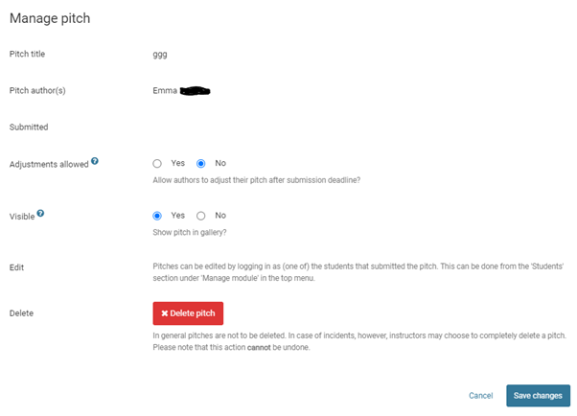

Here, you can choose whether students are allowed to make adjustments to their pitch (please note this only applies to the ‘pitch period’, not afterwards). You can also change the visibility of a pitch, for example if you deem it not appropriate. At the bottom there is the option to delete the pitch, but as everywhere else in Pitch2Peer you will need to type ‘delete’ manually to make sure you do not delete pitches by mistake.

During the Review Period

When the pitch-period has been completed and the review period has started, all pitches that are available at that point will be included in the review period. It is also at this point that the pitches from that specific assignment become available in the ‘Gallery’. In the Gallery, students can assign likes and medals to pitches they like best. They might also have to write reviews and reflections.

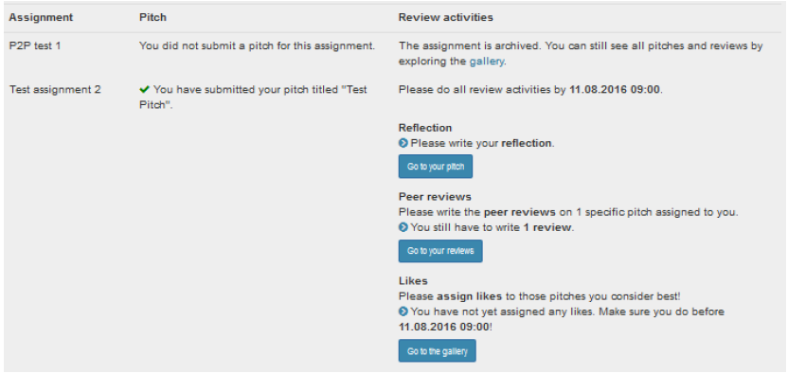

6.1 Reflecting on Pitches

Students who have submitted a pitch for the assignment will be asked to write their reflection as soon as they open to Pitch2Peer. On the ‘Home’ screen (see above) they can see if they have any activities left to complete. Clicking on the ‘Go to your pitch’ button will take them directly to the overview screen of their own pitch, where they can write the reflection (see below).

The students will be asked to write down a general reflection on their own pitch (open question), as well as rate themselves (on a scale of 1 to 5) on the criteria that you set up as instructor when you created the assignment. The students are then asked to answer the review questions that you set up as instructor when you created the assignment. These are open questions.

6.2 Reviewing Pitches

On the ‘Home’ screen (see above) students will also be reminded if they have to write any reviews. If so, there will be a button available that will take them to their reviews, which is ‘Go to your reviews’. Clicking this button will take the students to their ‘My reviews’ tab, where they can find all pitches they have to review (for all assignments). Clicking on a pitch will take them to the overview screen (see below).

Clicking the button ‘Write your review’ will give the students several questions. First, they are asked to write down a review (open question). Then, they are asked to rate the pitch on scales of 1 to 5, on the criteria that you set up as instructor when you created the assignment. Next, they are asked to choose a medal (gold, silver, bronze, or no medal) for this specific pitch. If they have to review several pitches, they can assign each medal only once. Finally, the students are asked to answer the review questions that you set up as instructor when you created the assignment. These are again open questions. Students can replay the pitches multiple times, which will help them with giving a better review. They can also come back later and edit their review, as long as the review period has not ended yet.

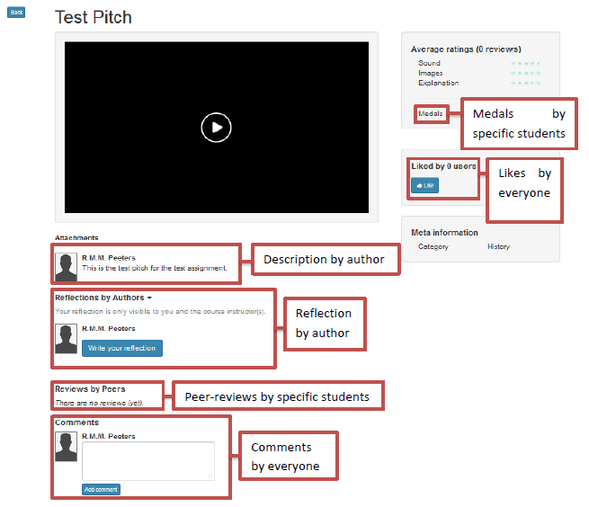

6.3 Liking and Commenting on Pitches

Liking and commenting are the two things all students as well as the instructors can do with all pitches. Students can only write reviews for pitches they have been assigned to, and they can only reflect on their own pitches, but likes and comments are open for all. As the instructor you may want to add comments and likes after the students have written their own reviews and reflections (see chapter 8.1).

If a student opens a pitch from the ‘Gallery’, they will be able to leave a comment at the bottom of the page. At the right side of the page, they can give the pitch a like. The ‘Gallery’ will show the total amount of likes for each pitch. The comments and likes can be viewed and read by all instructors and students in the module.

Managing Students

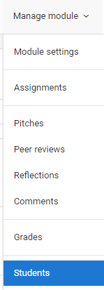

The ‘Students’ (via ‘Manage module’) tab will show the students that have clicked on the Pitch2Peer module in your course, and which are thus known in this module. Students that are enrolled in your Blackboard course but that have never opened Pitch2Peer within that specific course will not show up here. However, you can manually import them (see 7.1).

Per student, you can see their personal details (name and student-number), and how far along they are with each assignment. You can sort the student list by clicking on the blue headers. You can also filter your students using the search-bar at the top left (‘Filter students'). Furthermore, you can filter students on specific stages within the assignment process, by using the drop-down menu on the top right (‘Selection').

7.1 Adding and Deleting Students

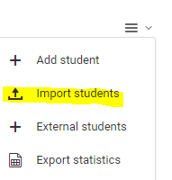

If you want to add students who have not opened Pitch2Peer in your course and are therefore not included in this module, you can use the button ‘Import students’ (top right). Please note that you should not use the button ‘Add student’.

You will need a .csv file to import students. If you click on the button ‘Import students’ Pitch2Peer will show a new pop-up-screen, with an explanation of how to create a .csv file from the Grade Center of your Blackboard course (see below). You will need to make sure all students are already enrolled in the Blackboard course. After creating the .csv file you can use the same pop-up-screen to upload the file to add all your students to your Pitch2Peer module.

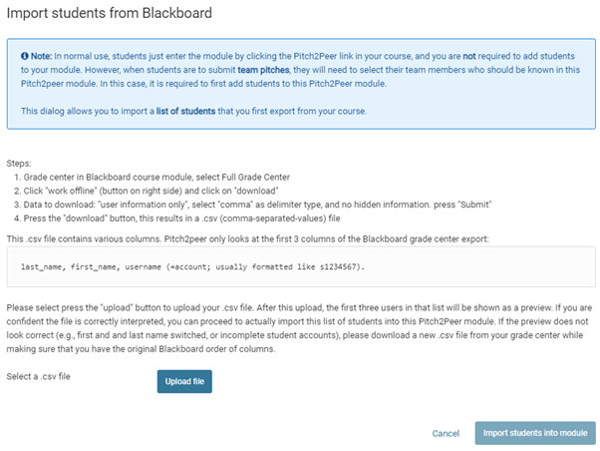

If you have imported students into your module, it is important to check for doubles. Students who were already in the module could have been added again. You can do this easily by sorting the student list on their last names.

On the other hand, it is sometimes necessary to delete students from your course, for instance if they have discontinued taking your classes or if they were never supposed to be there in the first place. You can delete a student from Pitch2Peer with the ‘Manage’ gearwheel button (). Clicking this button will give you a pop-up-screen with a ‘Delete’ button (). Again, just clicking this button is not enough: you will need to type ‘delete’ into a text-bar to confirm it. Please note that deleting a student user cannot be undone, and that it does not remove them from your Blackboard course or any other Pitch2Peer modules besides the one you are currently in.

7.2 Login as Student

Pitch2Peer offers instructors the possibility to see the assignments from a student’s perspective. You can find this option on the Students tab, under each student’s student-number. Clicking the button ‘Login as a student’ will take you to the ‘Home’ screen of that specific student, which looks like this:

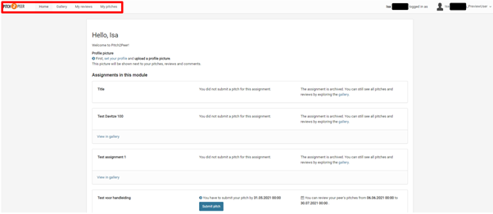

You can see that the menu-bar is a lot shorter for students: they only have the options ‘Home’, ‘Gallery’, ‘My reviews’ and ‘My pitches’. Their functions are roughly the same as the options for instructors. Furthermore, on the right you can see as which student you logged in. By clicking on the name and then on ‘Log out’ you will return to your own account. This can be used to easily switch between views.

While you are in the student view, you can submit pitches for students. This could come in handy when students are for instance unable to submit their pitch themselves (e.g., when they do not have access to Blackboard) but are able to send it to you by email. Pitch2Peer also allows you to submit reviews for students, but we do not recommend using this option. Students who cannot write their own review also would not have been able to view the pitches.

Assessments and Grades

As an instructor you can give an assessment of each student’s pitch. This is an evaluation of their pitch based on the criteria you set when making the assignment, along with a grade for each criterion and a final grade. When you click on a pitch via the tab ‘Gallery’, the following option will appear on the right of your screen: ‘Instructor grade/feedback'. You can also see the average peer ratings of the pitch you've clicked on.

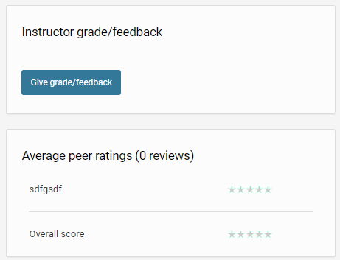

8.1 Giving Assessments

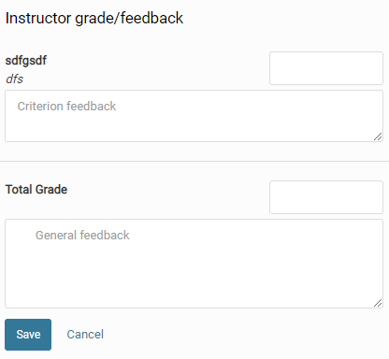

After you have clicked on the button ‘Instructor grade/feedback', an overview will be unfolded, including: your criteria for this assignment, along with text-fields at the bottom, one to enter their final grade (usually based on the grades for the criteria) and one to give the student some general feedback. Please note that the grades should be entered with a decimal point rather than a comma (so 7.5 instead of 7,5). This is to make sure they can be exported to the Blackboard Grade Centre later.

The grading you have entered for all pitches can later be found in the ‘Grades’ tab (‘Manage module’ --> ‘Grades'). If you do not want your students to see them, this is also where you can make them invisible (by using the ‘Manage’ gearwheel button). You can also ‘Reset’ the grading there, or by going back to the pitch and re-entering your grade/feedback.

8.2 Exporting Results and Grades

In Pitch2Peer it is possible to export almost all of the results. You can export the ‘Pitches', ‘Peer reviews', ‘Reflections', ‘Comments' and ‘Grades'. On each of these tabs within Pitch2Peer, you will find an ‘Export...’ button by clicking on this: . Clicking this button will give you a pop-up screen (depending on the web-browser that you use). The file that will be downloaded is a .csv file, which can be opened with either Excel or Notepad.

8.3 Synchronizing with Grade Centre

Instructors who use the Blackboard Grade Center may want to synchronize their grades in Pitch2Peer with the Grade Center. This is not done automatically, but you can do it manually. On the ‘Grades’ tab you will find the button ‘Send Grades’ when clicking on .

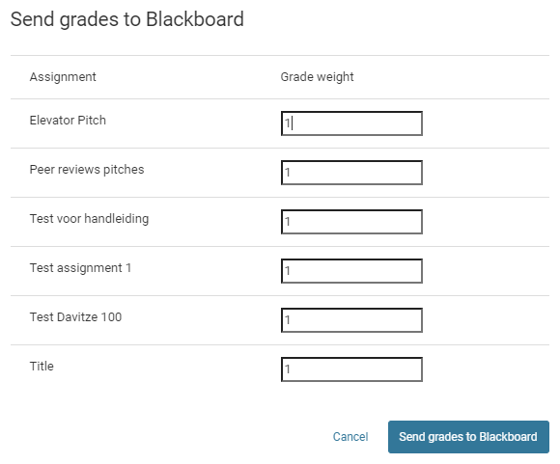

Clicking on the button ‘Send Grades’ will give you a pop-up-window, in which you are asked to weigh all of the assignments. Behind each assignment there will be a ‘1’. If you only used one assignment you can leave it as it is and click on ‘Send grades to Blackboard’. If you used more than one assignment, and you wish to have each of them count equally toward the total grade, you can also leave them at ‘1’.

If you used more than one assignment and do not want them to count equally toward the total grade, you will need to change the amounts so that each assignment has the specific weight you want it to have (for instance, two assignments count for 1, and the final assignment counts for 2. Or two count for 0.25 and one counts for 0.5). The specific numbers do not matter. What matters is that their weight is relative to each other. If you then click on ‘Send grades to Blackboard’ the grades will be exported to the Grade Centre. Please note that the marks could end on a fraction (such as 7.666666).

FAQ / Tips and Tricks

When do I use Pitch2Peer?
Pitch2Peer is meant as a review tool and therefore especially useful if you want your students to comment on each other’s work. It is best used on a moment when feedback can still be processed by the students, for instance with a concept version of a paper. Pitch2Peer is also meant to train students in giving presentations, giving feedback and to improve their communication skills. Furthermore, by having students reflect on literature in their pitches you can also let them gain substantive knowledge.

How do I choose what pitch-type(s) to use?
Make sure the pitch-type fits your assignment; do not choose it because it is ‘fun’. It needs to have value for the learning process of your students. Students usually prefer PowerPoint presentations, posters and blogs. Videos are more creative but will also take more time, both to learn how to do it and to produce the video. Make sure they are not too long. Also, keep in mind that presenting for a camera is a lot different from presenting in front of a class.

Furthermore, keep in mind what kind of students you are working with. First-years might be more used to working with videos and tools like Pitch2Peer than master students could be. On the other hand, they might still have a lot to learn with regards to presenting and writing.

How often do I use Pitch2Peer assignments and how big should the assignments be?
If you give Pitch2Peer assignments more often chances are students will view it more as a ‘social platform’, which will motivate them to use it more (for instance by viewing other pitches they did not have to review). On the other hand, certain types of pitches might take a lot of time (such as videos). It is important to maintain a balance between how much they learn and how much time it takes. You could use group assignments to limit how much time it takes or alternate the pitch types.

It is also recommended to take the time for each part of the process. Give students enough time to prepare their pitches and give them at least a week or so for writing their reviews (depending on the number of reviews they have to write). This way you will ensure their quality.

How do I integrate Pitch2Peer in my course?
Make clear to your students why you use Pitch2Peer and how it will contribute. What will they learn? How does it fit in the course objectives as described in the course description? It is also useful to have the assignment(s) contribute to their final grade. This will give the students an idea of what is expected of them and why they are doing their assignments.

Another way to integrate the assignment(s) in your course is to have them contribute to the students’ final product. For instance, having students comment on concept-versions of each other’s papers will contribute to their final papers.

Is it necessary to make my students upload profile pictures?
It is not required for students to upload pictures. It can, however, contribute to them perceiving Pitch2Peer as a ‘social platform’ and motivating them to use it more. Students will also get to know their peers better, which might lead them enjoying classes more.

How do I make sure my students write honest and constructive reviews?
It is useful to check if your students are experienced in giving feedback. If not, you could take some time during your class to discuss this. Make sure they know why you use reviews and how they can use them to improve their work. Also, you can use the ‘criteria’ and ‘review questions’ in Pitch2Peer assignments to give the students pointers on what aspects are important.

We have noticed that students usually keep their reviews kind and friendly, but that they will be honest and make sure to write constructive reviews. If a student has not put an effort in his/her pitch, this will be reflected in the feedback he/she receives. It is important to monitor the reviews that are being written. If they are either too sweet or too critical it can be useful to discuss them during your class.

What is my task as the instructor during all this?
If you as an instructor actively participate in the process, you will encourage students to do the same. It is therefore important to discuss the assignments beforehand and afterwards during your class. You can also check if students use their feedback, for example in a revised version of their paper. Another possibility is to show the best pitches in class as examples. And finally, you can place comments underneath all pitches. We recommend doing so after the reviews have been written.

Do I need to grade the assignments?
Using grades could encourage the students to try their best, both at the assignment and at the reviews they have to write. On the other hand, we have found that students are already likely to try their best because of the open nature of Pitch2Peer. However, receiving a grade can also be a form of a reward, or of recognition. Students put in a lot of time and if there is no grade it can let them feel like it was not worth it in the end.

I sent the grades to the Grade Center but made a mistake. Now what?
If you made a mistake, you could correct the mistake in Pitch2Peer and re-send the grades to the Grade Center. Keep in mind that students might notice that their grade has changed if the grades are visible to the students.

I do not like the medals and likes. Do I need to use them?
In our experience, using the medals and likes can have different results. They are mostly useful for big groups with students who are not yet familiar with each other, or with very ambitious students (such as honours students). In small groups students are usually less competitive and value the social element more. They are more likely to ‘like’ the pitches of their friends. Finally, using likes and medals will encourage the students to view more pitches than just the ones they were supposed to review.

My student missed his deadline. Can he still submit a pitch and participate in the reviews?
You will need to go back to the settings of the assignment and choose ‘Allow late submission’ for the ‘pitch period’. If the review period has already started the reviews will already be assigned. You will then need to go to the ‘Reviews’ tab and use ‘Add review manually’ to assign reviews for this student.

My students have missed the deadline for writing reviews and reflections, as well as giving likes and medals. Can they still do so?
You will need to adjust the settings of your assignment. Choose ‘Allow late reviewing’ for the ‘review period’. If the conclusion period has already started, you will need to adjust the dates for the review period (only the end date!) and the conclusion period.

My student was logged out by Blackboard during uploading his pitch.
When uploading takes too much time, for example because of a slow home network, Blackboard logs you off. Advise your student to upload his pitch using the University network.

I do not want my students to see their grades. What should I do?
You will need to go to the ‘Assessments’ tab and click on ‘Show/hide assessments’ to make the grades invisible. Make sure that you have selected the right assignment by using the drop-down menu on the top-right. Please note that if you have sent the grades to the Grade Center already, they will be visible there as well.

My question is not listed here. What should I do?
Please contact us:

Teaching Support | Utrecht University | Utrecht Science Park University Library, second floor: Heidelberglaan 3, 3584 CS Utrecht | Phone number desk: 030 253 2197 | teachingsupport@uu.nl | https://uu.nl/teachingsupport | Opening hours desk: on weekdays from 8.30h - 17.00h.

