Powtoon
Teacher manual
Teachingsupport@uu.nl

Table of content

Table of content 2
1. Introduction Powtoon 3
2. Creating an account 4
3. First login 4
4. Let's get started 5
4.1 Editing animations 5
5. Contact 5

Introduction Powtoon
Powtoon is an online program, designed to make it easier to create animations. An animation is a short video with sketched persons, objects or text. This program offers images, templates, movements, music, and much more to create animations that help you to convey your story. Powtoon has options to either work with premade settings to create and visualize your scenes as well as a studio to create your own avatar. You can combine any option you like to suit your creativity and material.

Creating an account
After you have sent a request for one or multiple Powtoon licenses, you will receive a link. Using this link, you can register on Powtoon.

- Since this link entails one or multiple licenses (depending on your license request) you should be careful with sending the link to the right person(s).

Since we have limited licenses for Powtoon, we need to be informed about how long you will be using Powtoon. If you need your license to be extended, please reach out to us – Teaching support

First login
After your first login on Powtoon, you arrive at the main dashboard. This is the main starting point for all actions. You can opt for personalized or popular templates, but starting with a blank canvas is possible as well. A view of the dashboard down below:

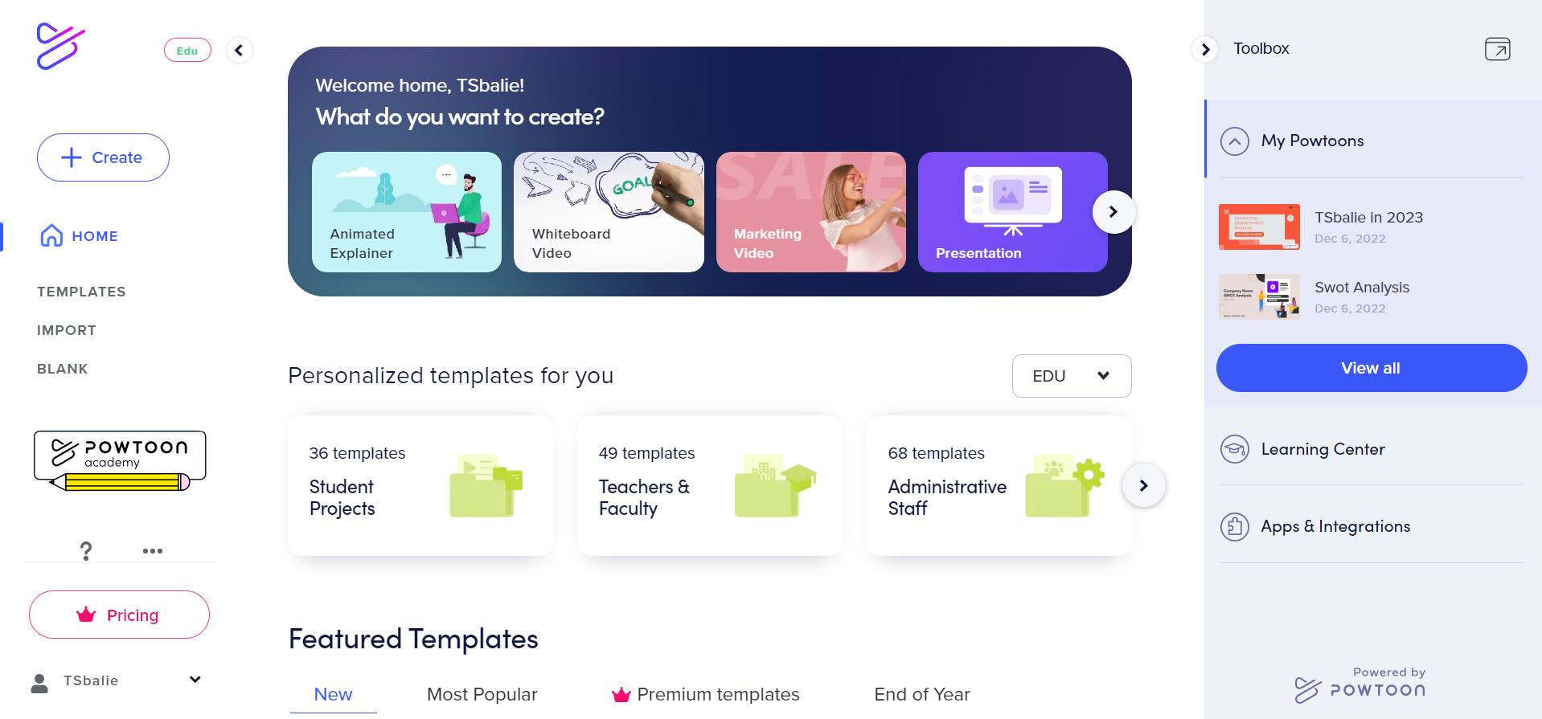

When you first log into Powtoon, you will receive a pop-up asking if you want to follow some ‘tours’ around the program. This tour includes some brief but useful explanations regarding the dashboard.

Let's get started
You start with the dashboard. In the left bar, you see the ‘home’ button. When you click on ‘home’ you return to the dashboard. Underneath ‘home’, there are the options ‘templates’, ‘import’, and ‘blank’. Depending on your preferences, you can choose how to start working on your Powtoon animation.

- Using ‘templates’, you arrive at a list of premade templates. Here you can choose from the different subcategories, like Marketing or Entrepreneur, or search for a different themed template by entering keywords into the search bar.
- Do you want to use an existing PowerPoint for your animation? Then use ‘import’. This allows you to upload PowerPoint files and turn them into an animation. Do keep in mind that the layout of your PowerPoint may be altered a bit when uploaded into Powtoon.
- The last option is ‘blank’. Choose this option when you want to start with a blank canvas.

For extra help and inspiration for the creation of animations you can always look into the tutorials from Powtoon, at https://www.powtoon.com/tutorials/.

Editing animations
After choosing an animation option, you enter the editing studio. The studio will look similar to this:
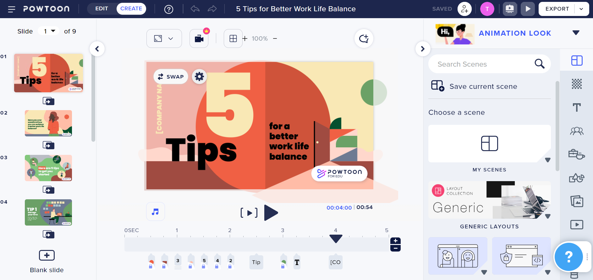

On the left you see the storyboard. It looks somewhat like editing PowerPoint presentations: It gives you a global view of the scenes/slides that are part of your animation.

On the right you see the toolbar. The toolbar is home to many editing options for the scenes/slides. These are things like changing the background, duplicating templates from other animations, uploading drawings/images or even videos.

Down below you can see the time bar, telling you what happens at what exact moment in the scene, like a name or figure popping up. This gives you an indication of time to synchronize visuals like figures and animations to your story.

At the top right corner is the ‘export’ button. You can use it to download the finished product. You can also use ‘export’ to send a link of your animation to others, so they can watch and/or edit it within Powtoon.

Contact

Do you have questions or are you in need of assistance regarding Powtoon?
Powtoon has multiple tutorials with practical as well as didactical tips. You can find them on https://www.powtoon.com/tutorials/?locale=en.

Of course, you can contact us with any remaining didactical or practical questions. We would also love to hear it if you have any comments or questions regarding this manual.

Address: University Library Uithof, second floor, red desk

Office hours: Every weekday from 8.30u - 17.00u

Telephone number: 030 253 2197

E-mail: teachingsupport@uu.nl

Website: https://www.uu.nl/en/education/centre-for-academic-teaching/contact-centre-for-academic-teaching

