Pitch2Peer
Studentmanual
teachingsupport@uu.nl

Content
Log in and handing in assignment 3
How to review the work of a fellow student (if this is part of the assignment) 5
Upload in Pitch2Peer from a mobile device 6
Contact 8

Log in and handing in assignment
Pitch2Peer is a review tool in which assignments ('pitches') such as a video, poster, blog or presentation can be submitted. Pitch2Peer is a tool that allows students to learn from the work and feedback of other students. The teacher can add Pitch2Peer to the Blackboard environment of the course. You can open and use the program via the Blackboard page of the course.
When you click on the Pitch2Peer module in Blackboard, you will be directed to the 'Home' page. Here you can find which actions are expected of you at which moment and which deadlines are linked to these. It could be that you have to hand in an assignment, give feedback to fellow students or that the teacher has given you a grade.
1. Go to the blackboard environment of the course and click on the assignment (see the pictures below for an example). Click on Launch.

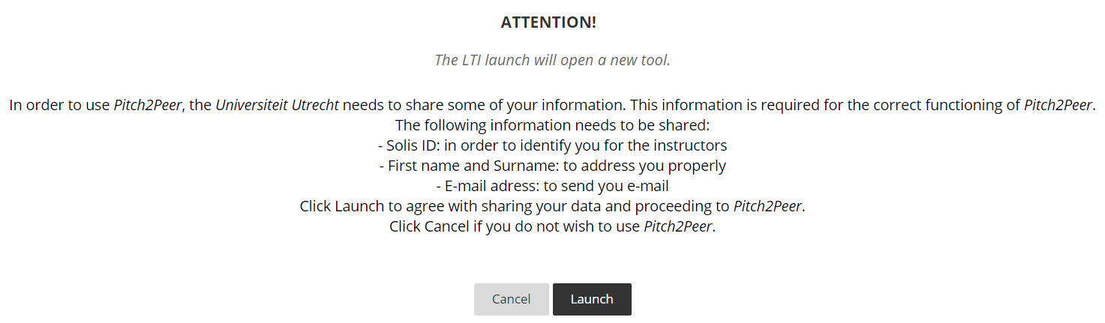

2. Under “Assignments in this module” you will see the assignment.

3. Click on the assignment and on Submit. You can also see what the deadline is.

4. You will be given the opportunity to add a title, to upload your pitch and to write a summary. After you have done this, you can click on submit. You can still edit the submitted assignment until the deadline.

5. If you have to hand in the assignment as a group, you can follow the next steps:
- All group members log in once by clicking on launch via Blackboard. This is how Pitch2Peer recognizes everyone as a student of the course.
- One student submits the pitch by going to “Assignments in this module” and clicking on submit pitch.
- Give the pitch a title and attach the file. You can also add a summary.
- Select the group members under Team. Click on the name of the group member and click on “Add to team”. Add all group members in the same way. Finally, click on Submit. The pitch will be submitted on behalf of the whole group.

How to review the work of a fellow student (if this is part of the assignment)

1. Shortly after the submission deadline, the review button will appear. Click on ‘’Go to your reviews’’ and click on the assignment of your fellow student.

- Click on “Write review’’. There are several review options. The teacher sets this in advance.
- Criteria: the teacher can set up one or more criteria to be taken into account during the review. When reviewing, you will be asked to rate the pitch against these criteria on a scale of 1-5.
- Questions: the teacher can set up questions that the student must answer when reviewing each other’s work.
- Annotations: these allow students to add time based notes to the pitch, making it more clear what they are referring to.
- Overall rating: the instructor sets whether you should assign stars or medals to the pitches. If the instructor has chosen: 'Overall star rating', you can assign one to five stars to all the pitches you have to rate. If the instructor has chosen 'Overall medal score', you can rank three pitches by assigning three medals. The instructor may also choose not to include both.
- Likes: if enabled by your instructor, you can give likes to pitches in the gallery.

Upload in Pitch2Peer from a mobile device

It is also possible to upload a video pitch in Pitch2Peer directly from a mobile device. It is no longer necessary to upload the video from a laptop/PC.

You can do this as follows:
1. Make sure you have been in Pitch2Peer at least once via Blackboard and have clicked on "launch".
2. Using a laptop or PC, go to the Pitch2Peer website (https://uu.pitch2peer.com). Log in with your solis-id, go to the assignment and click "submit pitch".
3. When uploading, you will see the following option: "Upload from mobile device".

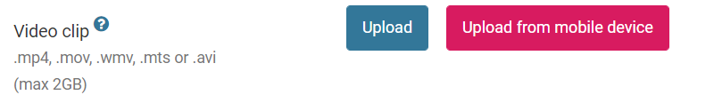

4. Clicking on this will create a code that is valid for a few minutes.
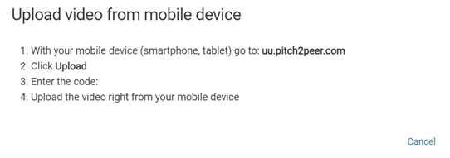
5. On your mobile device, go to https://uu.pitch2peer.com. You do not need to log in. Click on "Upload media from this device".

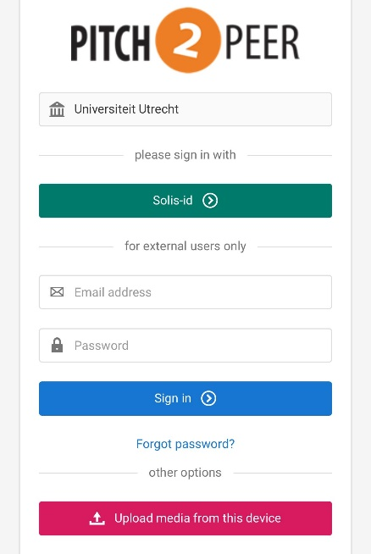

6. You can now enter the code on the following screen:
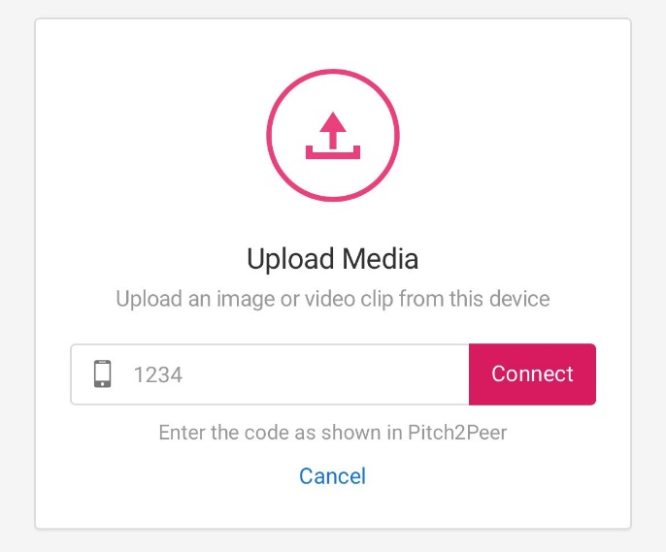

If too much time has passed between creating the code and entering it, the code may no longer be valid. In that case, click cancel and again on "upload from mobile device".

7. Once you have entered the code, Pitch2Peer will make a connection with your mobile device. If this went well, you will see the following screen:

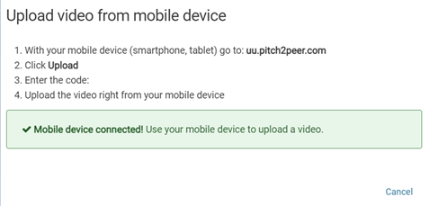
8. On the mobile device you can select and uplaod a file.
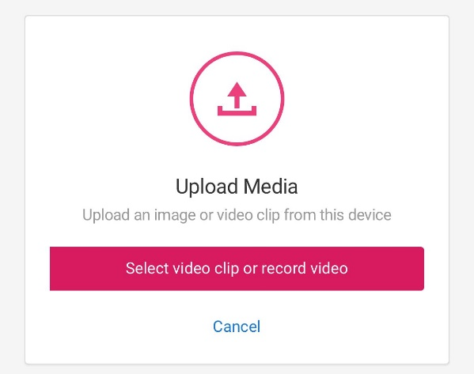

9. The video is then viewable in Pitch2Peer (also via a laptop or PC). Now proceed to process the Pitch, as described in step 4 on page 3.

Contact
Do you have questions about using Pitch2Peer? Or do you have any comments or questions about this manual? Please contact us.

Educate-it support desk:
Opening hours: Every workday from 8.30h to 17.00h
Telefone: 030 253 2197
E-mail: teachingsupport@uu.nl
Website: https://educate-it.uu.nl/

