Traintool
  - Teacher manual
teachingsupport@uu.nl

Contents
1. Introduction Traintool 3
2. Login and obtaining rights 4
3. Let’s start! 5
3.1 Creating programs 5
3.2 Adding trainees 7
3.3 Sending invites by E-mail 8
3.4 Assigning coaches 8
4. Contact 9

1. Introduction Traintool

Traintool is an online tool in which students can practise communication skills through role play. This way, students can rehearse job interviews or coaching dialogues. Students will be shown theory and examples. After that, they can try it themselves. Reactions will be filmed with a camera or webcam, and can be viewed before handing in. If the student is satisfied, they can hand it in for feedback. If not, they can try it again. This manual offers an introduction for using Traintool and can be used as a reference when using the tool. If you like more didactical and/or practical support, you can contact Educate-it by sending an e-mail to: teachingsupport@uu.nl.

Good luck!

2. Login and obtaining rights

Teachers as well as students of from the UU can login with their Solis-ID at
https://universiteitutrecht.traintool.com. However, without rights it is not possible to see anything yet. To obtain rights you can fill in the following form: https://educate-it.uu.nl/contact-informatie-formulier-tools/. Key-users of Educate-it will then grant you the rights to use Traintool.

3. Let’s start!

3.1 Creating programs

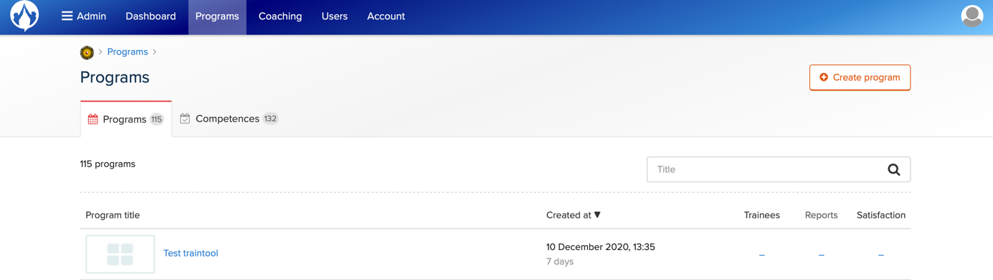

Once logged in as an admin, you can create a program. Click on ‘programs’ in the blue field above. In the right corner, you can click on the red/white square with ‘create program’ on it. Then, you can give the new program a title and select the right language.

3.1.1 Adjusting promo, introduction and conclusion

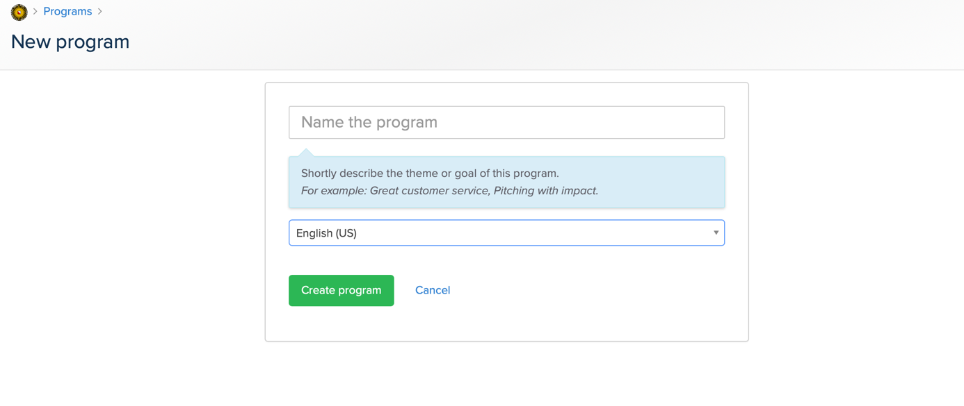

To adjust the texts in promo, introduction and conclusion, move your computer mouse to the text you would like to alter. For example, if you want to adjust the text in promo. Go to promo and write the text you have in mind.

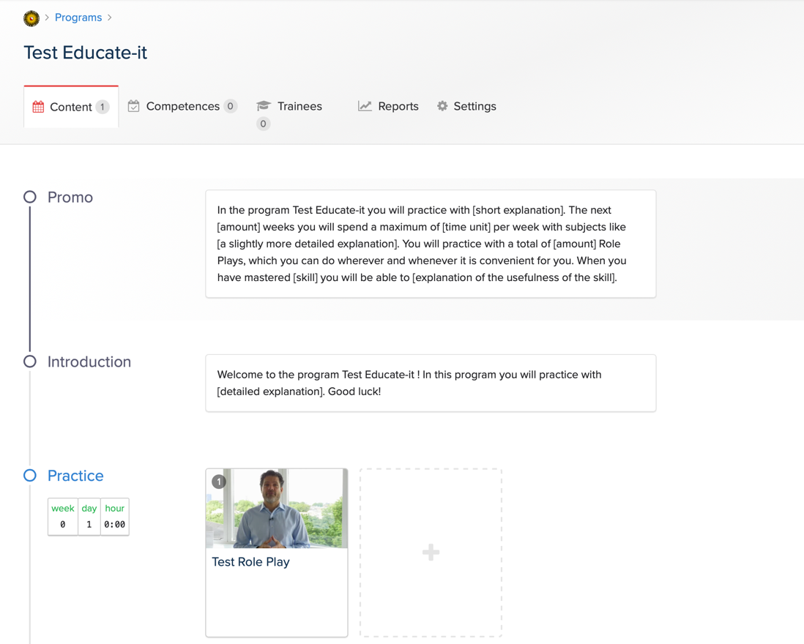
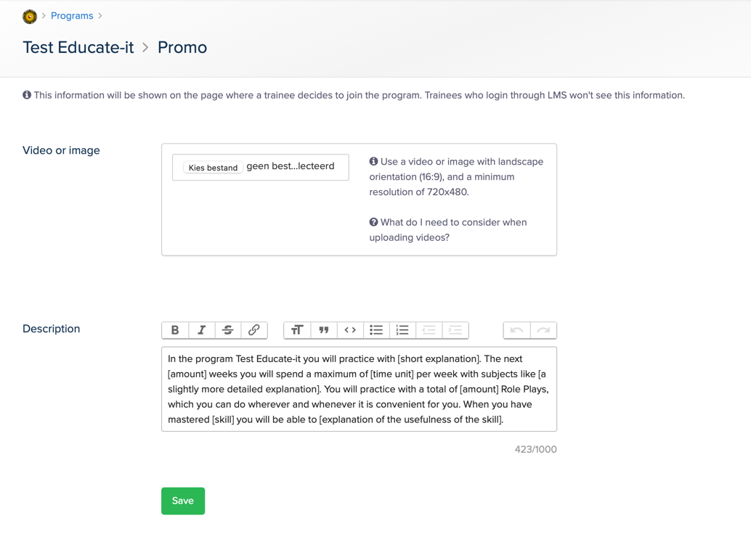

As you can see above, it is also possible to add videos and images.

3.1.2 Creating practices
When creating a program, Traintool will set up a general program that you can adjust to your own liking. By going to different sections (click on the plus signs next to the practice), you can add assessments or set a date and time. When adding an assessment, a new page will appear in which you can alter the description, upload an exercise and manage the criteria. By clicking on ‘practices’, you can manage general data like the title of the assessment, grading and deadline. If you like to know what the students will see when they’re using Traintool, you can click on ‘preview’ in the right corner.

ATTENTION: When setting dates for when an exercise will be available and when the deadlines will be you’ll have to set it in weeks after the startdate. After you added students you’ll set a start date for your students (you’ll see how in chapter 3.3). If you for example set the start date of the students is the first of January and an exercise will be available for them from week 1 day 2 until the deadline week 1 day 6, than the students will be able to start the exercise on the January the second and the deadline will be January the sixth. You will be able to see these dates if you set the ‘Set example start date’ to the students start date A green section will appear that shows the start date and deadline.

3.1.3: Different purposes
When creating a practice, you can select three different purposes:

1. Practice à “Trainees get theory and unlimited practice. They will not be scored. They can also share their recordings with friends and/or coach(es).”)
2. Test à Use a test to determine the skill level of a trainee. The score is determined based on appraisal questions. In a test, the number of attempts per Role Play is limited to two. Also, the trainee sees a clear indication that the Role Play is part of a test. Other than that there is no difference between doing a Role Play in a test or practice segment. Please note: Further Role Plays will not be available to the trainee until this test has been completed.”
3. Live à “Create a live segment to show trainees when they will participate in a live activity. For example a training day, workshop or a coach call.”

Selecting different purposes will give different setting options to choose from.

.

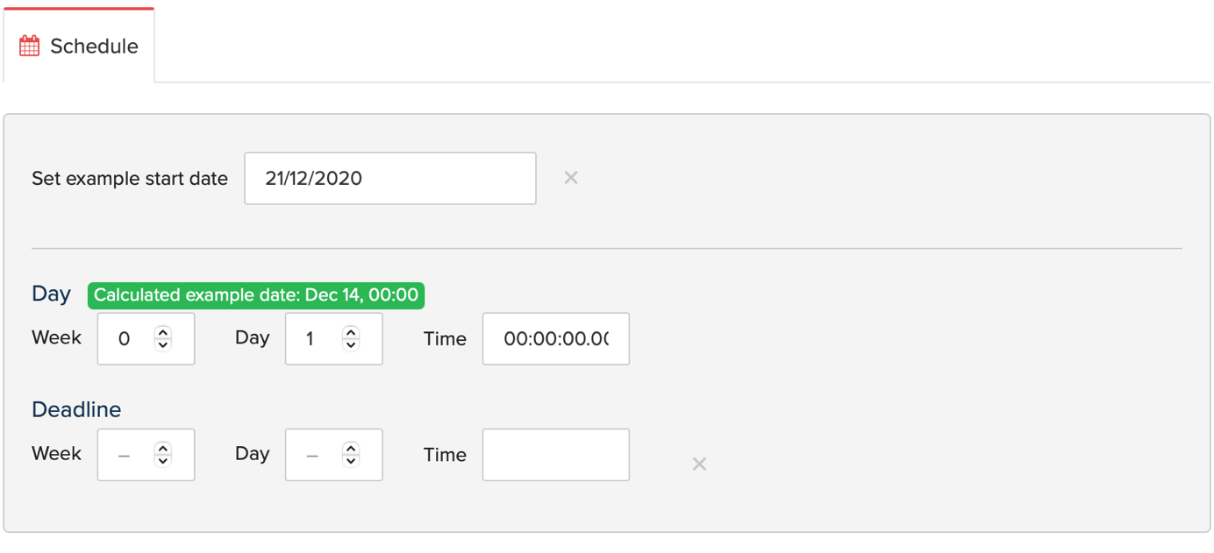

3.2 Adding trainees

Once you set up the assessments, you can add trainees. You can do this by clicking on ‘trainees’. Fill in the E-mail addresses of the students. You can copy and paste them in the right column. The addresses must by divided by a comma.

Another way to add trainees is to add them by a public link in ‘settings’. Once saved, a link will appear which you can copy and paste. Please note that this link works without a start date. You can copy the link and send it to the trainees. They have to sign up by clicking on the link.

When adding trainees, they will be automatically put in group 1. Therefore, you need to add them to the right group. You also have to select the right language; this is something that the program doesn’t do for you.

3.3 Sending invites by E-mail

Mind that students will not be able to start right after you’ve added them, and the will not receive an invitation mail right after. This will happen once you’ll start the trainees. Below the tab ‘trainees’, you can start the programs of the students by checking the boxes in front of their names. To select all students at once you can click on the box at the top and select ‘all’:
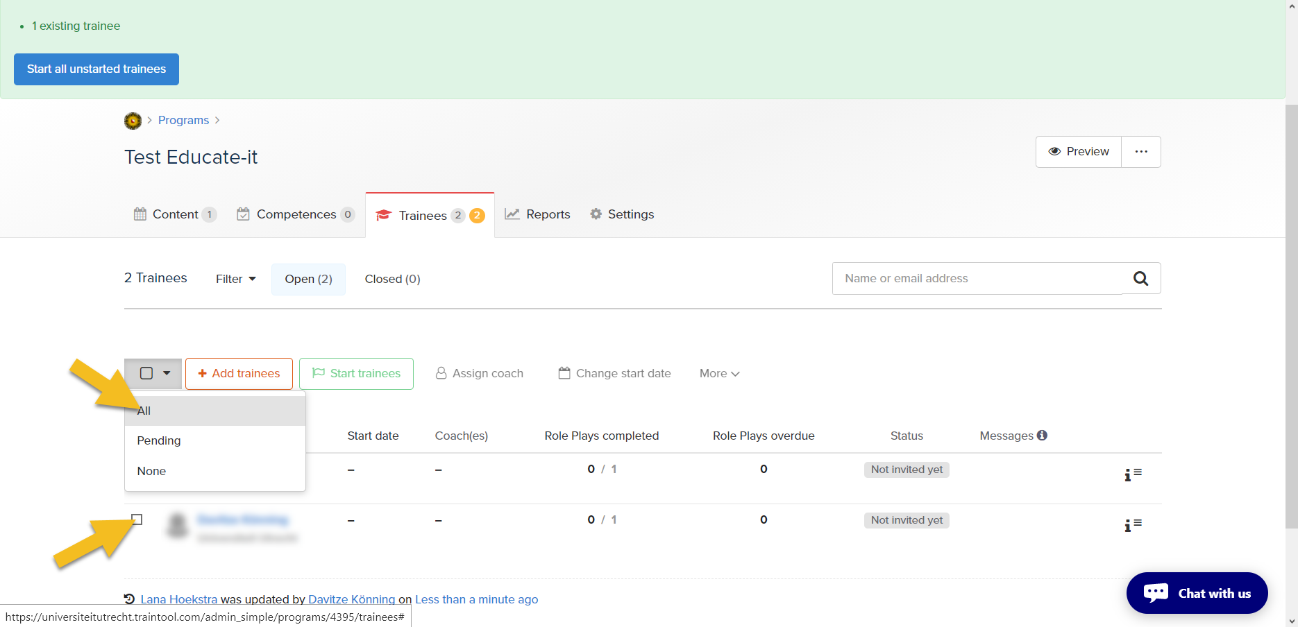

After doing this, you can click on the green box with ‘start trainees’ on it. A pop up will appear on which you can indicate the date. Then, a blue box will appear with ‘start trainees’. Then the students will receive an invitation as well.

3.4 Assigning coaches
Once you added the participants, they can be found under ‘trainees’. Now you can assign them a coach. To do that, you need to select the right participants (like you did when you started them). Then, you are able to click on ‘assign coach’. A pop up will appear in which you can write the name of the right coach. You have to click on the name and “assign coach”, which is the blue box below it.

4. Contact
Do you have questions or would you like support when using Traintool? Let us know! We also like to hear if you have any complaints, suggestions or questions about this manual.

Practical support
Teaching support
Address: University Library Science Park, second floor, red counter on the right.
Opening times: Monday till Friday 8.30u - 17.00u
Telephone: 030 253 2197
E-mail: teachingsupport@uu.nl
Website: https://educate-it-uu.sites.uu.nl

