FeedbackFruits – Assignment review
Docenthandleiding
educate-itbalie@uu.nl

Inhoud

Inhoud 2
1. Inleiding FeedbackFruits – Assignment review 3
2. Tool aanvragen 4
3. Via Blackboard of My University 4
4. Aan de slag 6
Startscherm 6
Het creëren van een opdracht 6
Instructions 6
hand-in 7
Give feedback on student work 7
Read and reflect on received feedback 8
Grading 9
Een overzicht van de opdracht 10
Instructions 10
Hand In 11
Give Feedback 12
Read and reflect on received feedback 13
5. Contact 14

Introduction FeedbackFruits – Assignment review
FeedbackFruits 1.0 is a complete online learning environment where interaction is being stimulated through discussion, (peer)feedback and knowledge exchange. In FeedbackFruits 2.0, these functionalities has been further developed as seperate Blackboard Plugins. This way, you can apply a specific working method to your education. In this manual focusses on one of these plugins: Assignment Review.
This plugin provides the teacher with the possibility of giving in-line feedback on submitted, written work. The criteria and the feedbackformat can be adjusted to your own liking. Assignment Review is an approachable tool that can be used on the webbased platform as well as in Blackboard. This plugin can be activated by Educate-it.
This manual offers an introduction for the use of Assignment Review and can be used as a reference work for further use of the tool. Educate-it happily provides didactical and practical support when using Assignment Review. You can contact us via teachingsupport@uu.nl

Requesting the tool
If you like to use this tool, you can fill in the application form: https://educate-it.uu.nl/en/contact-information-form-for-tools/. We will contact you as soon as possible to talk you through all the necessary information.

Blackboard or My University
Once we received your application, FeedbackFruits will be activated for your course. The tool and the corresponding plugins can be deployed in Blackboard or in My University. You can choose which one you prefer. Below you can find instructions for the use of the tool in both environments.
Blackboard
Go to the page of the course where you would like to implement FbF. Click on the ‘content’ tab and then on ‘Tools’. Next, choose the tool that you would like to use. In this case, you click on the ‘Assignments’-tool. Students can go to the assignment via Blackboard.
My University
Go to https://feedbackfruits.com/ . Click on the tab ‘log in’, then on Utrecht University (see Image 1). Then, you can log in with your solis-id and password.
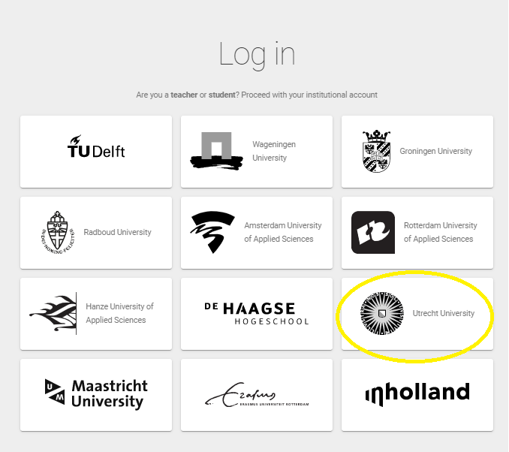
Image 1. Choose the right university.

You will be re-directed to your own personal page. Click on the blue ‘+ sign’ to create a new assignment (see image 2). Choose Assignment Review.

Image 2. Creating a new assignment

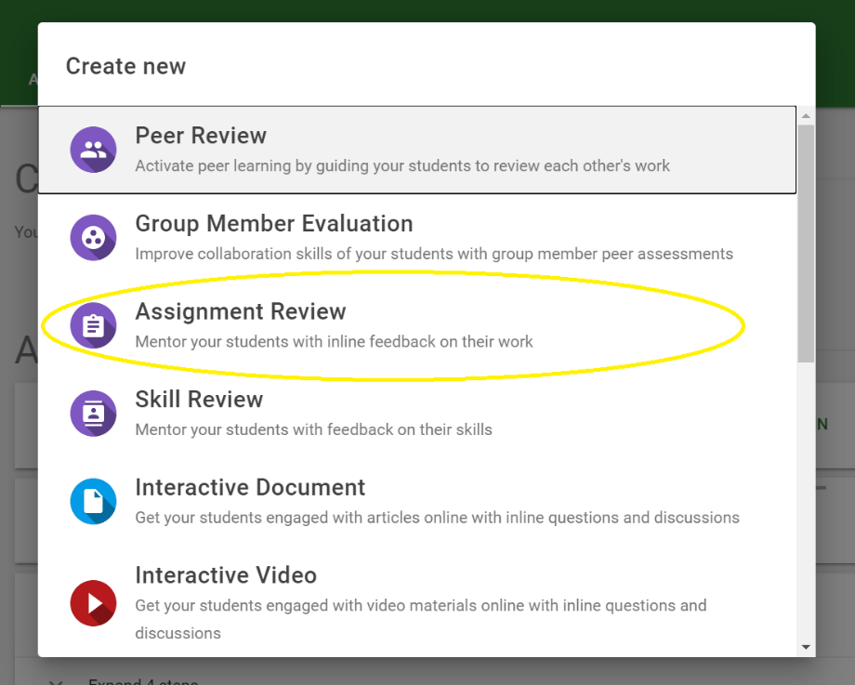
Figuur 3. Choose the right plugin
After creating the assignment, students can be invited via their student mail or with a link. The link kan be send by E-mail or be put on Blackboard.

Get to work

Startscherm
After choosing Assignment Review as shown above, you get redirected to the home screen. Here, you give your assignment a name. You can create a new assignment or copying an already existing assignment made by yourself or one of your colleagues. A copy will be made of the existing assignment, including notes, questions and instructions of the teacher. The contributions of the students will not be copied.
In the home screen, you can prepare the assignment in four parts: instructions, hand-in, give feedback on student work and read and reflect on received feedback. Below you can find the steps.

Creating an assignment

Instructions
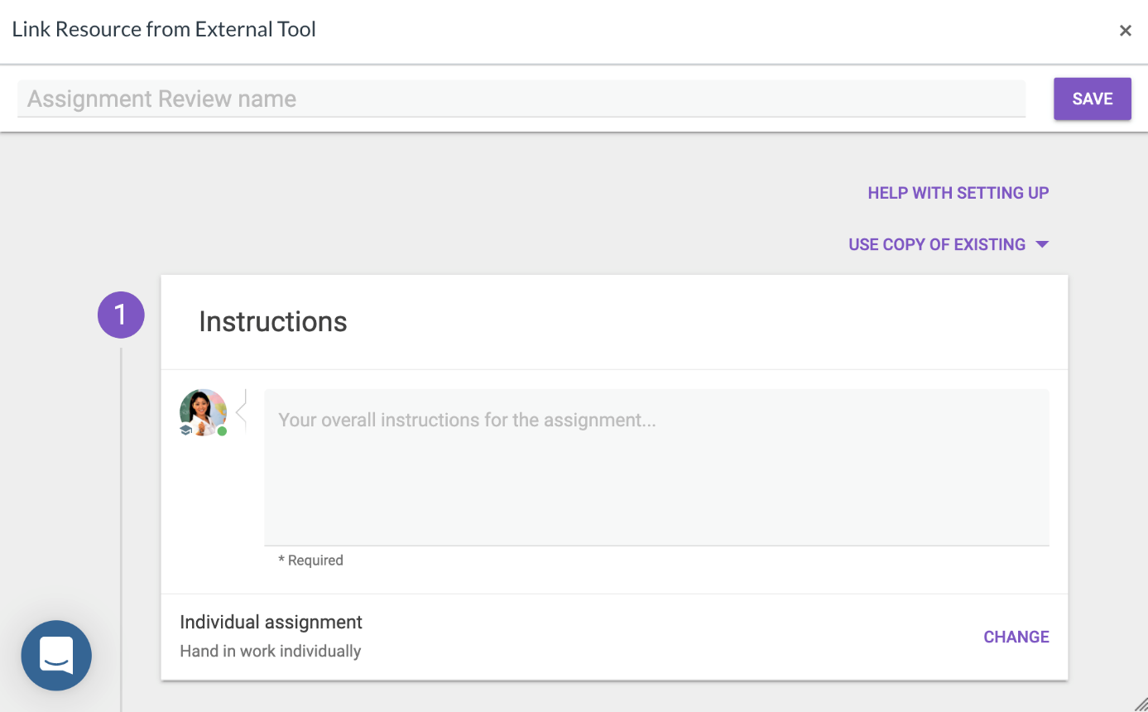
Fill in the instructions for the assignment. Select if students have to hand in their work individually or in groups.

hand-in
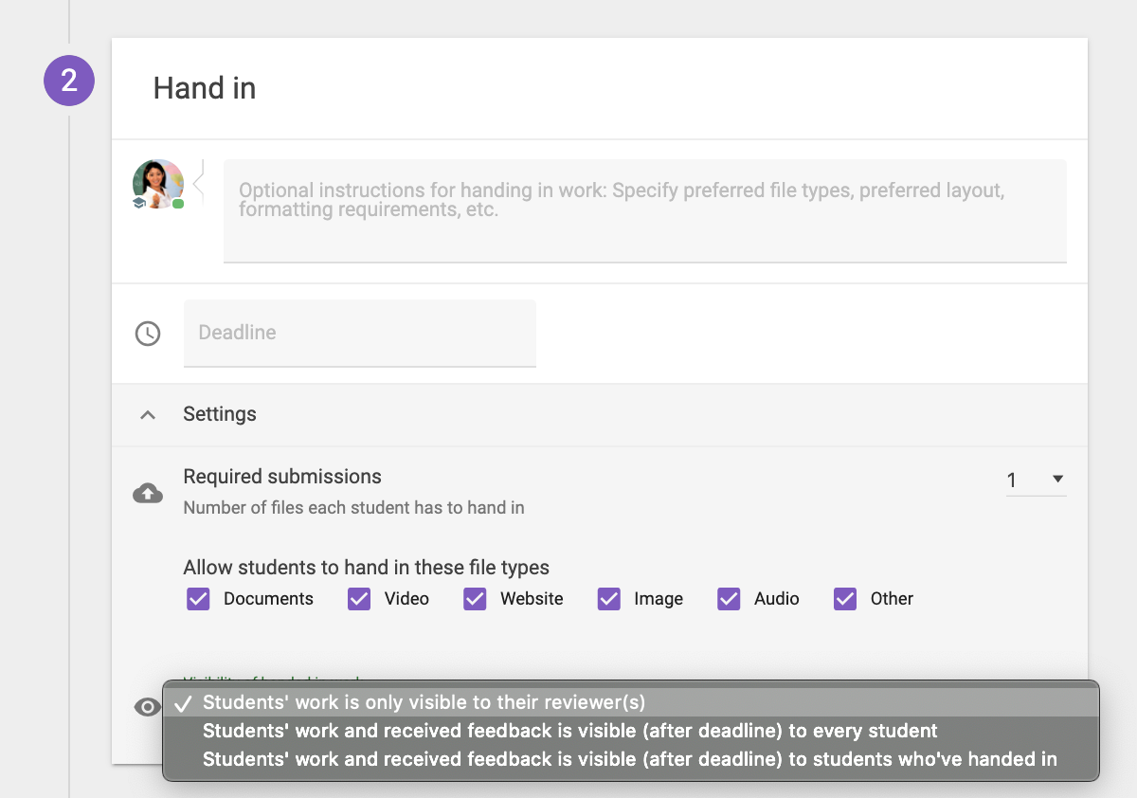
Add here extra instructions when necessarry. For exampe, font, line spacing, or the name of the file. Here, you can also set a deadline. Students have to hand in their work before the deadline. You can start checking right away when you don’t set a deadline.
Indicate how many attachments the students have to hand in. Students can always hand in more attachments. Make clear in which formats are allowed (.jpg, .pdf, etcetera
There are three options regarding the visibility of the submitted assignments
- Only the teacher
- All students
- Only the student that has to peer review

Give feedback on student work
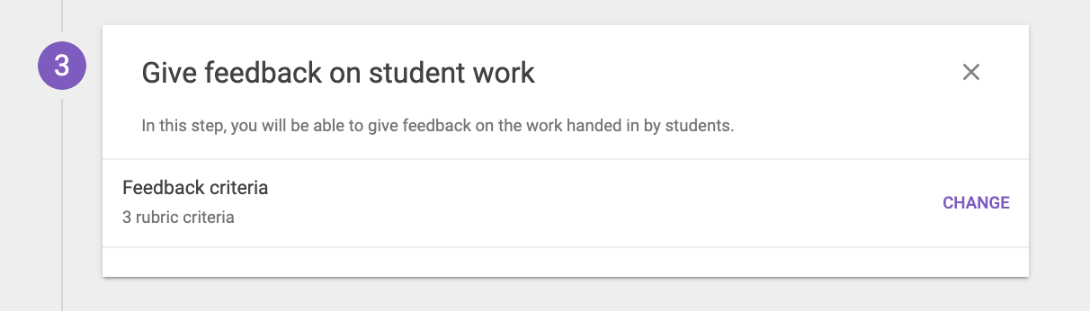
Here, you can fill in the criteria on which the feedback will be based on. This will provide the students with insight for specific improvement points in their work. You can make use of rubics. You can add, change or remove criteria by clicking on ‘change’ as can be seen above.
A general explanation about the use of rubics and scales as criteria can be found on this page: https://help.feedbackfruits.com/en/articles/3954677-using-rubrics-and-scale-rating-criteria-in-feedback-assignments

Read and reflect on received feedback
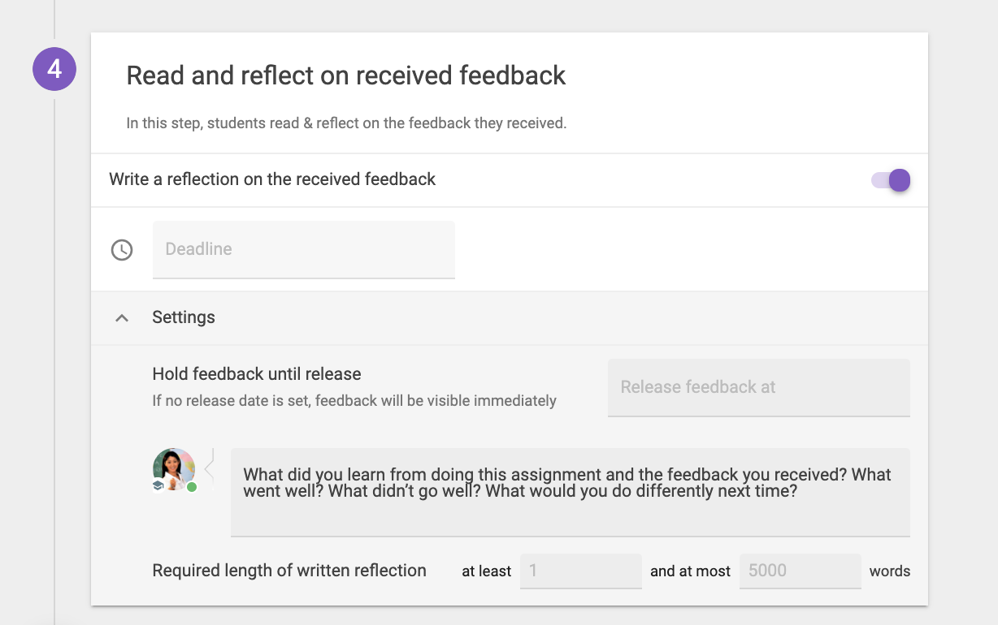
If you like to let you students reflect on the feedback by writing a reflection on, you can turn on this function. This way, students are able to express what they did with the feedback, how they interpret it en if they agree or disagree with the given feedback.
For this last step, there needs to be set a new deadline. Students won’t be able to hand in their reflection after the deadline. They will still be able to see their feedback and reflection after the deadline. Students can hand in their reflection at all time when no deadline is being set.
You can add instructions for writing a reflection under settings. It is also possible to set a minimum and maximum wordcount. Here, you can find a few general instructions which you can remove or change.

Grading

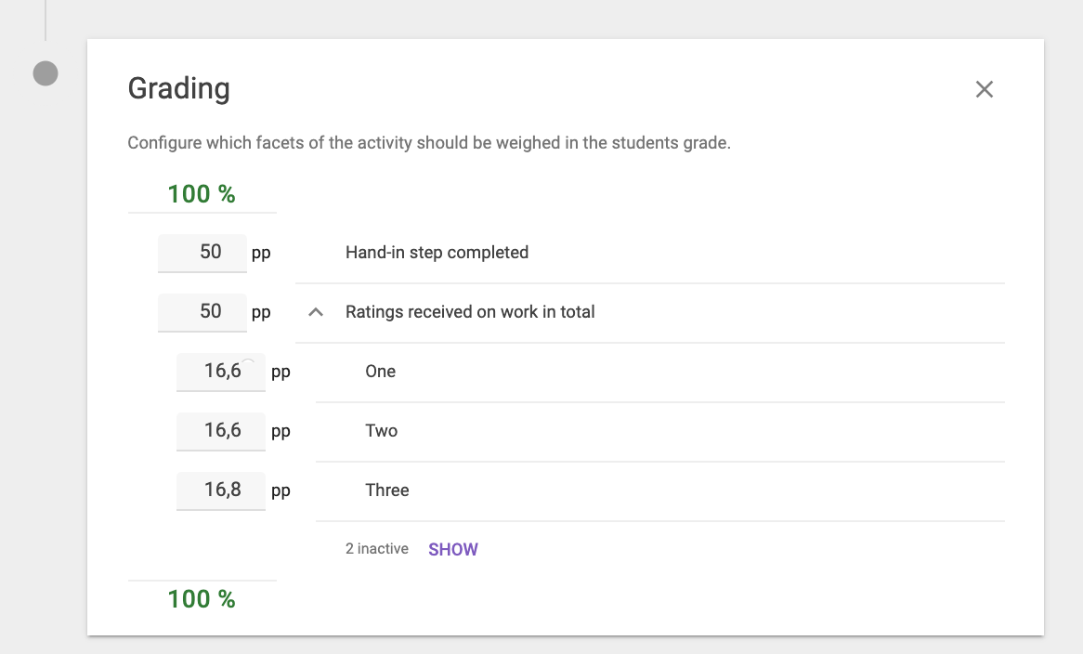
Finally, you can add an assessment to the assignment by clicking on the purple ‘plus’ sign in the left. You can split the assessment in multiple parts with different weightings. After that, click on publish in the top right corner of the screen.
You can always change the assignment by going to the tree dots in the right corner and clicking on edit.

Overview of the assignment
In the dashboard of the assignment you can keep track of the progress of your students, download submitted work en provide feedback.
In the top right corner, you can find the focus button to see the assigment entirely and to provide it with feedback. First, you’ll see general progress of the students within the assignment. By clicking on statistics per active student, you can zoom in on the progress of one student. Here, you can see
- If the student has read the instructions.
- Has handed in their work.
- If you as a teacher has given feedback.
- The amount of time that has been spended on this.
- Total amount of feedback points.
- If the student has read your feedback.

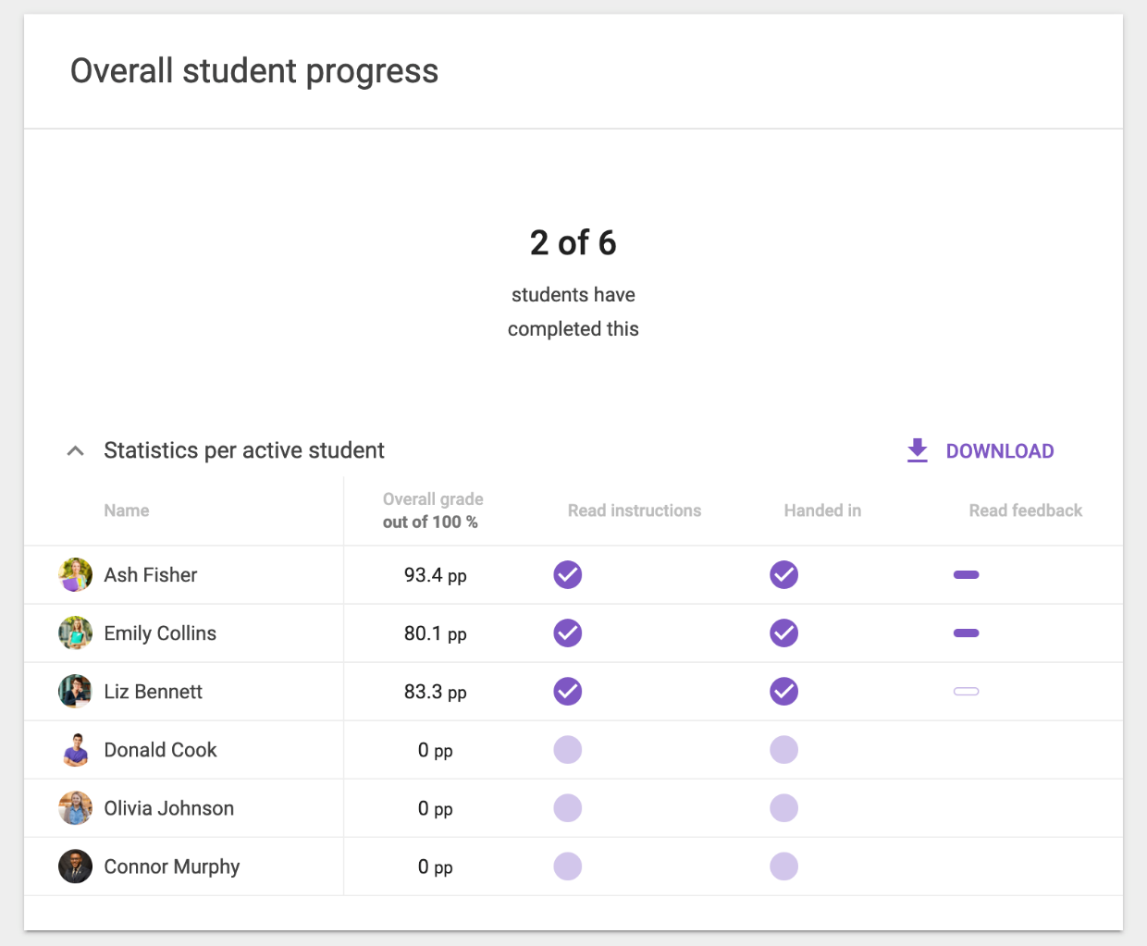

Instructions
Here, you can find the instructions back as you have set up at the beginning. You can change instructions by going to the three dots in de top right corner of the screen.

Hand In

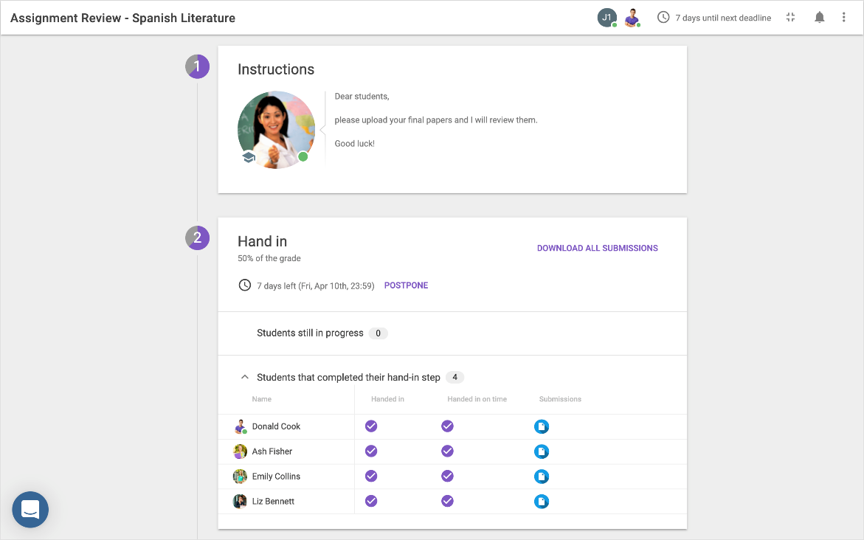
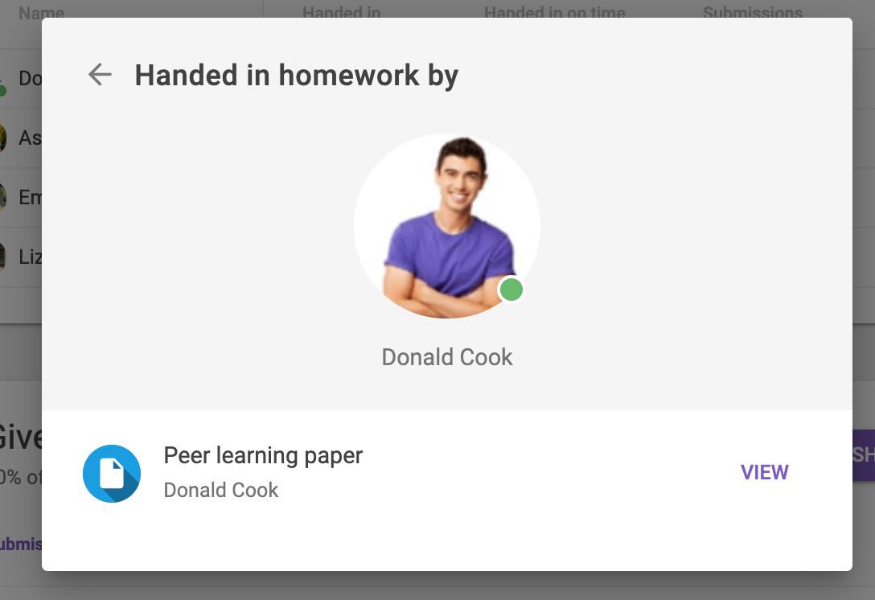
This part will give an overview of the studenst who have submittet their work. You can also trace back which student have handed in after the deadline or which are still working on their assignments. If a deadline has not passed yet, you can click on postpone. When the deadline is expired, but you want to let your students hand in their work either way, you can change the assignment in part 1, creating an assignment). Here, you can change the deadline or check the possibility to submit work after the deadline.
You can view the work of students online. Click on the blue, document icon (or video icon if the student handed in a video) from the student’s work that you would like to see. Click on view to make the work of the student visible.

Give Feedback
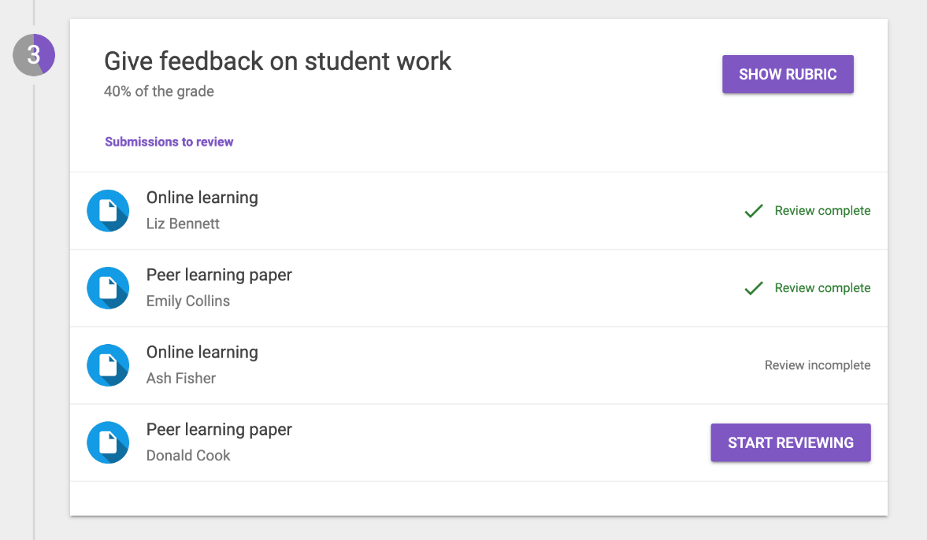
Click on the submitted work of the student that you would like to give feedback to. The assignment with the given criteria will then be showed. You can give feedback according to these criteria. It is also possible to select specific parts and add comments (see image below). You can do this by selecting the criteria where your comment is based on in the right corner and writing your comment.
If you have feedback for the whole tekst, you can click on the purple pen. Select the corresponding criteria.
Students can react on the given feedback. A more elaborate explanation about giving feedback on feedback can be found on this page: https://help.feedbackfruits.com/en/articles/2268372-providing-feedback-as-a-teacher-commenting-and-up-voting-on-feedback
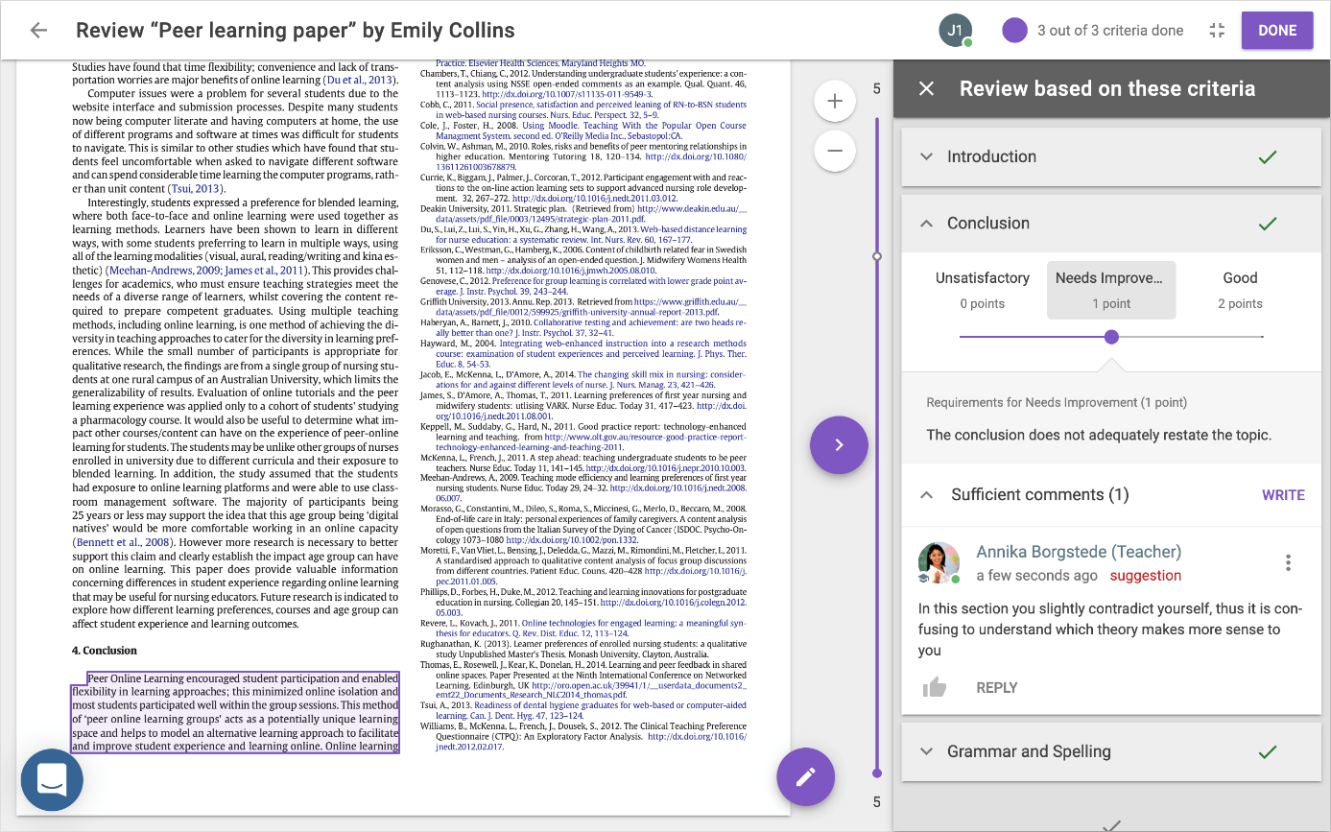

Read and reflect on received feedback
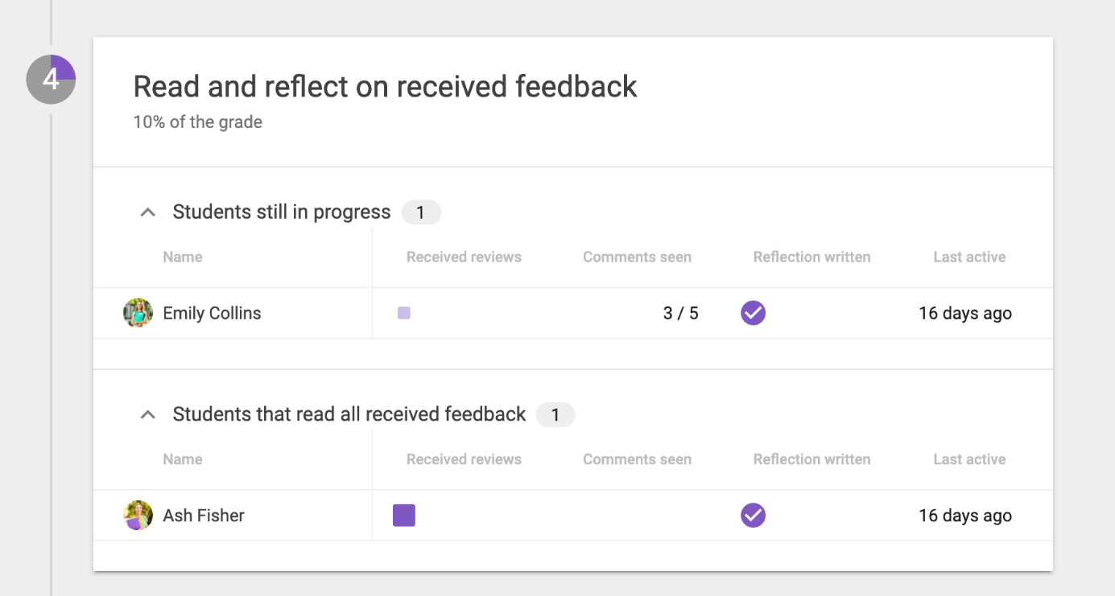
This screen gives more insight in which students have been reading the feedback and which students still have to read theirs. Click on the headers to change the order of students.

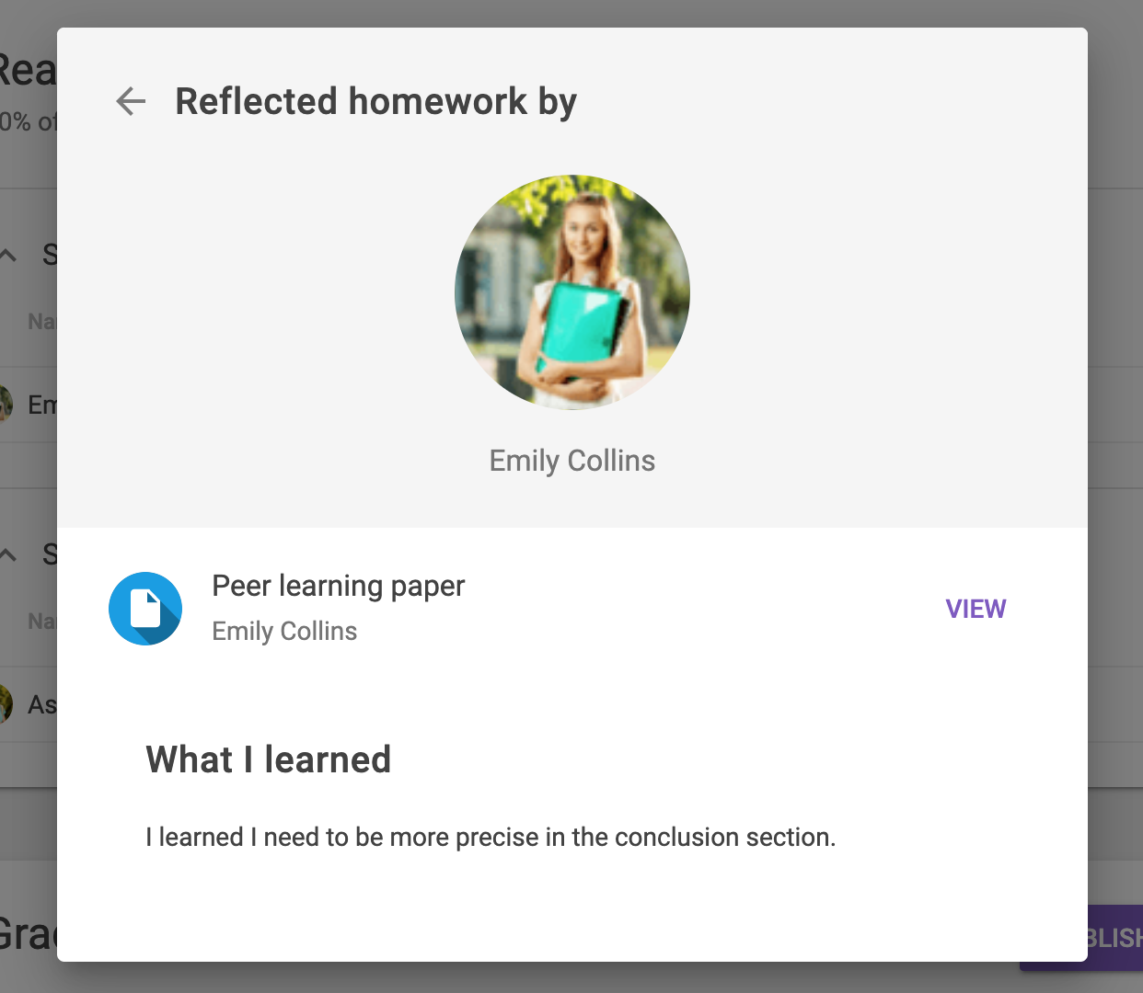
Click on the squares below received reviews to open the screen above. By clicking on view you go back to the work of the students (including given feedback). In this screen you can read the written reflection of your students.

Contact
Do you have questions or would you like support when using FeedbackFruits 2.0 Assignment Review? Let us know! We also like to hear if you have any complaints, suggestions or questions about this manual.
If you’re looking for didactical support, you can also contact us:

Teaching support
Address: University Library Science Park, second floor, red counter on the right.
Opening times: Monday till Friday 8.30u - 17.00u
Telephone: 030 253 2197
E-mail: teachingsupport@uu.nl
Website: https://educate-it-uu.sites.uu.nl

