Dialogue Trainer
Teacher's Guide
teachingsupport@uu.nl

Teacher's manual Dialogue trainer

Table of contents

Table of contents 2
1. Introduction 3
2. Log in 4
3. Building a scenario 5
4. Structuring the subject 14
5. Course of a scenario 15
6. Leave a scenario 18
7. View scores 21
8. Add students/members to a group 23
9. Add scenario to a group 26
10. Add administrators to a group 27
11. Participation codes 28

Introduction

In DialogueTrainer, teachers can easily create a simulation, in which students practice conversational skills with a virtual character. An example is a bad news interview or a pharmaceutical consultation. The character responds with both text and emotion to the choices a student makes and these choices lead to a score. DialogueTrainer can be used in preparation for face-to-face practice of conversational skills, so that students can practice with different types of conversations.

Log in
To log in, go to the Dialogue Trainer website (https://nl.dialoguetrainer.app/login). You will see the image below. Then, if you click 'Log in via Solis-ID', you can log in with your UU account.

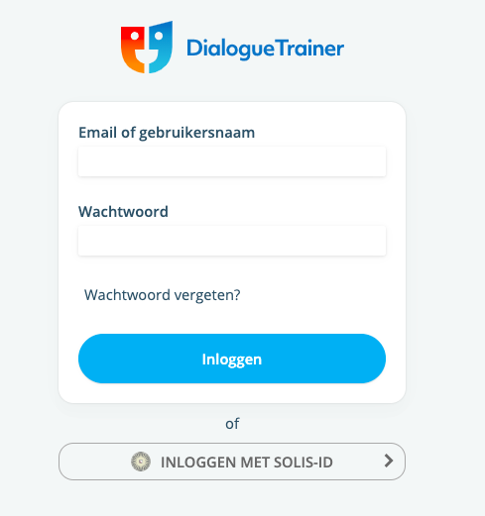

After you have logged in with your SolisID, you will end up on the homepage of Dialogue Trainer.

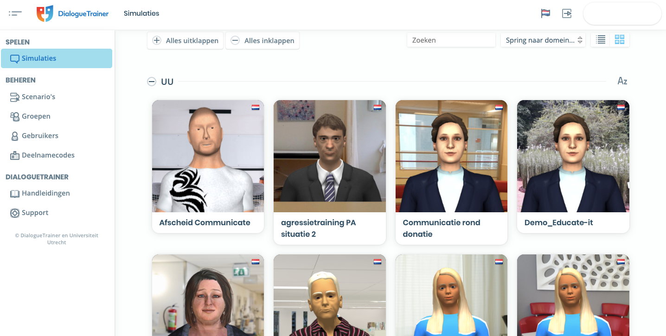

Building a scenario

Before you start building a scenario, we assume that you have a case study. Think of conducting a performance interview. It is important to know what kind of conversation it is, who is the opponent, what is the assignment etc.

TIP: Think of a scenario/situation and associated conversation structure in advance

step 1: create a conversation scenario.

To build a scenario, in the menu on the left, click Scenarios
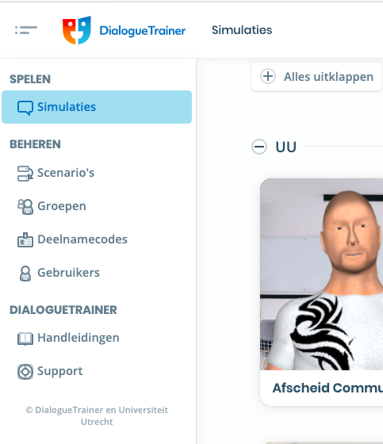

Then click Create Scenario

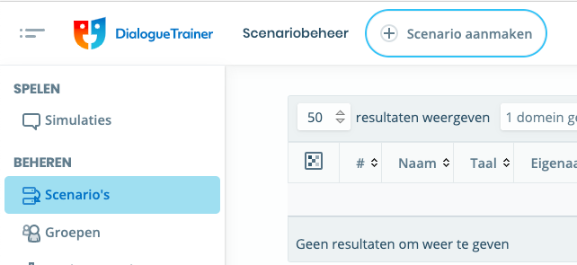

You can choose which name your scenario will get. Click Create to create the scenario.
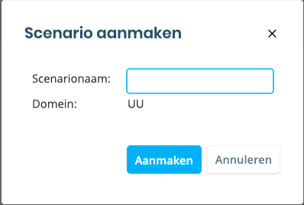

Step 2: Properties
First, it is important to provide the scenario with the right properties. The characteristics of a scenario determine the language, difficulty, introduction and functionalities that the student has at his disposal while playing the scenario.
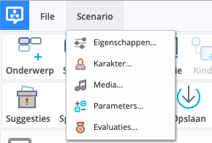

Introduction
The introduction outlines the situation and task of the player in the scenario (the case). This text will be shown to the player before the conversation starts. In fact, this is the introductory text that introduces the scenario.
TIP: The introduction comes first after loading scenario. If you first want to show media for the student's instruction, put the content of the introduction as text in a situation node (more explanation about this later).
Location
The location determines where the conversation takes place. This can be a background with or without foreground (for example, a table or counter). A video background can also be set up for more vibrancy. A gallery of available locations can be viewed (see image below)
TIP: The location may change during the call. Use the situation node (more information about this later)
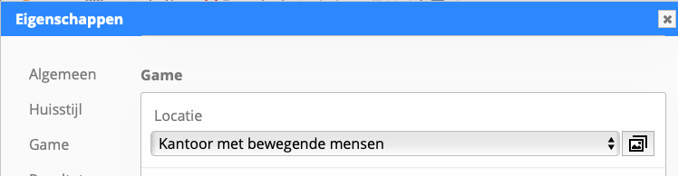
Step 3: Character
Setting a character is as follows:
Click scenario and then character.
In the character screen, choose a character from the Model list.
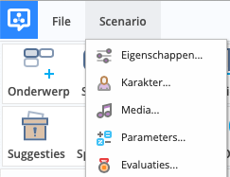
You can choose from several available models here. In this screen you can also set the Start motion. You can adjust the character in different styles of clothing, skin or hair.
TIP: The characters have different emotions. For the first scenario, we recommend leaving the settings under Emotions in the default settings.

Step 4: Topics
Topics are used to structure a scenario. Through topics that are each part of the entire conversation, you keep an overview of the steps/phases, or 'procedure' of a conversation.

Use this button to create a topic. You can post this topic with a click on the topic overview. If you're working within the topic, the topic summary isn't visible.
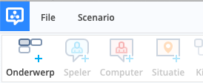

To name the subject, double-click the name, an input field will appear, you confirm with Enter.

Conversation order: Placement of topics
The position of the topics within the overview affects the course of the conversation. The further up a topic is placed, the sooner it will be discussed. The first topic, for example the opening, is therefore at the top left.
From there there are two possibilities:

Topics among themselves
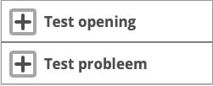

In this arrangement, topics are dealt with one after the other. The player starts with choices in the first topic. When that is completed, the student will see the second topic.
Topics side by side

In this arrangement, the topics are dealt with side by side. The player will see the start buttons of all topics as answer options. This allows the student to broach and complete topics.
TIP: For subject blocks, you can also check the Optional Topic option (on the right). In that case, the player does not need to start the topic before the answer options of the following topics appear; the subject can therefore be skipped.

Step 5: Create the conversation scenario
A conversation scenario consists of topics with nodes that explain situations together, contain the text of the virtual character and give the student choices.
Within a topic, you can add nodes of different types with the buttons from the toolbar:
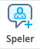
A Player Button contains text of the answer option that the student can choose.

A player knot can also be used as an opportunity to provide open answers. The student can enter a text himself, which is then also shown in history while playing and in the end screen. To do this, check the Sidebar Is an open response.

To prevent students who play a scenario multiple times from clicking on autopilot through the same answer options, it may be desirable to offer the different player buttons in random order while playing. You can set this by checking the Random Order of Player Choices option in the properties below game.

A Computer Node contains the text that the virtual opponent says to the player.

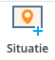
In a Situation Node you place descriptive text about the situation. This will be shown to the player as additional information in the scenario at the time the node is placed. The design is the same as the introduction.

Situation buttons can also show answer options at the same time. In this case, the player can answer based on given information or a question in a situation text: as with a multiple choice question. Select a situation node and check the keep overlay option in the sidebar for the following statements. The situation node in question should then be followed by player buttons.

Adding audio
Audio can also be added to nodes. For example, it is possible to have the text of the character or a situation node spoken out while playing a scenario. There are two ways to do this. Firstly, you can upload audio to the editor via media screen. For the other option, see chapter 7 of this manual.
Step 6: Adding emotions
In order for the opponent to react non-verbally to choices, an emotion can be linked to each node.
For computer buttons, set emotions as follows:
Click the computer node, and then click character. Then you can click on an emotion for effects.

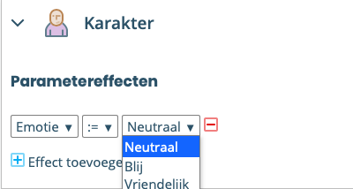
For player buttons, set emotions as follows:
Click the player node, and then click parameter effects. Then you get the choice of several emotions.
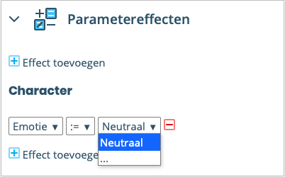

TIP: During construction, we recommend linking emotions to one type of node. Emotions on multiple types of nodes can lead to differences in timing of the emotions played.

Step 7: Add feedback
In addition to feedback in the form of responses from opponents, textual feedback can be added to each choice in the form of explanations. In this explanation, for example, you explain the relationship with the theory. These can be assigned to both computer and player buttons. However, it is more common to add feedback to player buttons, as these are answer options that the student chooses during the scenario. Depending on the answer, you as an author can provide targeted feedback on the choice made by the student. Furthermore, intention and nature of feedback (positive/negative) can be adressed.
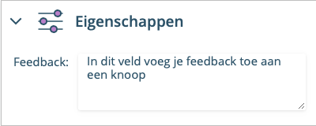

After completing a scenario, the user will see the feedback between the dialog played in the review screen, under the heading 'history and feedback'.
Live Feedback
The feedback entered at the button can also be displayed while playing. The player will receive immediate feedback on the chosen answers. This will then appear in the upper left corner of the screen. This option can be turned on in the properties screen under the Category Game.
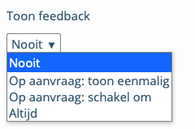

- Show once gives the student the opportunity to request this separately with each node where feedback is available
- Switch to gives the player the ability to turn the display of feedback on or off himself.
- Always the player does not give a choice; the feedback is always shown.
TIP: There is also the option to have the study confirm the feedback before you can continue playing. This option can be found under advanced in the same screen.

Thoughts
In addition to spoken text of the character, a thought of the character can be shown at the same time as this text. Thoughts, like emotions, can give indirect feedback. Thoughts can only be assigned to computer buttons.
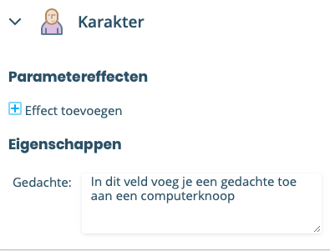

As with feedback, there are several possibilities for showing the thoughts while playing. You can set it in the property screen under the character category.
Hints
Students can also use hints. You use this as an author to help the player on the right path at a certain point in the conversation. You can point to correct next steps, or hint at relevant pieces in the theory. Hints can only be assigned to computer buttons.
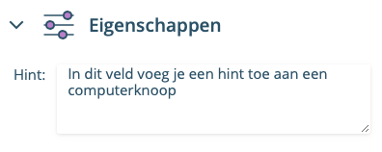
Enabling a hint while playing can be turned on in the properties screen under the same category, just like feedback and thoughts.
Step 8: Other Functionalities
Properties while playing
There are several important functionalities that can be checked and have an influence while playing a scenario. Below are a number of options highlighted in the propertiesscreen.

- Automatic Fullscreen – the call scenario automatically goes on fullscreen when starting and will return to its original size after completion.
- Going back to previous choice in the scenario – allows the player to return to the previous answer options to make a new choice.
- Speech recognition – allows the player to express answer options so that they are selected in this way.

Media
Earlier in this manual, it was explained how speech can be recorded and linked to nodes. Other types of media can also be assigned to nodes. To manage different media in the scenario, they can be uploaded, downloaded, and deleted via the
media screen.

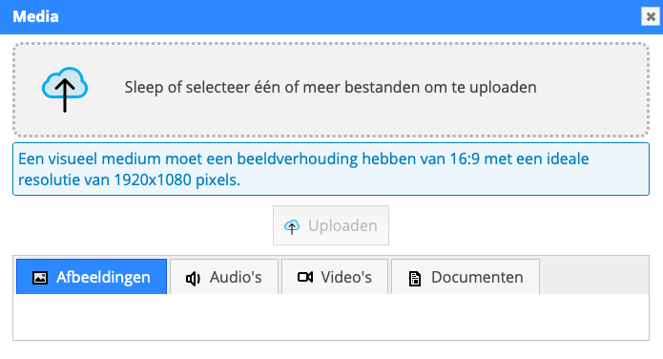

After successfully uploading media, they can be used with their file name in the different nodes (via the sidebar).

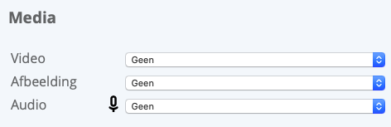

Step 9: End scenarioTo end the scenario after a
player, computer, or situation node, check the end scenario within a selected node. This functionality can be applied to any node in any subject. It is therefore also possible to make a scenario end earlier when a player makes a certain choice.
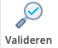
You can check if there are any errors in it by clicking the validate button. You will then receive any error messages that you can recover. Some error messages you can click on, then you will see the place of the error.

Make sure your scenario is saved frequently, only in this way you ensure that your edits are not lost.

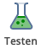
With the test button you can test your scenario. If you make changes during editing, this button allows you to update the still open test scenario with new changes so that they are immediately visible.

The publish button makes the scenario available to other users within the domain where the scenario is located. If a scenario has already been published, it must be republished to make saved changes visible to users.

Step 10: Continuously optimizing scenarios
Suggestions
It is possible to leave suggestions while playing the scenario. These may include comments on existing replies, a suggestion for an answeror a comment onthe text. Based on these suggestions from the students, it is possible to then align your scenario more with the target group and therefore optimize it.

Under the game category, check the player suggestion option.
Player suggestions can then be considered by authors in the optimization of a scenario. Buttons with suggestions get icon. Under suggestions in the sidebar, you will then see all unhandled (i.e. unarchived) suggestions on this node. With the help of the button, you can also view archived suggestions.
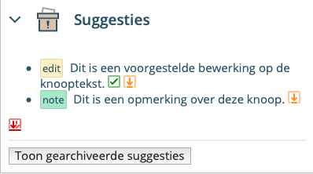
Accepts the suggestion and replaces the button text with the content of the suggestion.

Archives the suggestion, the change is not included in the scenario. As an author, you indicate that the suggestion has been dealt with.

Structuring the subject

The scenario always starts with the first subject block when playing. It can start with either a computer node or one or more player buttons.

By connecting the computer buttons and player buttons, various conversation routes can be created. It is desirable to end each route within a subject block with a computer node or situation node.
Conversation order: Placement of topics
The position of the topics within the overview affects the course of the conversation. The further up a topic is placed, the sooner it will be discussed. The first topic, often an introduction or welcome, is therefore at the top left.
There are two possibilities:
1. Topics among themselves
In this arrangement, topics are dealt with one after the other.

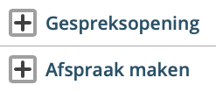
The player starts with choices in the first topic. When that is completed, the player will only see options from the second topic.
If a player gets to the end of the previous topic, the first nodes of the next topic in the same row become available together.
If the player has reached the end of a subject block, the scenario automatically moves on to the next subject block. It usually starts with one or more player buttons.
Two. Topics side by side
In this setup, topics are discussed side by side.

The player is shown the start buttons of all subjects on the same horizontal layer as answer options. This allows the player to broach and round topics.

When a player arrives at the end of the previous topic, the first nodes of the following topics become available in the same row.
Optional topics

Topics can also be made optional. When a topic is optional, this topic can also be skipped in its entirety. In this case, the scenario continues with the other topics without returning to the topic that has been skipped. If a topic is not optional, the player must always go through this topic to reach the end of the scenario.
With a subject selected, the optional topic option is available in the sidebar.

Course of a scenario

Just like in a real conversation, it is possible to switch between topics of conversation and come back to something later. In the scenario, this means that one can switch between different, side-by-side, placed topics.
Practically speaking, this means that after a computer node with the option allow subject change , in addition to player buttons from that subject block, player buttons from other subject blocks are also offered. If you have not entered the adjacent block before, the first player buttons from this adjacent block will also be offered in addition to the player buttons from the same block. If you then check the allow subject change option again within the adjacent block, – in addition to the player buttons from that same block – the player buttons from the first block will be offered following the computer node to which you have previously applied subject change.

Buttons with the option allow subject change can be recognized by the purple border and icon:
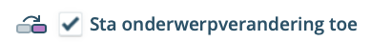
Ending a subject It is also possible to give the player the possibility to complete a subject
completely. As with the allow subject change option, the allow end topic option allows nodes from the current topic and topics that are listed next to and/or in the row below.

Buttons with the allow end subject option can be recognized by the blue border and icon:

End scenario
To end the scenario after a player or computer node, check End scenario. This functionality can be applied to any node in any subject. It is therefore also possible to have a scenario end when a player makes a certain choice.
Nodes with that end scenario can be recognized by the icon:

Parameters and scores

When building a scenario, it is often the case that as a teacher you want control over the paths chosen by the player. Especially if these paths are nonlinear. As a teacher, you have access to optional topics, topics where topics are changed, early termination of topics and more ways to influence the course of the conversation. As a teacher (editor) you have the option to keep track of which parameters the player has scored per player knot.
Parameter
A parameter is a variable with a chosen name that can be used within the scenario for:

Saving the chosen paths.

Whether or not to show the answer options conditionally.

As a score in the end screen.

Parameters are used primarily to assign scores. Through the score, the student's attention is drawn to this aspect of the conversation and at the end of the scenario the player knows how he/she did it and where there is still room for improvement.
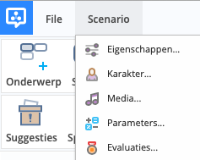

Adding parameters
A distinction can be made between four types of parameters. These are added via the sidebar:

1. String -A parameter that assumes a piece of text as a value

2. Integer - A parameter that assumes whole numbers as a value.

3. Boolean - A parameter that may or may not be true

4. Enumeration - A pre-set enumeration. The option can be assigned via a node.

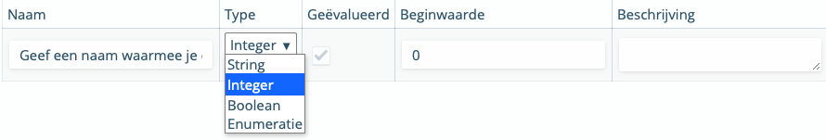

The most used type of parameters is Integer and Boolean.

Integers are used for scoring and tracking whether a player does a certain type of action more often

Booleans can be used for simple true or untrue conditions. This way you keep track of whether a player has made at least a certain important choice.

You can use these parameters in the scenario to show conditionally following player options or not.

When a parameter is evaluated, it is displayed as a score on the end screen. The value of the parameter is therefore included in the calculation of the total score.

The initial value describes the state of the parameter at the start of the scenario.

The description can be requested by a player by hovering over the

next to the parameter score. When no description has been added,

this option is not offered.

TIP: Parameters aim to draw players' attention to an aspect of the situation, to challenge players to score better and better at measuring. When setting parameters, make sure that you formulate them in such a way that they meet the needs of players; they must provide them with insight.

Evaluations

When a player has completed a scenario, they receive an evaluation of the results achieved during the interview process in the final screen. This section covers adding evaluations.

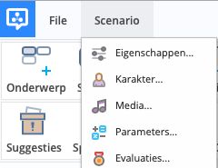

In the evaluation screen, the parameters are listed in order —from top to bottom— as they are also shown in the end screen. The order of the parameters can be adjusted by dragging the ↕ icon for the row in question to the desired order.

Leave a scenario
Add audio
Select the Computer Node you want to leave a message by selecting it with a single click. In the sidebar, various information about the selected BUTTON
IMPORTANT
Will not appear in the meantime and after you leave all the buttons to save the scenario and the audio! Below you can see the content of a scenario with one selected computer node
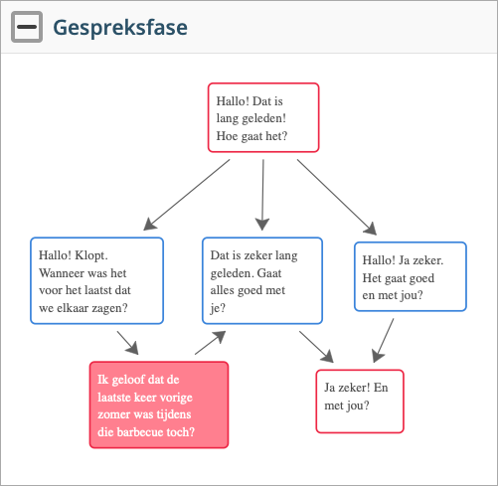

Under the Media category, open the 'record' window
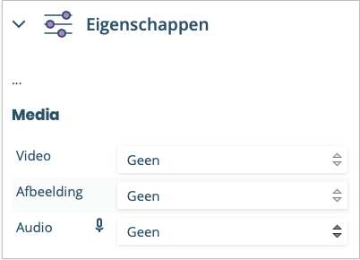

It contains several elements:
- The file name of the sound clip
- The emotional state of the character at that point in the conversation.
- The text to be spoken.
Below is an example of the record window:
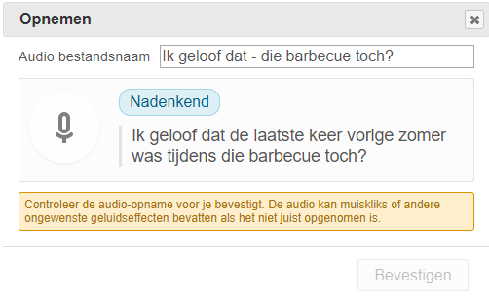

Recording the audio
You can start recording with the microphone button
The icon changes as a confirmation that you are going to record

During recording, you can check the volume by looking at the dark circle that fills the button, depending on the volume of the recording. When you are NOT sitting a moving dark circle, it is not observed by the window.

You can stop recording with the same button. The icon changes as a confirmation that you will stop recording.

Are you satisfied with the recording? Then click Confirm. The audio is then permanently linked to the (computer) node. Only the selected recording is saved.

Aren't you happy with the recording? Then you can open a new recording by clicking on the microphone head again. The last recorded snippet is selected. If you do decide to opt for an earlier recording, you can do so by clicking in the sphere for the recording in question. After this, you can choose Confirm to link the audio to the computer node.

Tips on recording!
- After the start of recording, wait shortly before you start talking. There is a delay between clicking and actual recording, otherwise the start of the recording will not be considered.
- This delay also applies to stopping recording. After speaking the text, wait before pressing the stop button.
- Clicking the mouse is audible in the scenario. Where possible, use a touchpad.
- Listen back to a recording immediately to see if it's suitable for the scenario.
- Sometimes there are multiple computer buttons with the same name in a scenario. If you re-enter it, you will receive a warning that the name is already in use. In that case, the most convenient thing to do is to cancel and then rename the file. Then you can confirm the recording with a new file name.
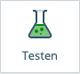
You can test your scenario using the Testbutton. You can listen to your recording directly in the scenario.
Tip: You can leave the test version of the scenario open in the additional tab. Did you make any new changes after testing? Then you can click on 'Test' again. You will then receive confirmation that the scenario is ready to be tested. By clicking 'OK', a change will immediately become visible in the current test version (in the additional tab) - without having to reload the scenario and play from the beginning. The "Reopen Scenario Player" button will reload the scenario, and thus play it from the beginning.

View scores

To see the scores, it is important to select a group first. In the sidebar, under the
dashboard, go to Groups.
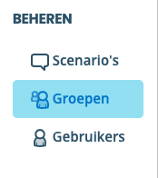

After that, choose the group you want to manage.

Managing a group
When you've chosen a group, you'll see a new screen. In this screen you can see the following things:

The scenarios the group can see

Which players are in the group now

Tip: The score is only credited when the student has gone through the entire scenario. When a scenario closes earlier, the results are NOT credited.

See which group members played a scenario

To see which group members may or may not have played a scenario, click the eye icon behind a scenario's play ratio in the summary table.

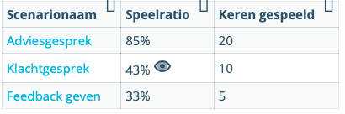

A new window now opens listing the group members with the times they played the scenario. This window contains a filter to select the students who may or may not have played the scenario.

Viewing the scores for a group
Viewing scores can be done in several ways.
- Results of different students on one scenario
To open the reporting screen for one scenario, do the following.
Click the Show report icon in the summary table
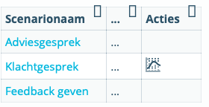
You will then see the reporting screen for the selected scenario.

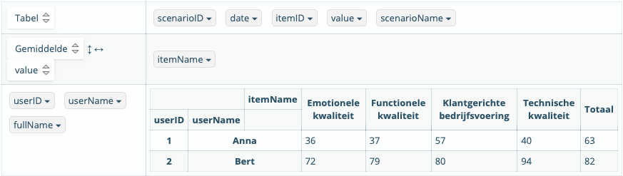
In the table you can read the scores achieved by students for the selected scenario in percent. The scores are an average, if a student has played the scenario more often, you can see the average of the scores they achieved here.

- Score over time
In the table above you can click on the date button. After this you will see rows with the individual playing sessions and the results obtained by the student.

- Results of one student on different scenarios
In the overview of a group, it is possible to click on the name of a student, to go to the user profile of the student and see the results for this student.
The user's profile screen shows an overview of the scenarios played with the best and worst total scores and the last playing date.

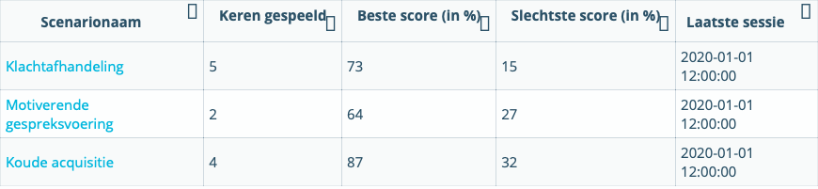

Add students/members to a group

In the sidebar under the Manage heading, go to Groups.

On this page you can create a group using the Create Group button
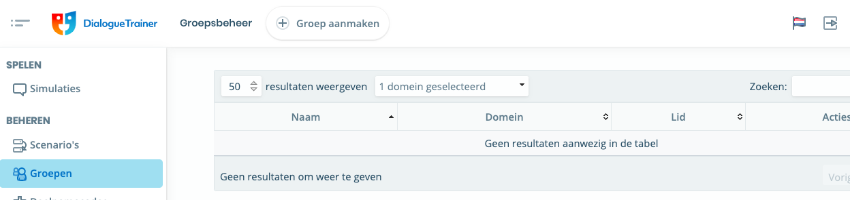

After creating the group, go to the created group to set it up for the link. Here you can link users, invite users, or add SolisID users to the group
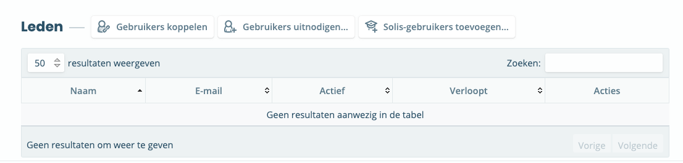

Linking users means that these people are already users of Dialogue Trainer

Inviting users are users who do not have an SolisID but want to use Dialogue Trainer. You can adjust some settings for this (see image below)
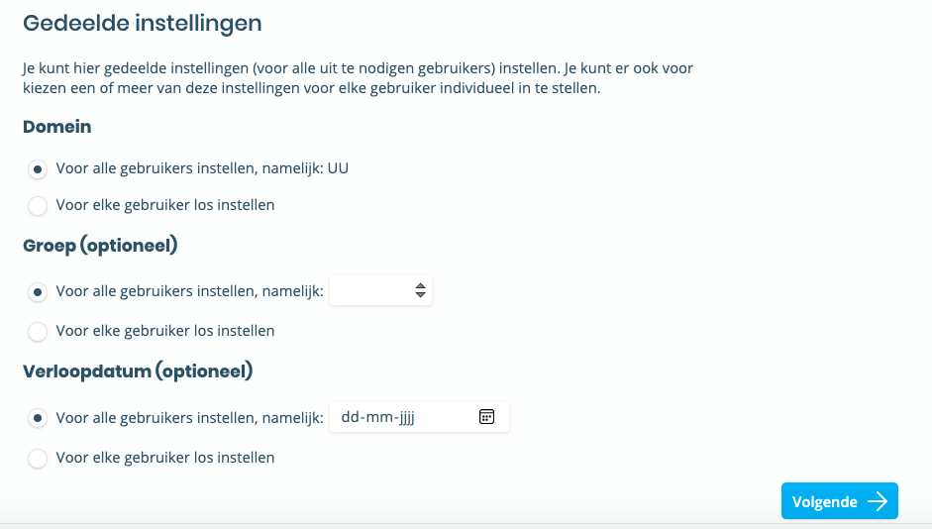
You can add users by uploading an Excel sheet of email addresses
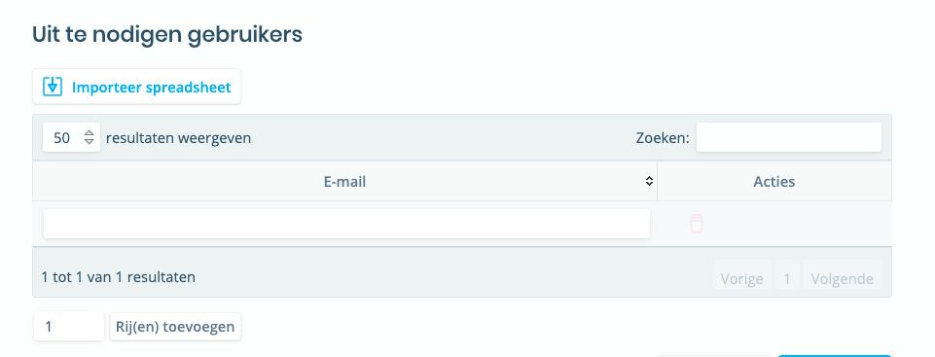
You can then compose a message that the users will receive with an invitation to use DialogueTrainer.

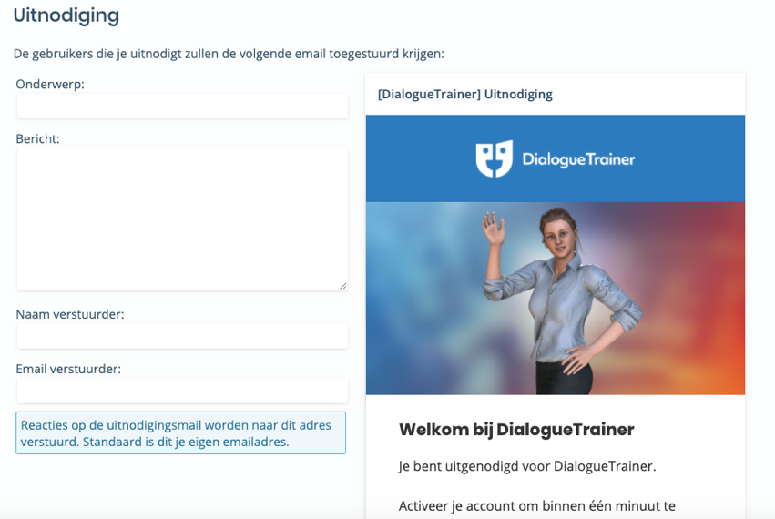

Solis-ID users can be added as follows:

You will end up on the next page with options to adjust settings

You can then add an Excel file containing the SolisIDs

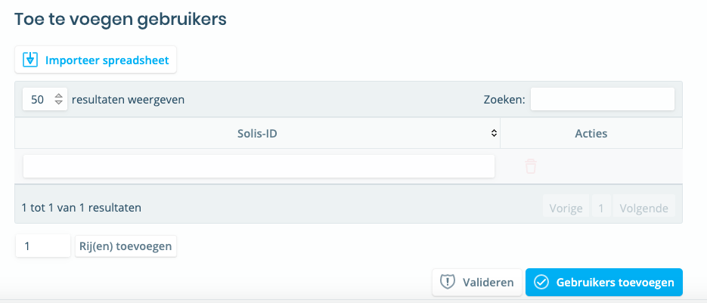
When the users are added, they do not receive an email but can use DialogueTrainer directly.

Add scenario to a group

In the image below, you can link the scenarios for the group. These are scenarios that you want students to go through.
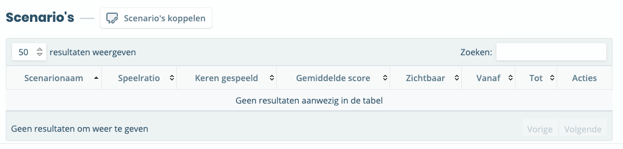
Then click link up scenarios where you can associate your scenario with the group.
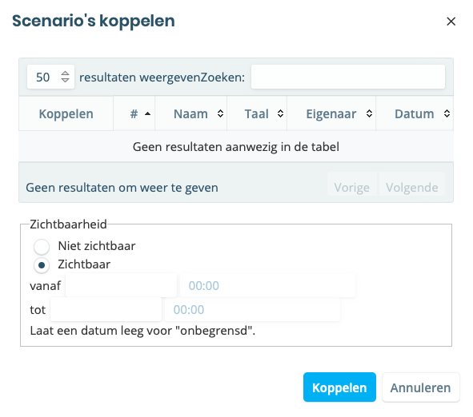

Add administrators to a group

To add other admins to the group, under Manage, go to Groups.

Under the Admins heading, you can add different users.
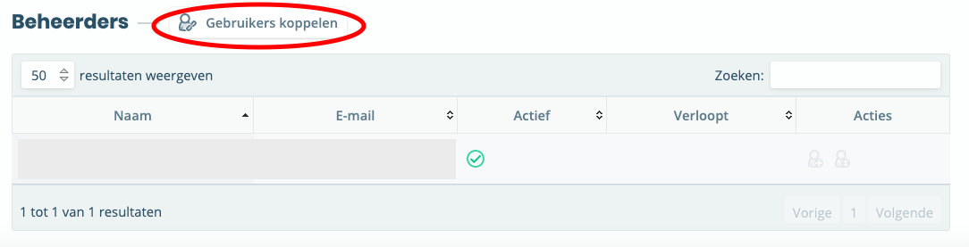

Participation codes

To invite participants, you can also share a participation code.

Under Manage, go to Participation Codes

Then click Create Participation Code
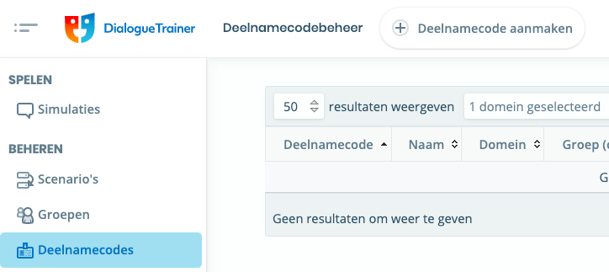

You can come up with a Participation Code name here so that participants know which group to join.
You can then select which group can access, how long the code is allowed, and when access has expired.
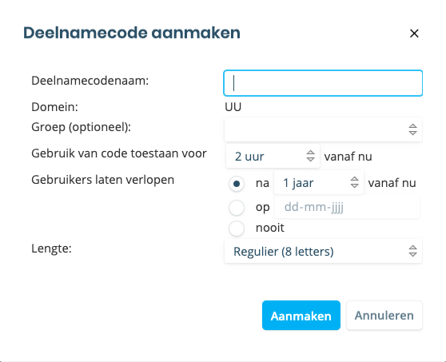

You will then receive the message below
(NOTE:this code is an example. You will get your own code!).
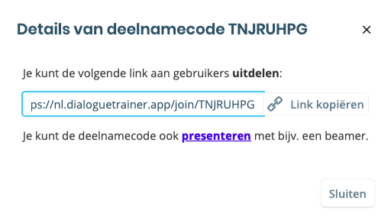
You get a link that you can share with users. The code gives participants access to the link

Do you need questions or support when using Dialogue Trainer? Please contact us. We would also like to hear from you if you have any comments or questions about this manual.

Practical support

Teaching support desk
Address: University Library Uithof, second floor, red desk
Opening times: Every working day from 8.30am - 5pm
Phone:030 253 2197
Email: teachingsupport@uu.nl
Website: https://educate-it-uu.sites.uu.nl

