Visual representation as learning method and assessment tool in interdisciplinary education
A manual for teachers and coordinators

Developed in the Visualizing Differences project with a USO grant from
Utrecht University

Project leaders and contact: Brenda Oude Breuil (b.oudebreuil@uu.nl) and Vassilis Gerasopoulos (v.gerasopoulos@uu.nl)
Course coordinators: Brenda Oude Breuil, Vassilis Gerasopoulos
Teachers: Domitilla Olivieri, Sabine van der Horst, Yvon van der Pijl and Kyra Lenting
Student assistants: Elise Wolfs and Hajar Jamad
Educational consultants: Hanne ten Berge and Judith Loopers

Date: May 2023

Introduction

This manual is about using film and video* making as a learning method and assessment tool in interdisciplinary higher education. Film and filmmaking is a great opportunity for students and staff to include diverse languages, experiences and perspectives in education. Perspective taking and understanding different perspectives is an important theme, in film making as well as in interdisciplinary education. Visualizing knowledge and perspectives, moreover, demands from students different capacities than the (much more common, in academic work) textual knowledge processing. It allows students to be creative, associative, original and sensory. Besides encouraging them to be actively involved in academic work, it sharpens their analytical skills to visualize what they have learned. We talk about visualization to refer to both a) learning to analyse film as a form of knowledge production and b) creating film (using moving images (and sounds)) as a form of knowledge making.
If you are interested in using filmmaking to let your students achieve the learning goals of your course, this manual can help you with:
- educational theory underpinning the power of using visualization as a learning method and assessment tool;
- educational theory underpinning the power of interdisciplinary education;
- tips & tricks of the process of designing an interdisciplinary course with films as
learning materials and film making as learning activity;
- what we did, choices we made and why, and how it turned out, as an example.

Example course: Vi-Di
The manual is developed alongside the course Visualising Differences (Vi-Di) at Utrecht University. This course will be the example referred to in this manual. Vi-Di is an interdisciplinary course, with students from Criminology, Gender Studies and Anthropology. The first edition of the course took place in the academic year 2021-2022, the second edition in 2022-2023. Because of the use of visualisation both as a learning method and an assessment tool, and the interdisciplinary nature of the course, Vi-Di serves as an example in this manual.
Vi-Di is about visual dialogues on diversity and discourse. The hands-on course aims to offer theoretical and practical tools in order to substantiate critique on existing media expressions, as well as to produce counter-hegemonic visual media messages. Vi-Di aspires to challenge students to sceptically perceive dominant societal discourses and media images of diversity, difference, and social exclusion, and, subsequently, to deconstruct these discourses. It encourages students to influence societal discourse through making their own visual representation (e.g. films), and so present ‘difference’ in an original, positive, and critical manner.
In terms of intended results, Vi-Di aimed to achieve the following:
- Didactic innovation: discover and gain experience with a visual, rather than textual way of communication and representation.
- Diversity & interdisciplinarity: students acquire an in-depth understanding of diversity and its relation to processes of social exclusion. They take part, critically and visually, in societal dialogues. Interdisciplinary collaboration teaches them to look at ‘difference’ from multiple perspectives.
- Lifelong learning for both students & staff: the project strengthens students’ academic specializations and teaches them transferable skills to be utilized throughout their career/ life. Teachers involved learn from inter-faculty collaboration (theoretically), as well as from experts (visual analysis and filming skills).
- Immediate professional skills training for students: Learning to make films is a skill that students can immediately put to use in their master research projects. By showing the films in cultural institutions, students learn to ‘translate’ and distribute their academic work to stakeholders, build a professional network and prepare for the job market.
- Societal outreach: The films created by students initiate significant and critical debate on pressing societal questions of diversity. By showcasing them in cultural institutes in the Netherlands and abroad impact is provided beyond academia.

Contact and information
Please contact for more information:
Brenda Oude Breuil: b.oudebreuil@uu.nl
Vasilis Gerasopoulos: v.gerasopoulos@uu.nl

*We use film and video as terms interchangeably

- About visualization and interdisciplinary education

Video projects in higher education
The use of video in learning is more and more common in higher education. It is not only used as a teaching tool, such as the use of knowledge clips, but also as a learning task of students. Media projects, such as video projects, are a form of expansive learning: “learning in which the learners are involved in constructing and implementing a radically new, wider and more complex object and concept for their activity” (Engeström & Sannino, 2010, p.2). This activity is at the level of knowledge creation, and thus serves as a way to enhance deep understanding of concepts and theories.
When students engage in a well-designed media project, their creativity, mastery of concepts, critical thinking and collaboration (in group projects) are encouraged (Fantini, 2019; NYU, n.d.; Perry, 2020). Besides, it provides “an active, fun and engaging learning experience for students” (Perry, 2020, p.38). It might also be intense, as students are challenged to step out of their comfort zone (Fantini, 2019). This is particularly true for the underlying project Vi-Di, which was conceived and created to broaden conventional understandings of knowledge and criticality, and allow students space to utilize and showcase a skillset that focuses on other than textual thinking and capacities. Such a swift in the educational paradigm is indicated if not demanded by the growing digitalization of contemporary culture. Moreover, students who participated in Vi-Di have shown an improved capacity in writing and research skills due to the sharpening of critical thought through actively visualizing messages.
More in general, a video project shows students that there is another way to look at science and data. Students learn that telling the story behind the data is important, and that emotions can also be effective in bringing a scientific message (Fantini, 2019). They learn to be more sensorily aware of, and engaged with their environment – meaning: to use all their senses in observing the Other and the world – creating a deeper level of understanding. Asking different skills, a video project therefore also works very well for students that are talented scientists, but who cannot really shine because text is ‘not their thing’.
Visual methods are especially fit to an interdisciplinary approach. Interdisciplinarity – both in the contents of the interactive lectures and in the cooperation with other students and staff – encourages students to find a common (or a new) vocabulary that they may use in order to make sense of phenomena or concepts that are studied across the disciplines but called by a different name. This creative discursive process significantly triggers a fruitful exploration of meaning and a strengthening of critical thought (see: Knowledge clip 1 on Critical Thinking). Moreover, it teaches students to take position within an academic environment: who are you (and what is your discipline about) compared to others and how can you (or: can your discipline) contribute to fruitful and innovative thinking? (see: Knowledge clip 2 on Positionality).
Earlies case studies in the Netherland have shown that video and interdisciplinary education work really well together (eg. Fantini, 2019). Interdisciplinary education encourages students to find a common (or a new) vocabulary. Using this vocabulary, students are able to make sense of phenomena or concepts that are studied across the disciplines but are called by a different name. Video opens up another way to talk about these differences, next to language. This creative process significantly triggers a fruitful exploration of meaning and strengthens critical thought

Engeström, Y., & Sannino, S. (2010). Studies of expansive learning: Foundations, findings and future challenges. Educational Research Review, 5(1), 1-24. https://doi.org/10.1016/j.edurev.2009.12.002
Fantini, E. (2019). Just like a movie: teaching visual storytelling on water. Journal of research and didactics in geography, 2(8), 63-70. https://doi.org/10.4458/2801-04
NYU (n.d.). Guidelines for video in teaching and learning. Consulted at 2023, January 9th, on https://www.nyu.edu/faculty/teaching-and-learning-resources/strategies-for-teaching-with-tech/video-teaching-and-learning/guidelines-for-video.html
Perry, M.S. (2020). Multimodal engagement through a transmedia storytelling project for undergraduate students. GEMA Online Journal of Language Studies, 20(3), 19-40. http://doi.org/10.17576/gema-2020-2003-02

Interdisciplinary education
In the last years, attention for interdisciplinary education has increased in higher education. Szostak defines interdisciplinarity as follows: “Interdisciplinarity involves a set of practices: asking research questions that do not unnecessarily constrain theories, methods, or phenomena; drawing upon diverse theories and methods; drawing connections among diverse phenomena; evaluating the insights of scholars from different disciplines in the context of disciplinary perspective; and integrating the insights of those disciplinary scholars in order to achieve a more holistic understanding.” (Szostak, 2015, p.109). Interdisciplinarity is a way to solve complex problems by seeing a problem from different perspectives. In interdisciplinary education, an open view towards knowledge and insight from different disciplines is important. This prepares students to integrate insights from different disciplines: a skill that is believed much needed to solve current complex societal problems. Questions in our society ask for the use of multiple sources to find solutions. For education, this means that “preparing young adults to be full participants in contemporary society demands that we foster their capacity to draw on multiple sources of knowledge to build deep understanding.” (Boix Monsilla, 2005, p.14).
Interdisciplinary learning can be erratic and unpredictable. Students learn to take different perspectives and synthesize these under guidance of lecturers. Doing this, they develop an open and appreciative attitude to the contribution that their own disciplines, together with other disciplines, can make towards complex social issues. Students in the VI-DI course appreciates this: “I also love that I've slowly come to learn people from disciplines I would have never even met otherwise. It was a worthwhile experience.”

Boix Mansilla, V. (2005). Assessing student work at disciplinary crossroads. Change: The Magazine of Higher Learning, 37(1), 14-21.https://doi.org/10.3200/CHNG.37.1.14-21
Szostak, R. (2015). Extensional definition of interdisciplinarity. Issues in Interdisciplinary Studies, 33, 94-116.

Question for teachers: Why do you want to design interdisciplinary education?

Educational models to design education in an interdisciplinary way
There are different educational models to design education in an interdisciplinary way, depending on the goal you have.

Boundary crossing: showing different perspectives in interdisciplinary learning
One model of working in an interdisciplinary way is called boundary crossing. Akkerman and Bakker define boundaries as “sociocultural differences that give rise to discontinuities in interaction and action.” (Akkerman & Bakker, 2011, p. 139). It represents a cultural difference, which can result in difficulties in action and interaction. At the same time, there is also the potential of communication and collaboration.
Akkerman and Bakker (2011, p.150) distinguish four learning mechanisms that can be used in creating new knowledge:
- Identification: “coming to know what the diverse practices are about in relation to one another”. With this mechanism, students get insight in one’s own and others identities, and how they complement or differ.
- Coordination: “creating cooperative and routinized exchanges between practices”. This mechanism helps students to communicate with each other by exchanging relevant information.
- Reflection: “expanding one’s perspectives on the practices”. Students recognize the differences between perspectives. Doing so, they learn something new not only about the perspectives of other, but also about their own.
- Transformation: “collaboration and codevelopment of (new) practices”. With this mechanism, the creation of new knowledge takes place.
Gulikers and Oonk (2019) gave an overview of the learning mechanisms of boundary crossing, shown in the attachments. These mechanisms can be useful in interdisciplinary education, as students are trying to integrate knowledge from different disciplines. They also defined questions to stimulate the learning mechanisms. Furthermore, they developed a rubric to assess interdisciplinary skills, also to be found in the attachments, and as well discussed in a section on assessment.
The Vi-Di course can be seen as an example of boundary crossing. The strategies are used to tackle themes around differences, and can enhance dialogues on diversity and discourse, as is done in the Vi-Di course.

Repko:
Another widely used model is that of Repko and Szostak (2017), defined as a model of doing interdisciplinary research. The model stated that students start from their own discipline, which suits the definition of the Utrecht University of disciplined interdisciplinarity. The steps in the model are as follows:
- Define the problem.
- Explain why the problem needs an interdisciplinary approach.
- Identify possible contributions of different disciplines.
- Conduct a literature review.
- Identify differences and similarities between different disciplinary insights.
- Create ‘common ground’.
- Integrate different insights and draw conclusions.

Akkerman, S.F., & Bakker, A. (2011). Boundary crossing and boundary objects. Review of Educational Research, 81(2), 132-169. https://doi.org/10.3102/0034654311404435
Gulikers, J.T.M., & Oonk, C. (2019). Towards a rubric for stimulating and evaluating sustainable learning. Sustainability, 11(969), p.6. http://doi.org/10.3390/su11040969
Repko, A., & Szostak, R. (2017). Interdisciplinary Research.

Question for teachers: Which model applies best to your course and learning goals?

Further reading
Do you want to read more about interdisciplinary education?
- Read more about educational models to teach students interdisciplinary thinking
- Read more about a four-stage model of interdisciplinary thinking, based on Repko
- Read more about integrating multi-disciplinary insights by creating common ground
- Read more about students working together in interdisciplinary teams
Visualising Differences
In Vi-Di, we choose differences as a topic. It aligns very well with interdisciplinarity. In Vi-Di, ‘difference’ is not only interdisciplinary difference, but also being different people and dealing with that. From an earlier study in higher education, we know that an interdisciplinary video project learns students to appreciate differences (Jensen, 2012). Difference is usually understood or employed as a boundary, a separation or the breeding grounds for exclusion. However, in VI-DI difference is an invitation for a productive dialogue, a constant exchange of views and experiences and a reality that should be celebrated instead of muted.

Jensen, M., Mattheis, A., & Johnson, B. (2012). Using student learning and development outcomes to evaluate a first-year undergraduate group video project. CBE−Life Sciences Education, 11, 68-80. https://doi.org/10.1187/cbe.11-06-0049

- Forming an interdisciplinary group of teachers

How do you create an interdisciplinary group of organizing teachers?
In the ideal situation, a group is formed quite naturally with people you already know. This can be from workshop around themes that you all find important or from overarching, interdisciplinary research groups. Pre-existing relationships have the advantage that everybody knows what to expect from the other, that there is a positive vide and dynamics are already established. The most important thing however is a common perspective to teaching, methods and epistemological positioning. It is very helpful and constructive if the teachers depart from a similar understanding about research and critical thinking. Within Vi-Di, a connecting factor was a shared fascination for film as (a way to) critique, and an overlapping educational philosophy that giving students ultimate freedom to explore, choose a topic, and co-decide what they want to learn and how they want to be assessed, would lead to sovereign projects in which students themselves take control over their learning (instead of teachers telling them what to do).
When a project gets bigger, it might be difficult to all feel the responsibility to the project. We have experienced that the bigger the group of participating staff, the less clear the responsibilities of every participating staff member are; there can be a tendency to wait for others to take action, meetings are less efficient and it is more difficult to keep everyone evenly engaged. This might be solved by appointing a project leader, where in a smaller team the organization might be more organic.

What does an interdisciplinary group of teachers bring the teachers?
In Vi-Di, working in an interdisciplinary group of teachers is a positive, inspiring and exciting experience. It is great to make use of the different skills and contacts all teachers have. The teachers speak the same language, even though they sometimes use different words to describe the same concepts. It is rewarding to realize that you can help the student achieve something, by sharing diverse insights from different perspectives. It is invigorating to see students actively thinking, doubting and questioning. Also, projects like this show that there are many people out there that think the same way, are inspired by the same things and have the same goals when it comes to teaching. It is not just about sharing a specific kind of knowledge, but it is about discovering knowledge together – for both students and staff. That is the driving force of the project.

- Organization of the course

What do you need to prepare before the program starts?
Different universities and different departments have different procedures. A project like Vi-Di thus fits differently in teachers’ regular (teaching) tasks. Therefore we here go into the different task. Assess for yourselves how many time these will take in your department and how they relate to your teaching load.
Writing the proposal for the USO grant, we completed the following steps:
1. developing initial ideas and brainstorming;
2. delineating the focus and fundamental aims;
3. envisioning the scope and the potential team;
4. drafting first version of the proposal;
5. familiarizing ourselves with the organizational/ administrative aspects of the proposal;
6. completing proposal and incorporating feedback from colleagues.
After that, it’s time to develop the course further. This means designing the meeting, contacting the (guest) lecturers and selecting the students. This will be described in the next sections.
As we work with colleagues from different disciplines, who have different year plannings, bottlenecks and administrative requests, the planning of the project is more difficult than an in the case of an ordinary disciplinary course - both for teachers and students. Making the course extracurricular, as we did with Vi-Di, and have it take place in the evening timeslot (17-20 pm) can largely solve this problem.

Who do you invite to teach students about the filming process?
You might not have the knowledge and skills about filmmaking in your team. To assist the students in the filming process, we advise to invite people with practical experience in filmmaking. You might want to select these filmmakers based on the topics they make films about, so that it matches the topic of your course.
In the Vi-Di course, we invited several filmmakers to assist the students with filming. Two filmmakers were the main guest teachers, and were present in several sessions. These filmmakers make documentaries in which they do not avoid controversial or anti-hegemonic themes, in particular in the field of sexuality/ sexual identity, and thus they fit the content of the course very well. They were present one of the seminars in the beginning to help setting up the filming process, and at the end to share insights and techniqueson editing. They were also available for individual subgroup meetings between the last seminar and the seminar in which the films were displayed, to further help students with editing.

Who can be interesting guest speakers?
Next to the filmmakers, one can think of inviting guest speakers in the seminars, for example the director of a documentary on a theme that is related to the course, a person who was part of the documentary as the main protagonist or other visual artists. Guest speakers mainly have the role of inspiring the students to sparkle their creativity.
The following list encompasses (potential) guest speakers for the Vi-Di course. Mind that the list makes sense for this course, as the filmmakers play with visuals in the way the course aims for.
Who | What | Their role in the seminars | Their presence
Dylan and Lazlo Tonk | Filmmakers | Share their knowledge of filming and editing | Several seminars as well as individual consultation
The Transketeers  (Jonah Lamers, Chris Rijksen, Bart Peters) | Filmmakers, specialized in telling unheard and invisible stories from original sources | Inspire, share their knowledge on filming and perspective taking in films around counter-hegemonic themes and make students move forward by having them make crucial decisions on groups and themes | Seminar 2
Yvette Luhrs | Media maker, sexworker, activist | Inspire, share the story of the main protagonist in a documentary on working in the sex industry | Seminar 2
Bloom de Wilde de Ligny | Visual artist | Inspire, sparkle creativity | Seminar 3 (2022-2023)
Jonnah Bron | Photographer and filmmaker | Inspire, challenge students to reflect on intimate topics | Seminar 3 (2021-2022)
Guest speakers in the Vi-Di course

Questions for teachers: Which knowledge or skills do you miss in your teacher team? Can you think of guest lecturers who can bring this experience?

How can student assistant(s) be of help?
A student assistant can be of help with assisting in several practical tasks, such as taking notes in the teacher meetings or setting up the course environment. In the Vi-Di-course, we had two student assistants consecutively to assist us. One was also participating in the course, which can be helpful because of as the close contact she had with the other students, but is not a necessity. Selecting a student assistant who has some intrinsic interest in the topic of filming, or some creative talent, is of additional value. Student assistants can be involved in/ charged with:
- being the main communicator between the teachers and the students;
- creating a list of participants, making a mailing list and setting up a WhatsApp group;
- designing the recruitment flyer;
- setting up (and maintaining) a Blackboard environment;
- making a syllabus for the course;
- making practical arrangements for the course, e.g. applying for the venues, arranging for coffee/tea, planning and organising the final screening;
- designing an invitation for the final screening;
- inviting guest lecturers;
- planning the teacher meetings and making notes.

Questions for teachers: Do you want to have a student assistant? Which tasks does the student assistant have? Do you have somebody in mind?

- Selection of participating students

On what grounds do you select participants? What are the admission criteria?
When determining selection criteria of your course, think about the goals you have with the course. Do you want students from different disciplines? Do you want students with certain skills? The three criteria we used in Vi-Di were:
- students are from one of the three different Master programmes the teachers were involved in and were more or less equally included to enhance interdisciplinarity;
- students must show (in a motivation letter) that they are enthusiastic about and/or have a feel for films/the visual (but no prior film knowledge is required);
- students should be available on the proposed timeslots for the seminars.

Question for teachers: What do you think are important criteria to select students?

Admission criteria
Thinking about a way to select students, keep in mind your admission criteria. Do you want them to have filming skills? You might ask for a short video. Do you want them to use their creativity in a broader sense? You might keep the format open. You also might want them to answer some questions they need to include in their admission.
In Vi-Di, we asked students to write a short motivation (300 words) in which they explain why they wish to be part of Vi-Di, what they expect to learn and why they believe they are suited to participate in the project. A motivation letter encourages the student to think about what they want to learn, what they bring to the course, and why they are enthusiastic about the course. That helps you to select enthusiastic and capable students, which was considered more important than having filming skills. Nevertheless a minimal number of students did drop out the course. This might have to do with the extracurricular nature of the course and more pressing tasks.
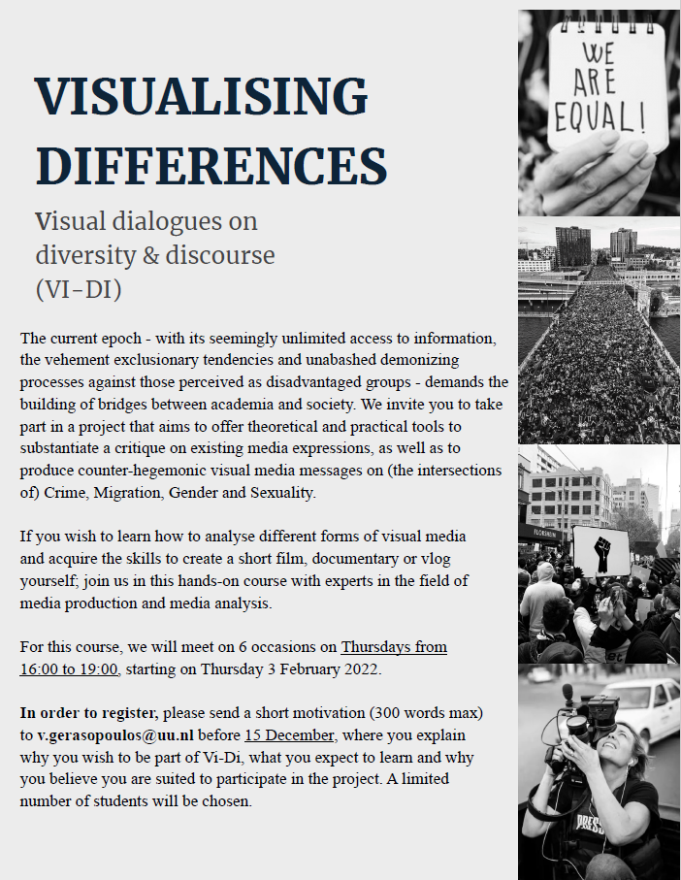
Flyer of the course Vi-Di 2021-2022

Question for teachers: How do you find out if students apply to the admission criteria?

What do you do when a large group of students from one discipline and only a few students of another discipline apply for the course?
This depends on how important it is to include different disciplines. If you want every student to participate in a diverse subgroup of students, you need a more or less balanced division of disciplines.
We included 3 to 5 students per discipline (Anthropology, Gender Studies and Criminology). We could include all students from two of the disciplines as between 3 and 5 students of each discipline had applied. We had to select more strictly for the third discipline because there were too many applicants.

Questions for teachers: Which disciplines do you want to include in your course? How many students per discipline?

What do you do with perfectly capable students but a limited number of places?
If we had more than enough students from a discipline and needed to select students, we were inclined to go for the people who had some previous experience with filming or editing, or we chose students we thought would profit most from the course for their individual learning paths.

What made students apply for the course? And what do they expect?
At the start of the Vi-Di course, we asked some student why they applied and what they wanted to learn:

“In our master program we had a course on analysing movies. So we didn’t really do something before that in our own criminology field. So therefore I thought it would be interesting to learn more about how these movies or documentaries are actually made.”

“For me, as I am going to do my thesis about media, I wanted to explore further this topic and complement also what we explored in our master. I want to know a little more about this topic, about media, and explore also the topic of queer community and those different populations in the media.”

“What we expect of this course? I guess for me, I expect to learn how to be more practical with what I learned in my own master’s program. And I am hoping this will help with the internship I will start next week. So that’s why I assigned“

“And for me I would like to see how visual methods can help convey messages in a different way than maybe more academical texts.”

How do you compose a group of the students who applied?
If you include students from different disciplines, they most likely do not know each other, or only the students of their same discipline. To enhance collaboration between the disciplines, it is important to get to know each other better, and to break down the boundaries between the disciplines.
In the first edition of the course, we asked the students to bring something visual to the first meeting. By showing this and telling the story behind it, we wanted to make a start to get to know each other, to enhance creativity and to stimulate an open sphere. The assignment was as follows:

To embark on our visual exploration, we invite you to bring something visual (photo, artefact, object, adornment, instrument, tool or whatever you can/ want to bring which we can see ;-) that represents or symbolises what you are focused on or inspired by, professionally. This can be something linked to the topic/ theme you want to explore in this course, or (since we guess many of you do not yet have a topic, which is fine!) something that you are triggered or inspired by. When introducing ourselves, we will ask you to show it and tell us about it.
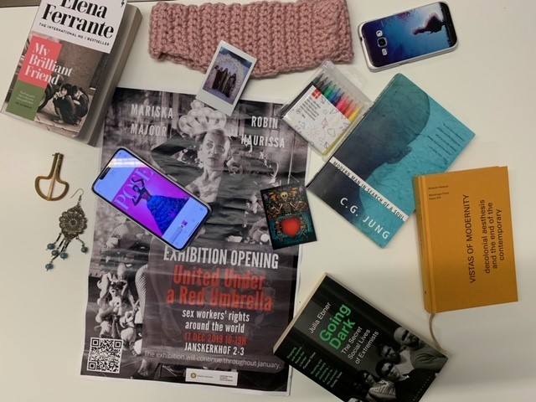
Visuals the students brought to the first meeting of the course Vi-Di 2021-2022

We started the second edition of the course with a different meeting, preceding the first seminar. We invited all new students to the screening of the films of the first group of students. This served as a way to already get to know each other a bit before the first seminar and to have an idea of how the final product of the course may look like.
Students formed subgroups of 3 students in which they worked on their film themselves. We ensured to have a minimum of two disciplines in each subgroup to enhance interdisciplinary thinking.

Further reading
- Read more about students working together in interdisciplinary teams

- Program and assignments

What topics are important to cover?
When designing your course, think about the learning aims and which topics are important to cover to achieve these aims.
For the Vi-Di course, the following topics were important to cover:
- Representation, social exclusion, othering, stigma, impact of media, (hegemonic) discourse
- Filming: genres, discuss several examples/ fragments of films
- Film techniques: making a storyboard, deciding on narrative line, framing, camera positioning, rhythm , editing etc.
- Positionality: what kind of researcher am I? (How) do I appear in my film?
- Distribution: who’s my public, how to spread the film beyond this course, etc.

For inspiration purposes, click here to find the course program of Vi-Di.
 | Theme | Learning objectives | Guests
Starting session | Getting to know each other | To get to know each other and the video project
Seminar 1 | Introduction  - Concepts of discourse, hegemony and difference  - First steps in filmmaking | To establish (some of) the vocabularies of knowledge that will guide us through the project. | Filmmakers Dylan and Lazlo Tonk
Seminar 2 | Positionality – both in academic work and in film making | To explore your own positionality. This exploration aims to supports working on the narrative (story board) of your intended films. | The Transketeers (Jonah Lamers, Chris Rijksen, Bart Peters)
Seminar 3 | Aesthetics and creative recovery | To relate different aesthetic styles to positioning in your films.  To unleash your creativity. | Bloom de Wilde de Ligny
Seminar 4 | Editing and the significance of working with rhythm | To learn what editing means and about the various techniques, and how it affects the experience of watching a film.
Seminar 5 | Audience | To think about the audience of your visual projects.
Seminar 6 | Work session | To continue working on your films. | Filmmakers Dylan and Lazlo Tonk
Closing session | Showing the films
Program of the second version of the Vi-Di course (2022-2023)

Questions for teachers: How many seminars do you have in mind? Which topics / themes do you want to cover?

How do you make use of the interdisciplinarity within the group of teachers?
Each teacher prepares a seminar, in which the other teacher act as a critical friend. It is helpful for students to see that the teachers from different disciplines are curious and interested in each other’s interests and research. All teachers are eager to reflect on things from their own point of view. To see how teachers from different disciplines and domains of knowledge can share their knowledge and reflect on the topics we discuss in an open, respectful, horizontal way.. They see a constant process of critical thinking, asking new questions and an open discussion. Taking part in such an open academic debate makes them better academics. Furthermore, this teaches them that science is not a given, but an ongoing debate and nuanced. For some students, the insight that science is not yet established, but an ongoing project, and the personal stories of the teachers about their struggles and doubts while being a scientist, made it easier for them to see how they might fit in academia.
To achieve this, it is very important to prepare the project well. The choice of topics is an important consideration. Choose topics that have a link to everyone’s discipline, so that everyone can relate to it, and it is interesting to see the topics from different disciplinary perspectives. In example of Vi-Di, the theme sex work has a gender dynamic, has criminal dynamic, and anthropological dynamic. In this way, students learn to see themes from another discipline which stimulates their out of the box thinking.

Question for teachers: What do you want to achieve by working with an interdisciplinary group of teachers? Think about outcomes for yourselves as teachers as well as for students.

What assignments do students receive?
Students work in interdisciplinary groups on a video project. The short film, documentary or vlog they make is about a theme around diversity and differences. An interdisciplinary video project is useful to tackle a topic around diversity and differences, and to implement interdisciplinary learning. In a creative task, students are engaged more deeply and actively with the different perspectives (Perry, 2020). From an earlier study in higher education, we know that an interdisciplinary video project learns students to appreciate differences (Jensen, 2012). “Students reflected upon the experience as one that introduced them to new ideas, new people, and new ways of behaving in a classroom setting.” (Jensen et al., 2012, p.75). Analysis of interactions that took place between students while working on this project, showed “a creative and complex process to combine diverse ideas into a single product.” (Jensen et al., 2012, p.78).

Jensen, M., Mattheis, A., & Johnson, B. (2012). Using student learning and development outcomes to evaluate a first-year undergraduate group video project. CBE−Life Sciences Education, 11, 68-80. https://doi.org/10.1187/cbe.11-06-0049
Perry, M.S. (2020). Multimodal engagement through a transmedia storytelling project for undergraduate students. GEMA Online Journal of Language Studies, 20(3), 19-40. http://doi.org/10.17576/gema-2020-2003-02

Question for teachers: What kind of assignment do you have in mind for your course?

What do you do in the meetings and which learning activities/assignments do you plan for outside the meetings? How do you align the meetings with the out of the meetings activities?
Students work at home on their assignment, as well as during work sessions in the seminars. The course has been developed in such way that the students do a big chunk of work in the seminar, especially towards the end of the course. The students really appreciated this, and suggested that there could be even more working sessions. In some sessions, certain activities are planned to help the student develop their film. The pictures show two examples. In one of the first seminars, students are asked to play around with the camera, to learn about what you can do with visuals (picture on the left). In another seminar, students are drawing a storyboard (picture on the right).
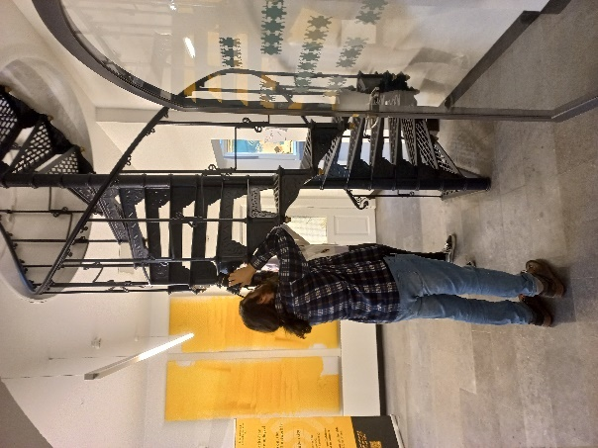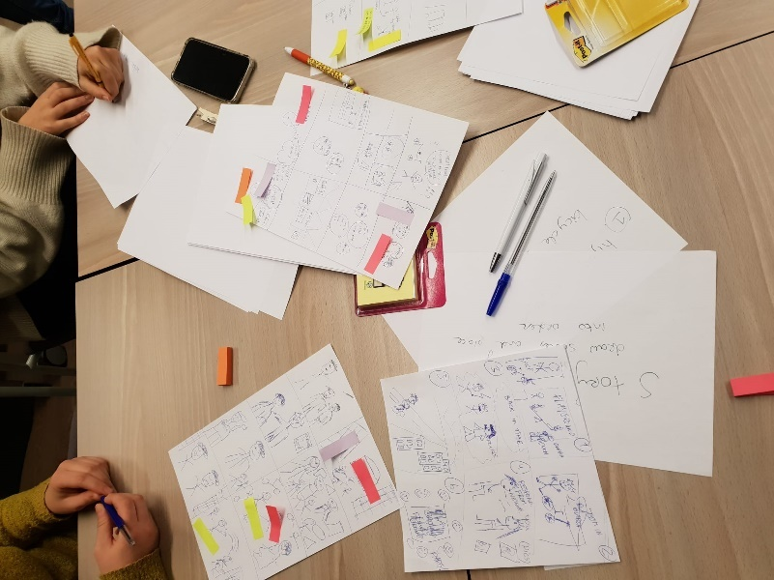
Activities during the seminars

How do students receive feedback on their work before they finalize it?
The work on the assignment is a continuing process. Students can discuss their ideas in the meetings with both the teachers and the film makers. This can be done in several stages of the process, such as the decision about the theme of the film, the construction of a story line and their filming plans. Moreover, they can show their editing work to the film makers in the last seminar. Next to that, the film makers offered them an individual consultation between the seminars to receive feedback on and help with their editing. The film makers thus act more like the experts, while the teachers act like critical friends thinking along and asking questions.
Students appreciated this way of working:
- “The dialogues with the filmmakers helped a lot! (their perspectives, ideas and understanding of our projects, questions and struggles)”
- “I really liked the filmmakers (Dyzlo). Their concrete examples & tips were extremely helpful & I loved the parts where they actively brainstormed with the groups. They helped us immensely.”
- “(…) the enthusiasm & questions of the teachers really helped us in looking outside of our bubble of ideas.”

- Process during the seminars

How do you create an open, horizontal climate in the classroom?
One of the approaches to enhance student engagement, co-creation, is getting more attention over the last years. “Whole-class co-creation in learning and teaching involves inviting a whole group of students who are studying together in any teaching setting face-to-face or online, to actively collaborate and negotiate with the teacher and each other, elements of the learning process” (Bovill, 2020, p.1025). Dialogue and building relationships are important aspects of teaching and learning. Power relations change: students and staff are more equal (Bovill, 2020). In co-creation, students and staff learn together: “students and staff can critique knowledge together using shared expertise and perspectives. This co-creation approach recognises that knowledge is contingent and messy, and it accepts that students can play a role in knowledge co-creation. Students are making sense of what they are learning collaboratively with their teacher and peers.” (Bovill, 2020, p.1028). Co-creation askes a different approach of teachers: “this may require academic staff in most cases to adapt their current teaching practice, and learn to adopt more relational approaches to teaching that are open, collaborative, dialogic, and democratic.” (Bovill, 2020, p.1034).
The teachers in Vi-Di created an open climate in the classroom, for example by these quotes:
    - “We very go beyond the idea that anything is a taboo.”
    - “You are here to talk about things you are passionate about.”
    - “Voice your own ideas.”
Teachers are open and learning themselves, creating a horizontal climate and stimulating cooperative learning:
    - “It might be helpful to share the stories how we came where we are now. So that you also see the road that I or anyone here travelled is actually comparable to your road. I can now look back and see what I missed in the stories of my teachers.”
    - “We know things, other people know other things, and we will bring it together.”
Answers are not right or wrong; teachers ask questions and think along to make the message of the films more clear. Also things like bringing some food and the physical position teachers have during the seminars (teachers who are not presenting sit within the group of students) created this horizontal and cooperative environment.
The students really liked the classroom climate:
- “The casual atmosphere was nice & really helpful.”
- “The open atmosphere was amazing.”
- “There was also a really good vibe during the lessons, I felt really comfortable in this group!”
- “I really enjoyed the course and liked the teacher student dynamic, it really felt like a very welcome learning environment.”
- “Love the open educational approach: students are welcomed to express their ideas.”
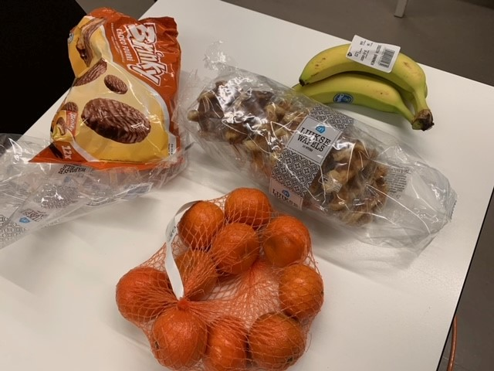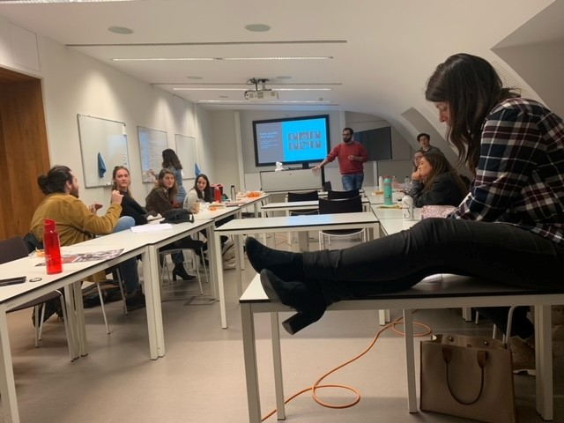
The relaxed climate in the seminars

Bovill, C. (2020). Co-creation in learning and teaching: the case for a whole-class approach in higher education. Higher Education, 79, 1023–1037. https://doi.org/10.1007/s10734-019-00453-w

How can teachers keep track of the process before and during the seminars?
A Blackboard environment and WhatsApp group was used for communication outside of the seminars. During the seminars, teachers and guest lecturers are very approachable and willing to give feedback. A check-in at the beginning of the seminar also helps to keep track of the progress of the students.
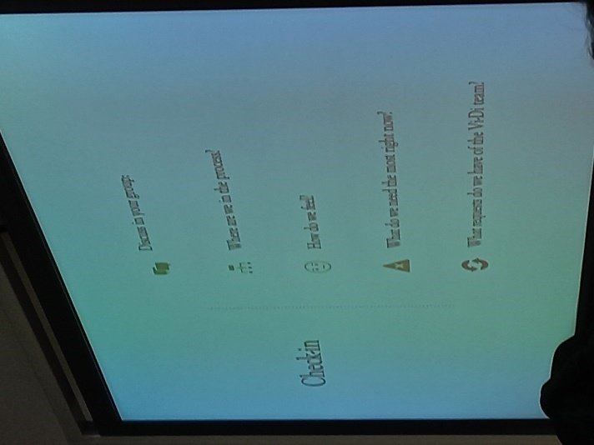
Check-in with the students at the beginning of a seminar

- Assessment

What type of assessment fits this interdisciplinary activity?
Assessment of interdisciplinary skills might be challenging, whether the student work is a paper, video, artwork or anything else. What actually is a good interdisciplinary piece of work? Boix Mansilla defined three important criteria (p.18):
- Disciplinary grounding: “Is the work grounded in carefully selected and adequately employed disciplinary insights?” Knowledge of the disciplines underlies good interdisciplinary skills. Students need to decide which aspects of the different disciplines are useful.
- Integrative leverage: “Are disciplinary insights clearly integrated so as to leverage student understanding?” A good interdisciplinary piece of work integrates the knowledge of different disciplines. The new understanding could not have been reached with a single discipline only.
- Critical stance: “Does the work exhibit a clear sense of purpose, reflectivity, and self-critique?” This askes for meta-disciplinary awareness and a critical view on the piece of work.
Gullikers and Oonk (2019) developed a rubric based on the boundary crossing learning mechanisms (see the first part of this manual for information about boundary crossing, and the attachments for the full rubric).

Further reading
- Read more about assessing interdisciplinary skills

Boix Mansilla, V. (2005). Assessing student work at disciplinary crossroads. Change: The Magazine of Higher Learning, 37(1), 14-21.https://doi.org/10.3200/CHNG.37.1.14-21
Gulikers, J.T.M., & Oonk, C. (2019). Towards a rubric for stimulating and evaluating sustainable learning. Sustainability, 11(969), p.6. http://doi.org/10.3390/su11040969

How do you assess students work, in this case visual material? How do you assess content, product and process?
Group video-projects allow to not only assess learning goals such as knowledge, but also developmental goals, such as interpersonal skills (Jensen, 2012). You might want to include this in the assessment form to represent the process. Furthermore, Bowen (2017) developed a rubric for assessing visual literacy competence (attached). The rubric includes skills like visualisation, analysis, and design of visual material.
The main message learned from Vi-Di is to choose an assessment method that is appropriate for students’ own projects. We created an assessment form with criteria on the filming skills as well as themes of diversity and interdisciplinarity. The assessment is open-ended; that is to say, the evaluation does not translate into a numerical grade on the normative grading scale of 1-10. Rather, the assessment is geared towards giving constructive feedback the students can use to improve their film project. Additionally, the assessment is meant to be shared with the students while the film projects are almost finished but still in progress, instead of focusing on the final product. Mind that this was possible because of the extracurricular nature of the course.
Click here to find the assessment form.

Bowen, T. (2017). Assessing visual literacy: a case study of developing a rubric for identifying and applying criteria to undergraduate student learning, Teaching in Higher Education, 22(6), 705-719, https://doi.org/10.1080/13562517.2017.1289507
Jensen, M., Mattheis, A., & Johnson, B. (2012). Using student learning and development outcomes to evaluate a first-year undergraduate group video project. CBE−Life Sciences Education, 11, 68-80. https://doi.org/10.1187/cbe.11-06-0049

Questions for teachers: What are your current thoughts about assessment? Are their obligations from your department(s)?

How do you shape the process of creating assessment criteria? Who has which role in assessing?
In the Vi-Di course input for assignment criteria as given from different perspectives:
- The teachers focused on content >> what are the differences between disciplines and how do you handle these when assessing students’ work? How do you take positionality?
- The filmmakers: focused on filmmaking and visual representation skills.
- The students were asked their opinion on what they found important to be assessed on (see 8.5).
- Educational advisors can provide input about what wo know form educational literature.
In the end, the teachers made an assessment form, which was agreed on by the filmmakers. We used a co-assessing procedure which means the following: First, each film and group of makers will be assessed not only by teachers, but also by filmmakers and fellow students. For the product part of the assessment form, students were allowed to choose 3 out of 5 criteria that they wanted to be evaluated on. Secondly, the group of students who made the film can choose which themes they want to be assessed on, based on the bellow specified set of criteria.

Questions for teachers: Who develops the assessment criteria in your course? Who has which role in assessing?

How can you give students a say in what they will be assessed on?
From a perspective of co-creation, students may also have a say in defining the assessment criteria. During the last seminar, students were asked what they found important to be assessed on. However, this was a surprise for the students. Learners are often unfamiliar with the process of co-creation, which may hinder their understanding of roles and provoke uncertainty (Bergmark and Westman 2016). A student replied: “It is the first time for me someone is asking me: how would you like to be assessed?” The teachers tried to stimulate the students to give their opinion, by saying things like “What could help you? Also for your future, your orientation towards what kind of scientist you want to be. What could help you in your development?” and “For you, it is more like, what do we think the project should be about and I want to be assessed on those points.(…) So that we assess you on the things you want to be assessed on.” In the end, this approach was appreciated, as a student pointed out in the evaluation: “Love this course, we need more out of the box educational approach: ask students how they want to be assessed, include them into the learning process.”.
Having a chance to say what they want to be assessed on gives the students the chance to get feedback on their own learning goals. This is reflected in the following quote of a student: “Maybe also how well a certain message comes across in the end work. Because that was mostly why I wanted to take this course, to learn how to do that.”
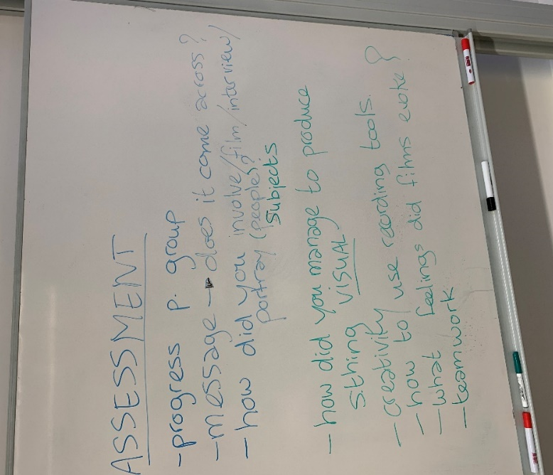
Students are quite aware of important aspects of the course. The following quote shows that students acknowledge the interdisciplinary nature of the course: “I think it is also about teamworking right? We constantly have to relate each other’s ideas. And this is a peaceful process with these people right now but in other cases it was not peaceful for me, in other projects. Maybe with these experiences we are able to do it smoothly. But still, it is always about relating your vision of the video with the people that are doing that with you.”
Students opinion about what they want to be assessed on during the Vi-Di course (2021-2022)

Questions for teachers: Do you want to give students a say in what they will be assessed on? If yes, how are you planning to organize this?

Bergmark, U., & Westman, S. (2016). Co-creating curriculum in higher education: Promoting democratic values and multidimensional view on learning. International Journal for academic development, 21(1), 28-40. http://dx.doi.org/10.1080/1360144X.2015.1120734

References

Akkerman, S.F., & Bakker, A. (2011). Boundary crossing and boundary objects. Review of Educational Research, 81(2), 132-169. https://doi.org/10.3102/0034654311404435
Bergmark, U., & Westman, S. (2016). Co-creating curriculum in hinger education: Promoting democratic values and multidimensional view on learning. International Journal for academic development, 21(1), 28-40. http://dx.doi.org/10.1080/1360144X.2015.1120734
Boix Mansilla, V. (2005). Assessing student work at disciplinary crossroads. Change: The Magazine of Higher Learning, 37(1), 14-21.https://doi.org/10.3200/CHNG.37.1.14-21
Bovill, C. (2020). Co-creation in learning and teaching: the case for a whole-class approach in higher education. Higher Education, 79, 1023–1037. https://doi.org/10.1007/s10734-019-00453-w
Bowen, T. (2017). Assessing visual literacy: a case study of developing a rubric for identifying and applying criteria to undergraduate student learning, Teaching in Higher Education, 22(6), 705-719, https://doi.org/10.1080/13562517.2017.1289507
Jensen, M., Mattheis, A., & Johnson, B. (2012). Using student learning and development outcomes to evaluate a first-year undergraduate group video project. CBE−Life Sciences Education, 11, 68-80. https://doi.org/10.1187/cbe.11-06-0049
Gulikers, J.T.M., & Oonk, C. (2019). Towards a rubric for stimulating and evaluating sustainable learning. Sustainability, 11(969), p.6. http://doi.org/10.3390/su11040969
NYU (n.d.). Guidelines for video in teaching and learning. Consulted at 2023, January 9th, on https://www.nyu.edu/faculty/teaching-and-learning-resources/strategies-for-teaching-with-tech/video-teaching-and-learning/guidelines-for-video.html
Perry, M.S. (2020). Multimodal engagement through a transmedia storytelling project for undergraduate students. GEMA Online Journal of Language Studies, 20(3), 19-40. http://doi.org/10.17576/gema-2020-2003-02
Szostak, R. (2015). Extensional definition of interdisciplinarity. Issues in Interdisciplinary Studies, 33, 94-116.

Appendices

Learning mechanisms of boundary crossing

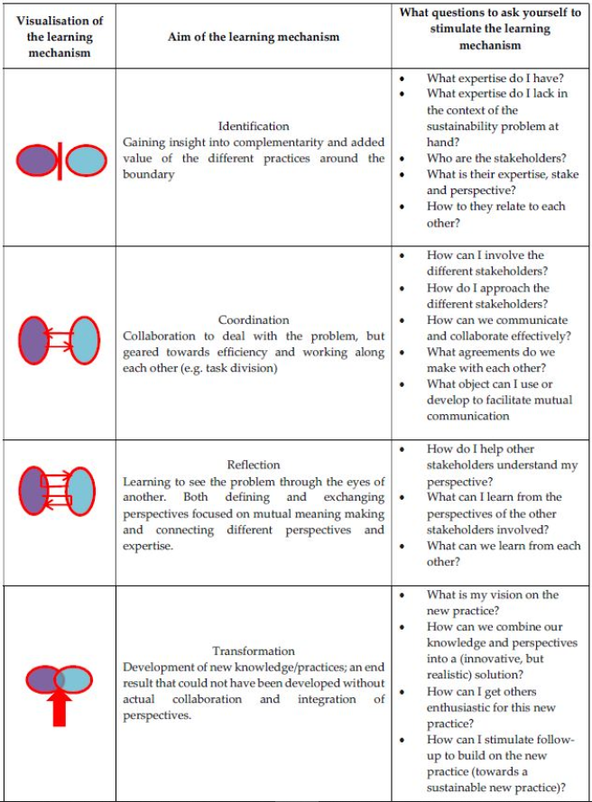
Copied from: J.T.M. Gulikers, & C. Oonk (2019). Towards a rubric for stimulating and evaluating sustainable learning, p.6.

Boundary crossing rubric

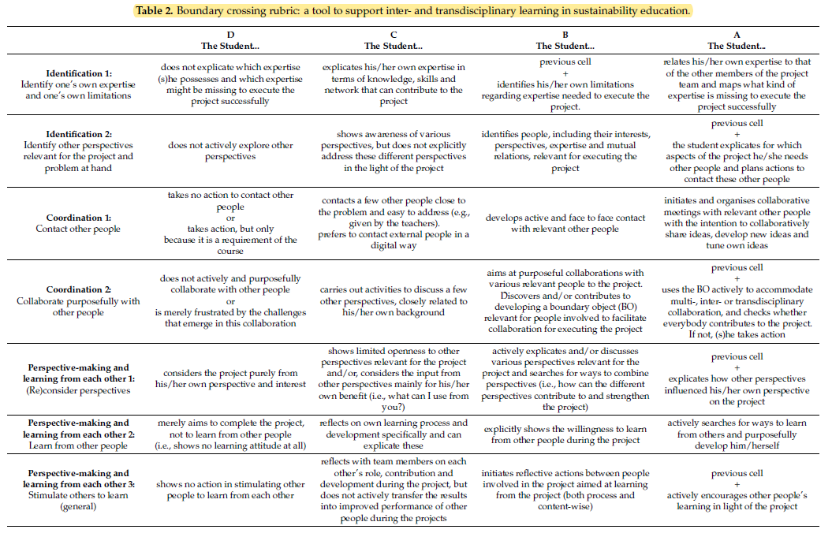
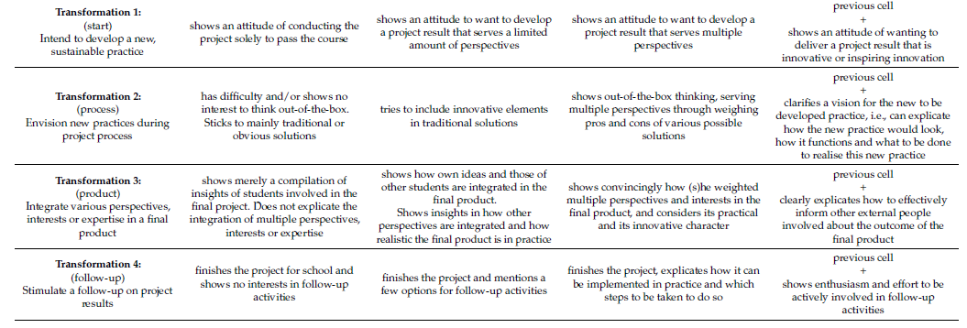
Copied from: J.T.M. Gulikers, & C. Oonk (2019). Towards a rubric for stimulating and evaluating sustainable learning, pp.12-13.

Visual Literacy Competence rubric
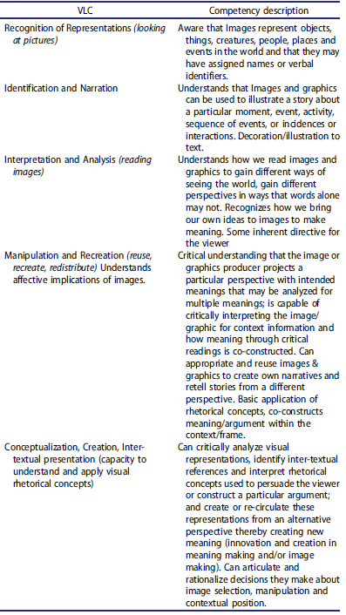
Copied from: Bowen, T. (2017). Assessing visual literacy: a case study of developing a rubric for identifying and applying criteria to undergraduate student learning, p.713.

Handout filmmakers: Dylan&Laszlo

Ready to start creating your film? We’ve got you covered! To help you along the way,
here are some resources that will come in handy on this creative journey.

If you’re new to filming and editing, please watch these tutorials we’ve selected for you. They’ll give you all the information you need to start filming.

Let’s start with this one, Vertical Video Syndrome:
https://www.youtube.com/watch?v=f2picMQC-9E

To get a full understanding of the possibilities of filmmaking, watch
The Basics of Filming: https://www.youtube.com/watch?v=mB_9X354BWc

If you’re filming on your smartphone, the tutorials of Patrick Levar are
a good starting point: https://www.youtube.com/watch?v=x-gfkXu8OpI

Our advice: do not overcomplicate things! The quality of your film
doesn’t depend on technical perfection, but on great storytelling.

If you do want to up your game with smartphone filmmaking and learn more about the technical possibilities of camera movement and lighting, watch the Ultimate Beginner’s Guide to Smartphone Filmmaking: https://www.youtube.com/watch?v=-6hCY2FT6AY

Keep in mind that every camera/smartphone/tablet and every editing tool has its own way of working. What we usually do when we can’t find the answer right away, is to type a ‘how to’ question on Google or any other search engine, with the specifics of the device or software you are using.

Another helpful resource is the Vimeo Video School. It’s a fun place for anyone to learn how to make better videos: https://vimeo.com/videoschoolvideos

For editing, we suggest iMovie on Apple devices and Adobe Rush on Windows. Don’t edit your footage on a smartphone. It’s better to transfer your filmed material from your camera to a laptop and work from there.

If you have a specific question and you can’t find the answer online,
don’t hesitate to reach out to us on info@dyzlofilm.nl

Good luck and have fun!
Lazlo & Dylan

Handout filmmakers: Transketeers

SET UP: beginning
CONFLICT: middle
RESOLUTION: end

Questions to ask:
- What story are you telling?
- Why do you want to tell this story?
- Who is telling the story?
- Whose story are you telling?
- What are they getting out of it? (anthropological concept: reciprocity!)
- Who is gaining what?
- What should my story do?

Pitfalls & Tips:
- PITFALL: hoarding of film material & filming a sh..load of stuff, keeping camera on all the time. SOLUTION: pre-production! Make prior interviews (phone) with interviewees, think ahead of what the story will be, make a plan, know what you want to ask the interviewee, what you need to bring along (objects, material, instruments, lunch..), plan the day (be Jonah )! Make it into a fun day (for interviewees as well) as you/ your filming might be demanding. Think about aftercare (doing something nice after the shoot, referring them to support structures, keeping them involved in what you do with their stories).
- PITFALL: Thinking you have more time than you actually have. (see SOLUTION above)
- PITFALL: That it becomes YOUR story instead of theirs. SOLUTION: Show people the last edited version before you show it to public, make sure you are transparent about decisions you take, make the film WITH them, not (only) ON/ABOUT them.

