


Grasple
Teacher manual
Teachingsupport@uu.nl

Content

1. Introduction 4
2. Creating an Account 4
3. First login 4
4. Get to work 5
4.1 Creating a module 5
4.2 Create a ‘Subject’ 6
4.3 Create a ‘test’ 11
4.4 Adding Students and Teachers 12
Contact 16

1. Introduction

- Grasple is an online platform that allows teachers to provide students with exercises. These exercises are easy to create and to share with other colleagues and students. Step-by-step students walk through different modules within a course, where they can practise different components. Grasple is primarily useful for exercising maths and statistics.
- Teachers can easily add and edit already existing assignments.

2. Creating an Account

- You can create an account by navigating to Grasple.com and to go to ‘Log In’
- Select ‘Log in with university account’.
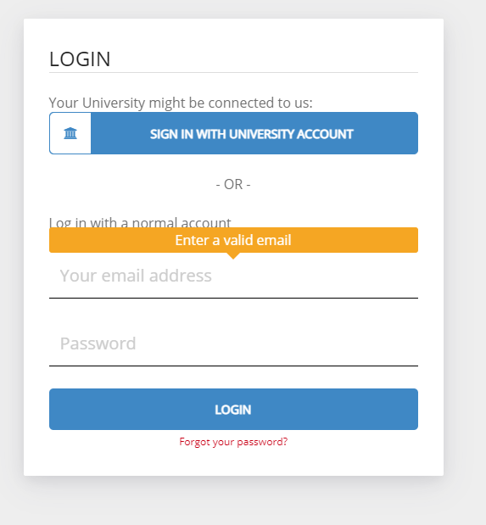

- You can log in with your Solid-id. Grasple will show you a standard course statistics, To change your account to a teacher account, you have to send a mail to fbinnovatietools@uu.nl. You could also get in touch by filling in this form: https://educate-it.uu.nl/contact-informatie-formulier-tools/

3. First login

When you are added by Educate-it to your preferred course, you are a teacher in Grasple. From now on you are also able to create new courses. When you log in to your account, your own courses will be shown.

4. Get to work

A course in Grasple includes e-modules (see 4.1). These e-modules are filled with subject (see 4.2) which include text, exercises and assignments. You are also able to add an formative test at the end of and e-module (see 4.3). Of course it is possible to add collaborators, such as other teachers, and students to the course in Grasple (see 4.4).

4.1 Creating a module

- Select ‘edit’ to edit the course.

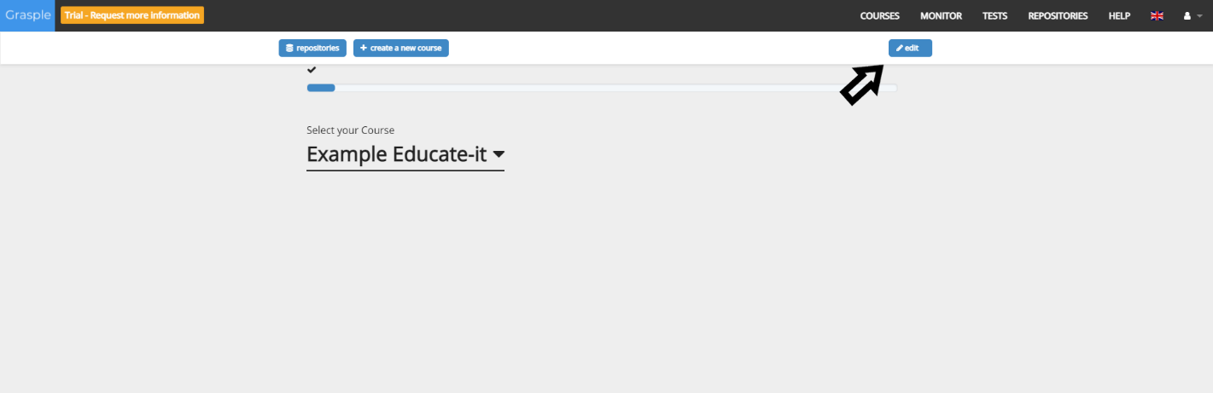

- As shown in the illustration below, you are able to add ‘Subjects’ to a course. A subject is a smaller e-module which exists of text slides and exercises. Your created subjects, you will find in the repository.

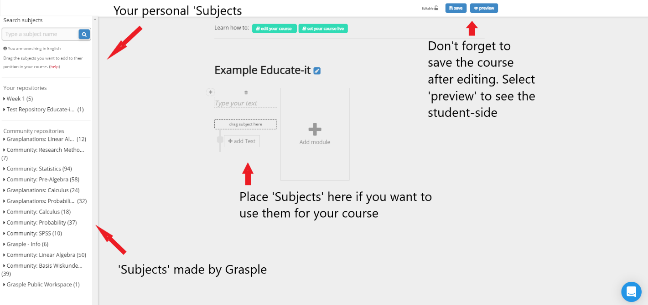
In chapter 4.2 it will be shown how to create a ‘Subject’.

4.2 Create a ‘Subject’

To create a new subject, go to the homepage. A repository is a database of ‘Subjects’. The ‘Community repositories’ folder include ‘Subjects’ made by Grasple. Besides this, there is a folder containing your own repositories. This folder is where self-made ‘Subjects’ end up.

It goes like this:

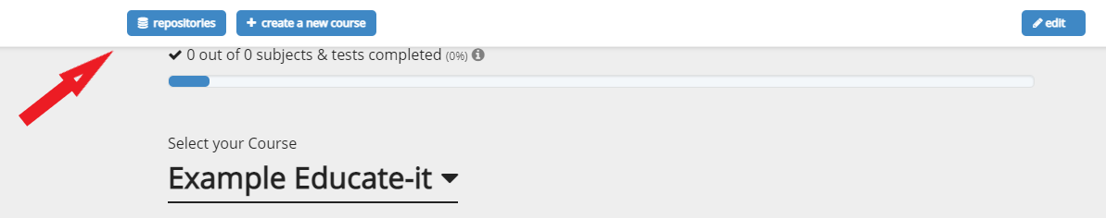
- Select ‘Repositories’

- Select your own repository. You are also able to create an extra repository and share it with other users, so you get the option to collaborate on different subject.

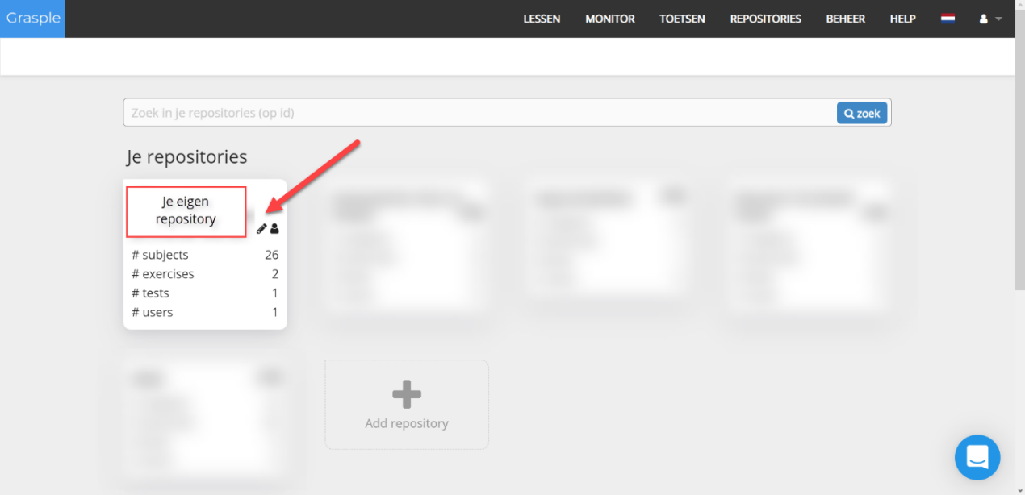
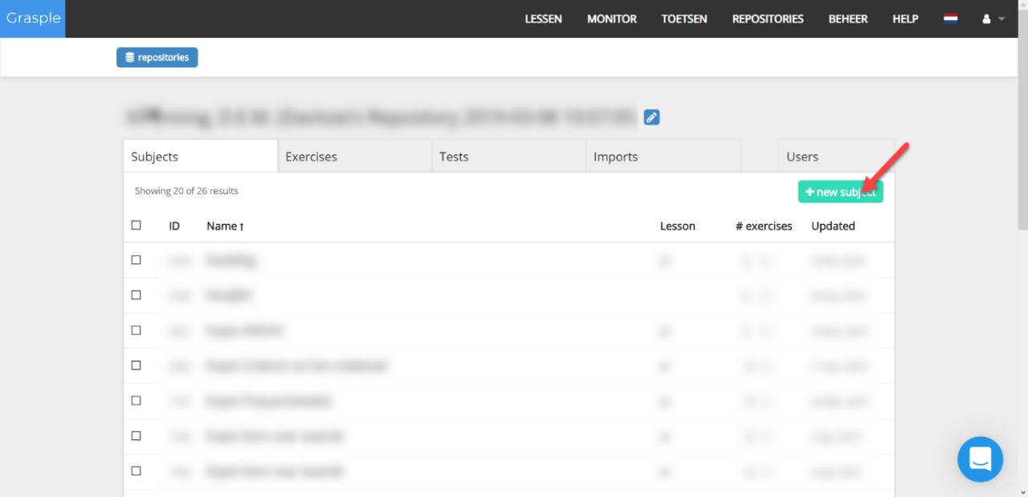

- Select ‘new subject’ to create a subject.

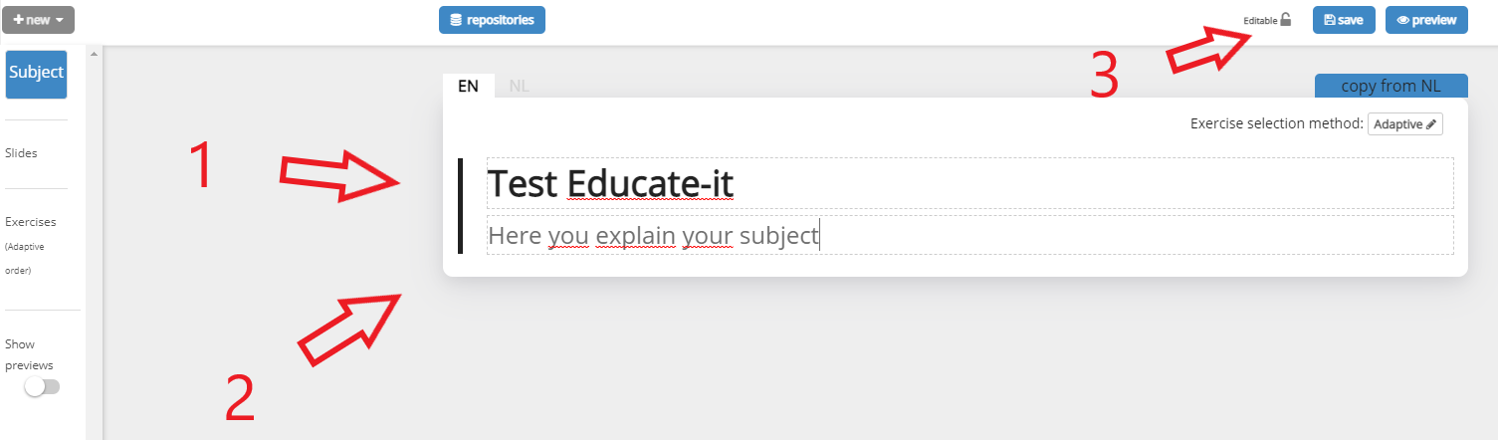

- Name your subject.
- Explain what this subject includes.
- Save this page, so you could add new pages.

Textslide

To add a textslide follow these steps:
- Select ‘new’ on the left top.
- Select ‘text’.
- Type your text.
- Select save.

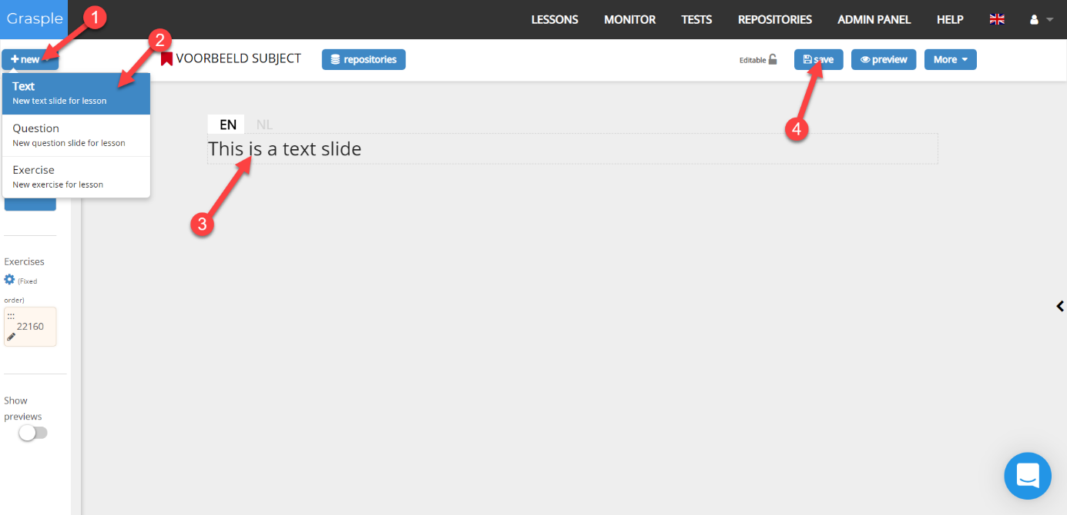

- You are able to provide students with Dutch or English text. To edit the Dutch text you select the option shown below.

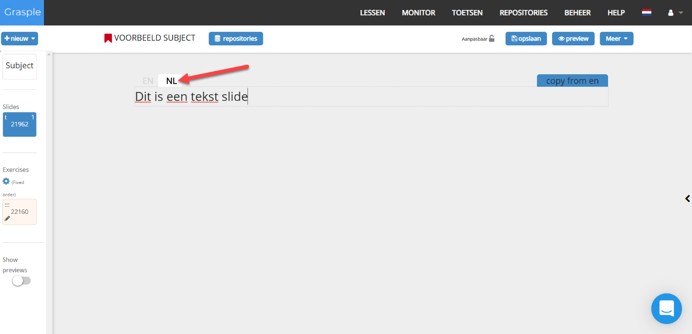

- If one of the two languages isn’t provided, the student will receive the notification that this module is not available in their chosen language.

Questions & Exercises

In this module you can create two types of questions: questions and exercises. A question is a part of a subject that sits between two textslides. Questions are meant to test the user after reading the information from the textslide. They could be provided at the end of a serie of textslides, so students have to actively use the knowledge they read.

- To add a question slide follow these steps:

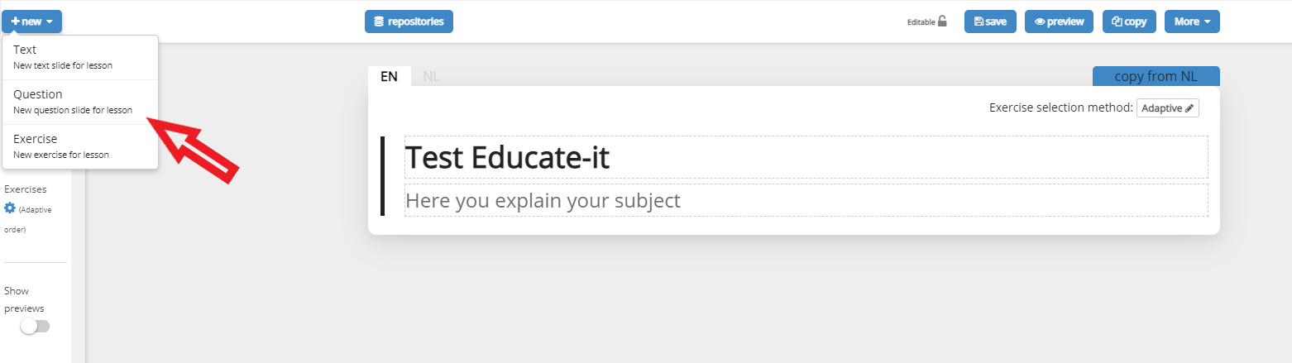

There are four types of questions: multiple choice, numerical, one word, mathematical equations. U are able to provide feedback when students gave a wrong answer.

- Describe the question.
- Select the type of question you want to use.
- Provide the right answer.
- Add other answers when necessary.
- Provide the feedback the students will be shown after choosing an answer.

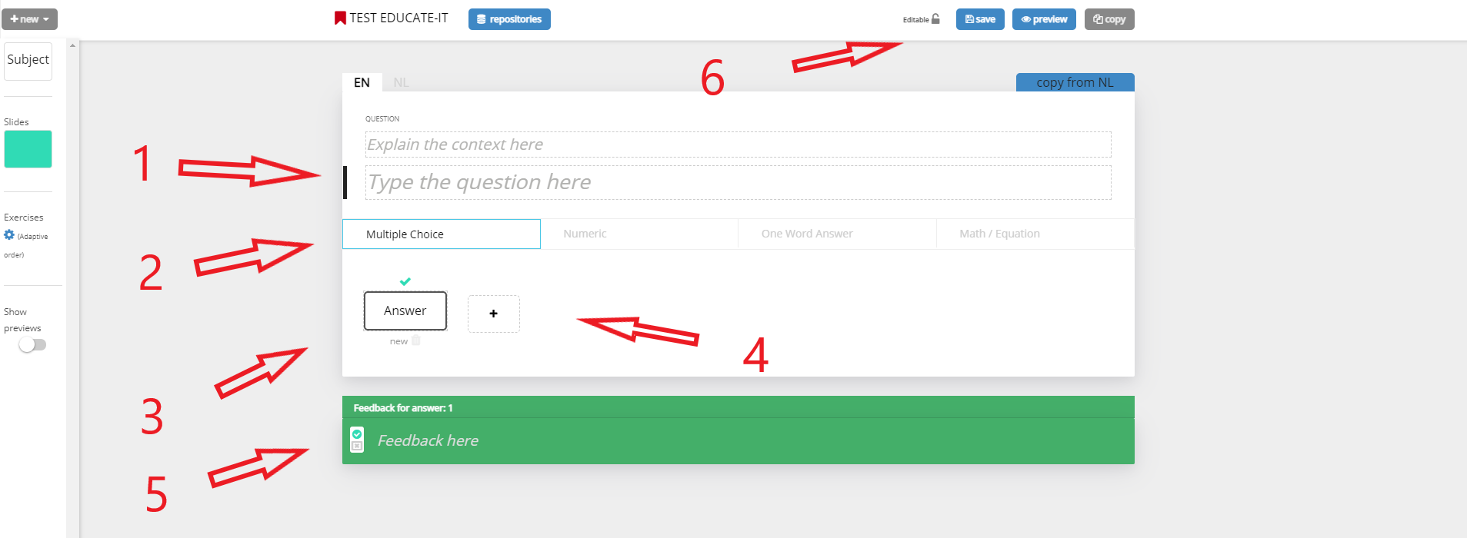

An exercise always sits at the end of a subject, to provide students a test to check if they know the knowledge provided during the subject. Exercises are provided again when a student gave the wrong answer. Students can’t skip an exercise.

- To add an exercise, follow these steps:
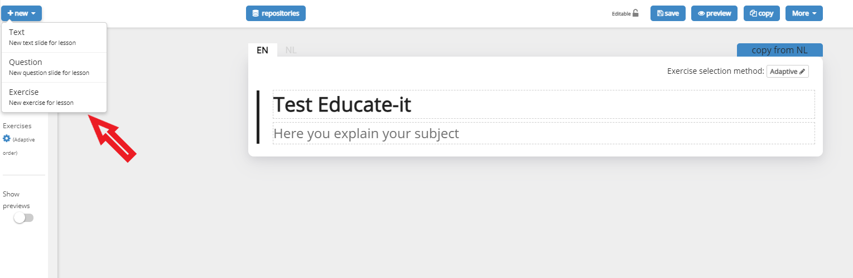
- Follow the same steps shown when adding a questions. The difference between the two is the purpose: questions are meant to get a sense of the knowledge obtained by the student. Exercises are a real test to get to know if students understand the knowledge and are able to use it.

- When you have finished the editing of your modules, you are able to add them in the main screen of your course by selecting ‘repositories’ and drag in the module you want to add.

4.3 Create a ‘test’

A test could be provided at the end of a module to show students to what extend they are familiar with the knowledge. It also provided teachers with the results, so they know too.

- Select ‘edit’:
- Select ‘add Test’:
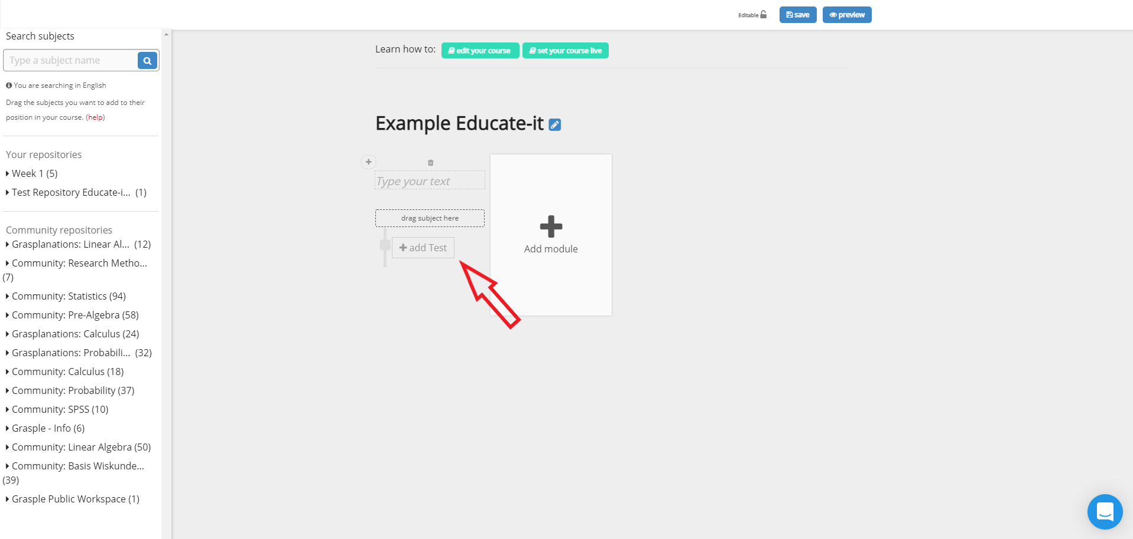

- You are able to choose between automatic or manual. By selecting Automatic, Grasple will select random exercises from all the subject provided before this test. By selecting manual you are able to personally select which exercises you prefer.

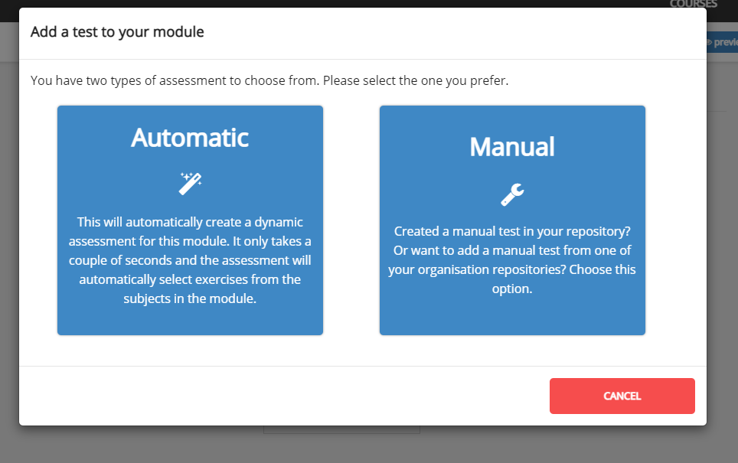

4.4 Adding Students and Teachers

Adding a teacher

By following these steps you will add a teacher to your Grasple course:
      - Go to the right top and select ‘monitor’.
      - Select the right course.
      - Select ‘invite teacher’ and enter the name and E-mail address of the teacher you want to add.

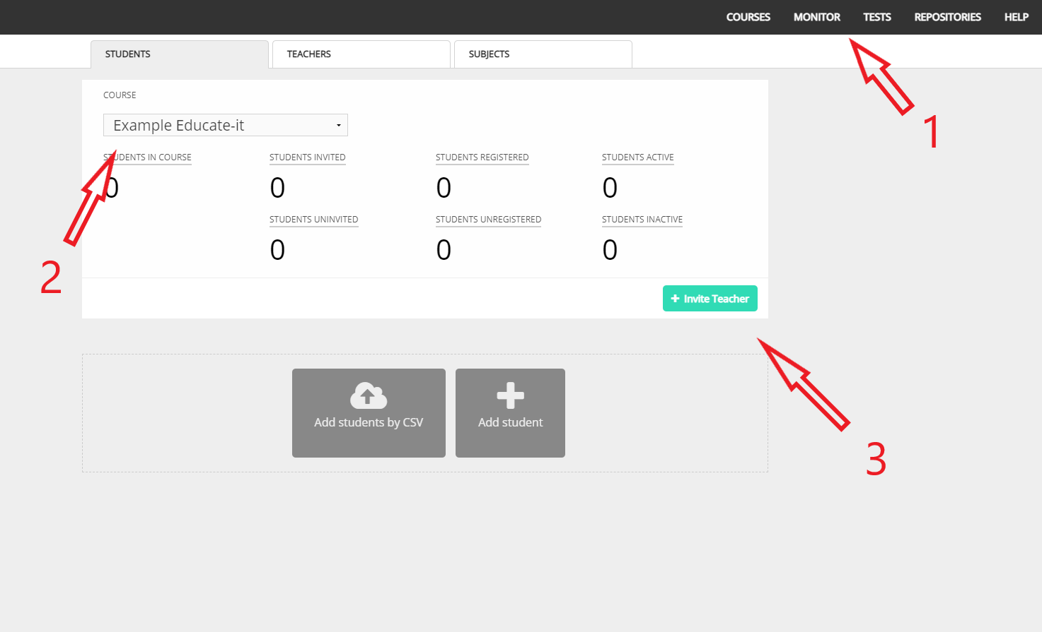

- Certain rights could be given to this user. You are able to select teacher or tutor. A tutor is able to monitor, test and add new students. A teacher has, besides all the rights a tutor has, also admin-rights and is therefore able to add students and change the content of the course.

Adding students

There are three ways to provide students access to the Grasple course: sharing an URL or to add one or more students manually.

- Sharing a URL

The easiest option is to share a URL. You could share this URL by mail or via, for example, Blackboard. After the students navigate to the course using the URL, they are asked to sign up. Immediately after signing up, they have access to the Grasple course. Warning: everyone who is able to access the URL is able to access the course.

- To create a URL you have to contact the Grasple Helpdesk by sending them a message. At the right lower bottom you are able to send them a message.

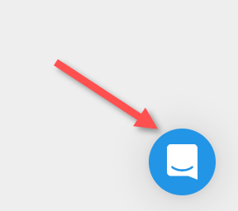

- Adding one student manually

You could also add students separately.

- Select ‘Monitor’ and ‘Add Student’
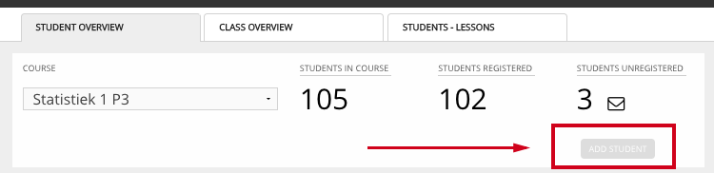

- Fill in the name, Email address and Solis-ID of the student.
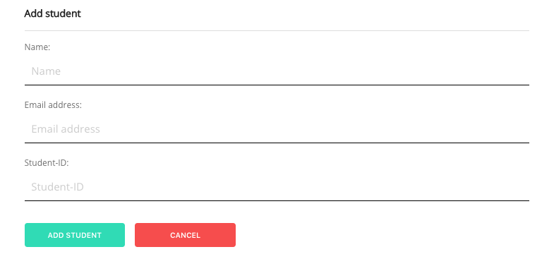
- Select ‘Add Student’. The student will appear in the list now.

- Adding a group of students manually

You could also add multiple students at the same time by using a CSV-file. A CSV-file is an excel-file containing all the information separated by a comma.

- Select ‘Add Students by CSV’ when in the teachers overview

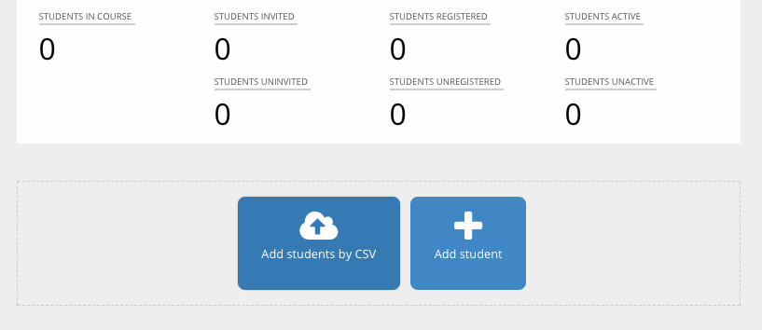

- Upload a CSV-file (comma separated value) containing the full name, Email address and if possible the group they belong to.

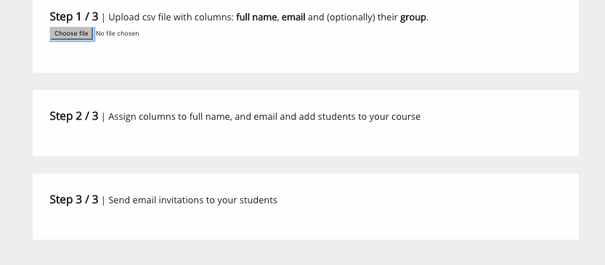

- Check all the columns and upload if they are correct. If you get an pop-up saying there is an error, remove the mistake form the CSV-file. Refresh your browser and try again. If you receive the error ‘there are rows with too few columns’, than check if there is an empty cell.
- Send students immediatly an E-mail, or wait till the course (almost) starts. In case you want to send the invitation mail later on, you are able to send an E-mail by navigating to the dashboard and select ‘send invitations’, after that select ‘To all uninvited students’.

Removing students

You are able to remove students if necessary.
- Select on the right top ‘Monitor’
- Select the name of the students
- Select ‘Remove Student from Course’

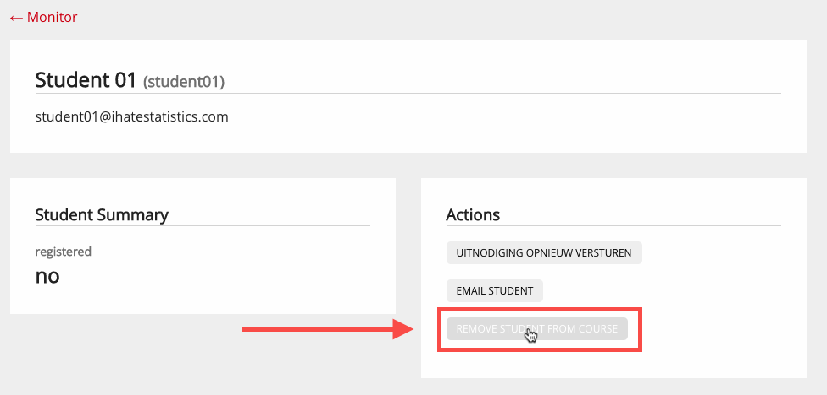

- Confirm you want to remove the student by selecting ‘OK’ in the pop-up window.
- The students is removed and will not be shown in the list anymore.

Contact

For any questions, please get in contact with the Teaching Support Helpdesk by dialling 030 253 2197 or sending an Email to teachingsupport@uu.nl.

