7

Xerte
Teacher manual
Teachingsupport@uu.nl



Contents

Contents 2
1. Introduction 14
2. Creating an account 15
3. First login 16
4 How to get started? 17

Introduction

Welcome to Xerte Online Toolkits (Xerte)! Xerte is a development tool which gives you the availability to independently create online learning modules. These learning modules could include:

- Media: text, pictures, video (youtube, vimeo, mp4), pdf, websites, etc.
- Interaction: multiple choice questions, open-ended questions, gap fill, questions which ask the student to combine elements, decision trees, quizzes, etc.

Creating an account

To use Xerte, you don’t have to create an account. When you are an employee of Utrecht University you have automatically permission to use Xerte. Just use your Solis-ID to log in.

First login

When you want to login in to Xerte, follow these steps:

  - Navigate to xerte.uu.nl (if your webbrowser can’t find it, search ‘xerte uu nl’ in your searchengine).

  - Log in using your Solis-ID.

  - You are now ready and set to work with Xerte!

  - If you want to change the language, select in the right top the preferred language.

Important: Your login data for Xerte are centrally managed by Surf. When you have used another tool before which is linked to Surf (for example Grasple), you will be automatically logged in to Xerte, without providing your Solis-ID.
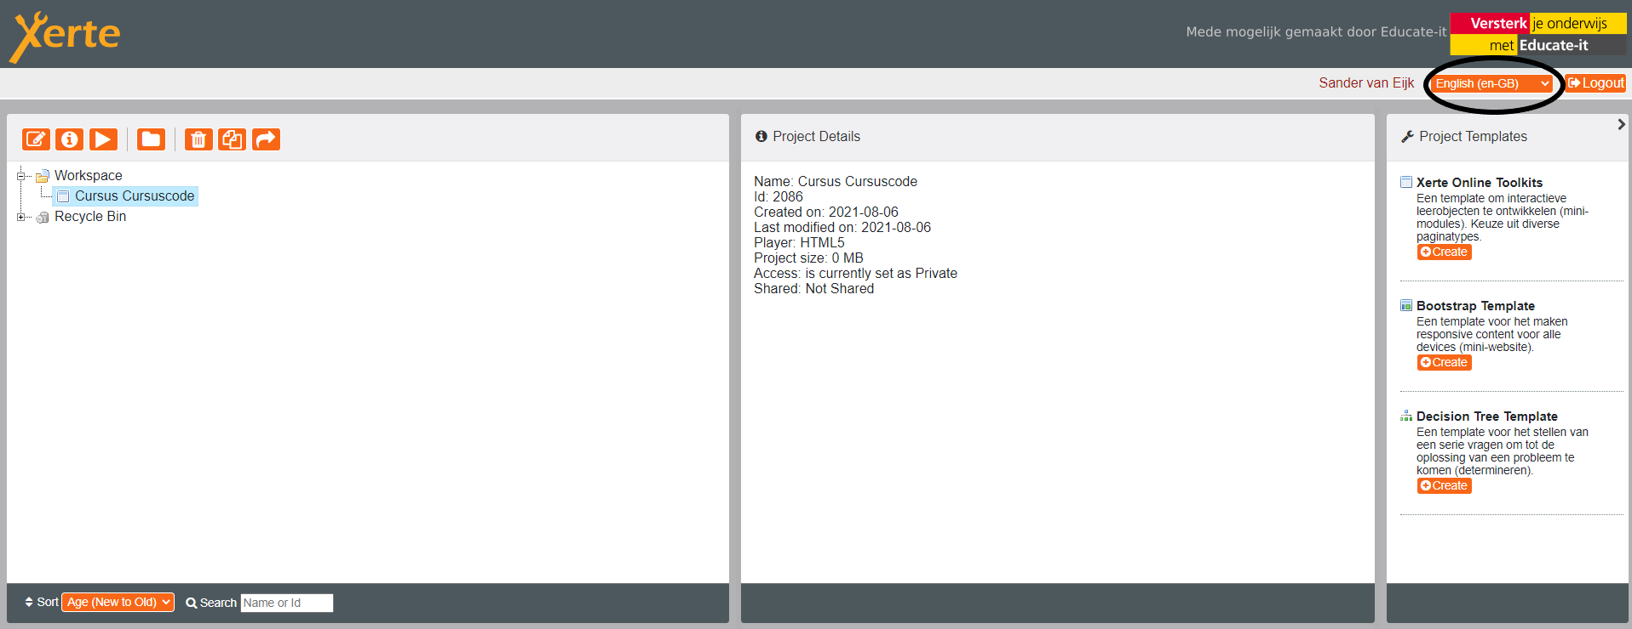

How to get started?

Creating a project

Firstly, you start by creating a new project. To set up a new project, follow these steps:

Go to the right side to ‘Xerte Online Toolkits’ and select ‘create’

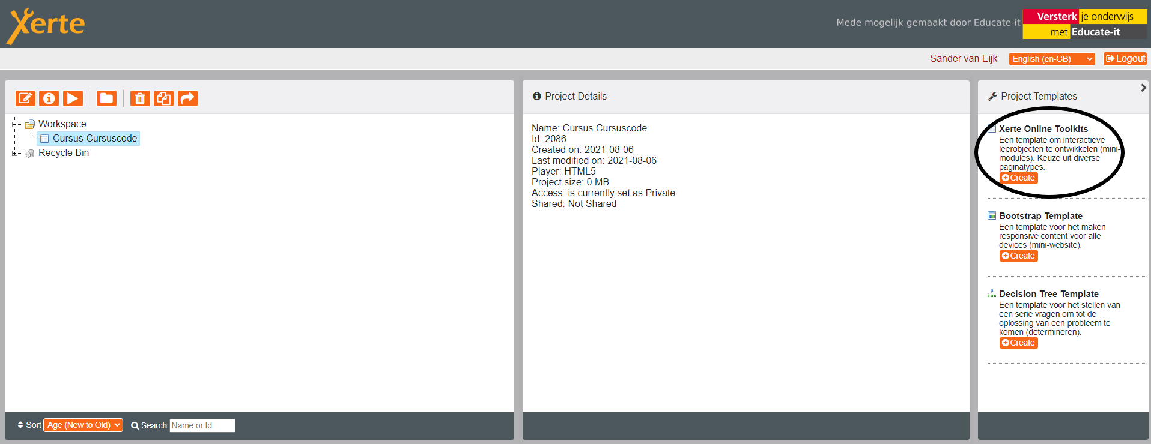

Give the learning object a name that is appropriate for the online interactive environment. For example [Course] + [Coursecode]. Select ‘create’.

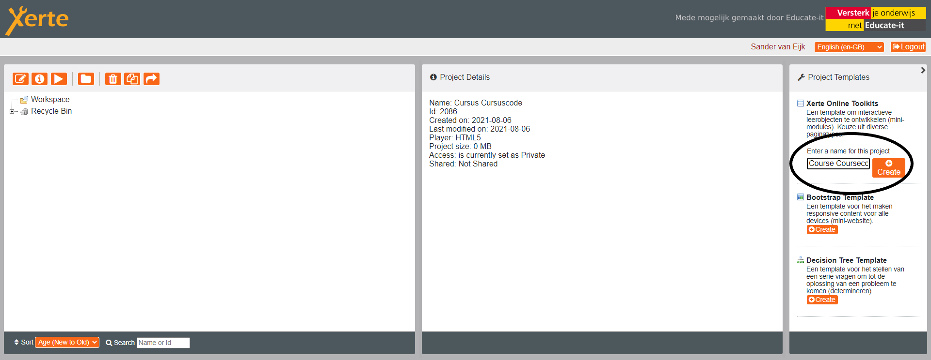

A new learning object will be added and another window will pop-up. In this window you can edit the basic settings of the whole learning object. These elements can be adjusted:

Learning Object Title: Here you can give your learning object an appropriate name.

Navigation: How are students able to navigate through the course?

Linear: In one straight line. Students can only move forward and backward through the learning object.

Historic: Students are able to move forward or, if they press a certain button, all the way to the beginning.

Menu: A menu which provide students the option to navigate to specific parts of the learning object.

Menu with page controls: Linear and menu combined.

Default Text Size: The default text size in which pages of learning objects are presented.

Language: The language of a learning object.

Theme: Xerte offers multiple theme’s to choose from. In Xerte an example is shown below this menu.

Display mode: Select what size a screen becomes when students use the learning object for you course (standard of full screen).

Responsive text: When students use the option ‘full screen’ when using the learning object, the text will scale accordingly to their screen. The text will be smaller or bigger depending on the screen size.

Next you can start building your learning object.

(1) On the left you will see an overview of how the learning object is structured. If you want to add additional pages (see 4.2), than they will be displayed in this overview.

(2) In the middle you will find the place where you can edit your pages.

(3) On the right you see some optional properties for a page. When you hover over the information-icon it will show the applications of this property.

Important: Learning objects and independent pages have their own selection of optional properties. Some properties are only applicable to the entire learning object (such as tracking) and other specific pages (such as audio).

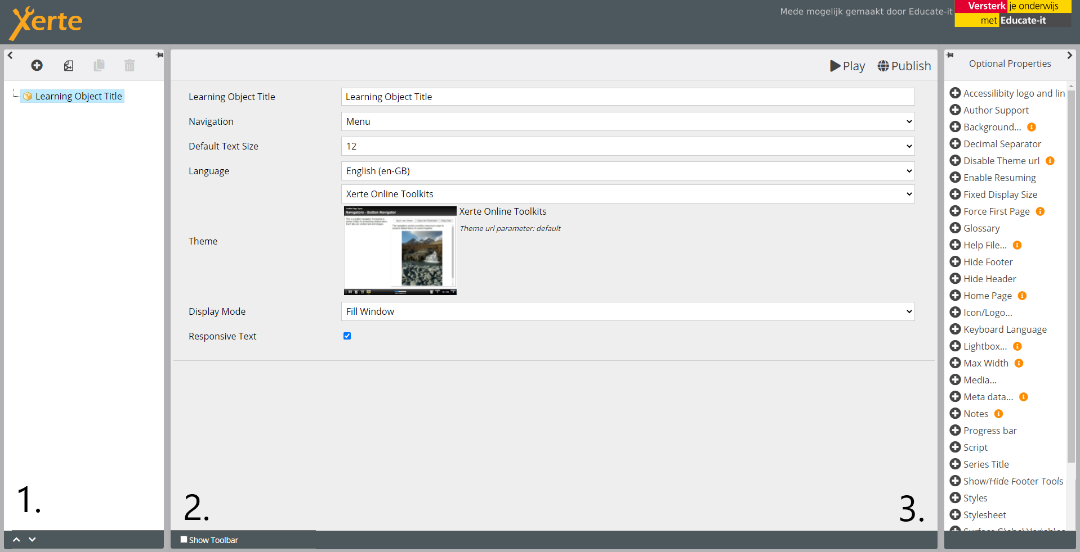

Creating individual pages

Navigate to the left op and select the ‘plus’-symbol. A list of multiple page-options shows up.

Tip: Think about a ‘storyboard’ in advance, so it is easier to structure your course. For example you could think about which elements you want to use and what pages are connected to each other.

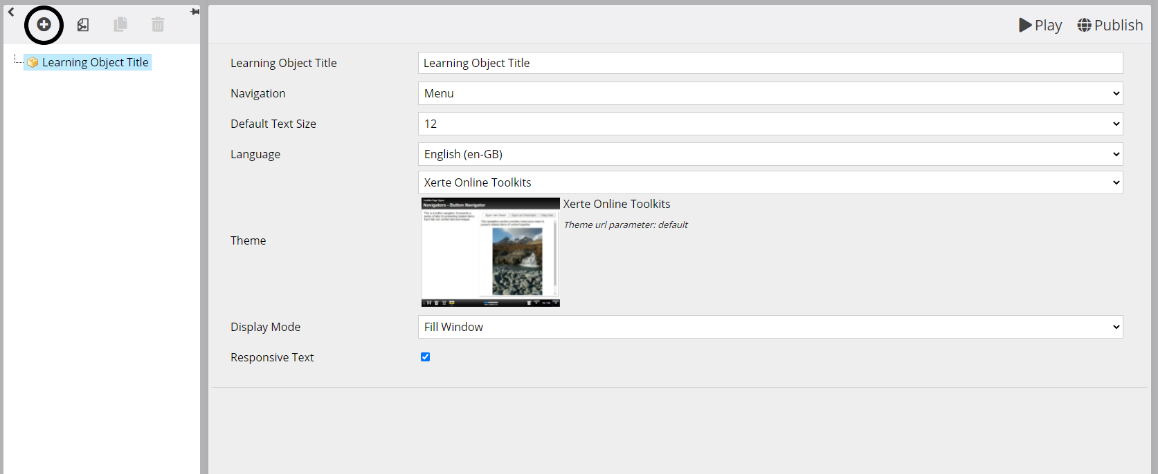

Xerte has multiple page types to choose from. When you hover with your mouse over the page types you will be shown how each page looks like. You can choose a certain page depending on its use. We suggest starting with a titlepage at the beginning. You will find this when navigating to ‘text’.

Text: Different page types with text. (Bullets, columns, summaries, etc.)

Media: Different page types with a media option. (PDF-files, video's, pictures etc.). For more information, see 4.3.

Navigators: Different page types which let you navigate to specific pages. These could be used for providing step-by-step instruction.

Connectors: Normally students navigate through a learning object in a specific way. By using this page type students are provided to move the other specific pages without following the set path.

Charts: Different page types showing a graph or a table.

Interactivity: A lot of different page types, such as questions, quizzes, forms, etc. These pages’s could be useful for testing certain knowledge.

Games: Different games to stimulate interaction.

Links/feeds: Different page types which provide options to navigate to external internet pages. Also QR-codes or a feed could be provided.

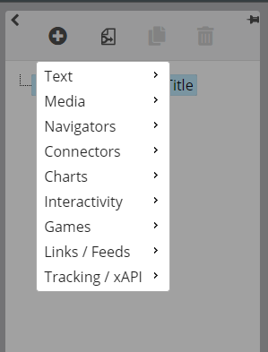

When adding a page, you are able to choose where you want to add the page. Three options are provided:

Before: This will add the page before the page you are currently on.

After: This will add the page after the page you are currently on.

At the end: This adds the page at the end of your overview.

When you have chosen the page which fits your need, you are able to edit this page. To edit a text page, it is quite familiar to editing text in Blackboard.

Important: If you can’t find a the toolbar, you first have to extend the toolbar by pressing the little arrow. Otherwise you could select ‘show toolbar’ at the bottom of the screen.

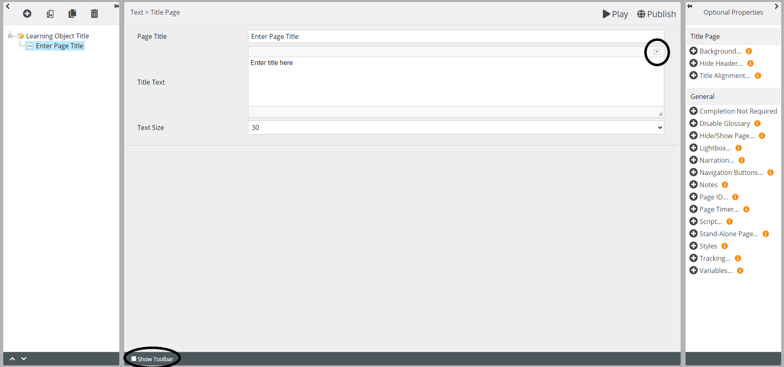

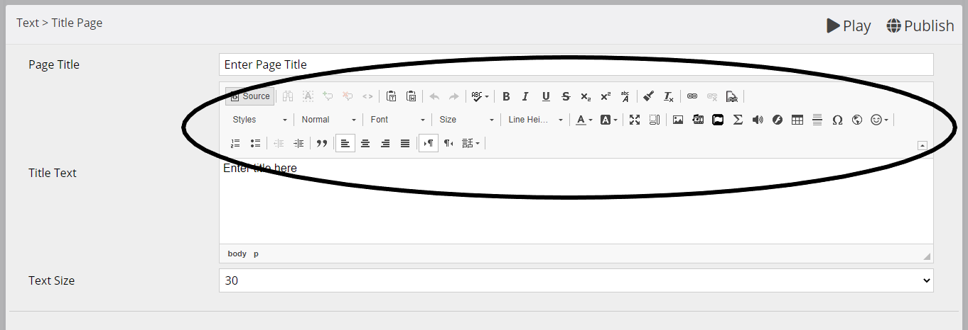

When you are finished editing your text, you are able to get a preview by selecting ‘Play’.

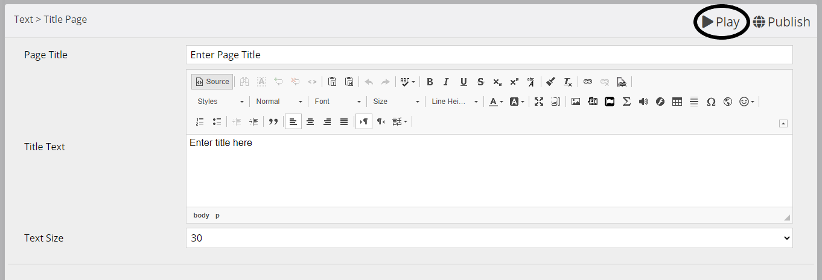

When you have added multiple pages and you need to change the sequence, you are able to drag the pages to the right spot on the left side of the screen. Here you are also able to remove or copy pages.

Important: After editing the pages, it is important to save this by pressing ‘publish’. If you don’t do this, you will lose all your adjustments.

Adding media to your learning object

When creating a learning object, you are able to add pages with media content such as pictures and video’s. Certain page options will be explained below.

4.3.1. Image viewer

Using this option, it allows the student to enlarge certain parts of a picture. This picture could be enligned to the left, right, on top or below.

Important: The enlargement limits are depending on the picture size. The minimum picture size to use this option is 900x1200 pixels.

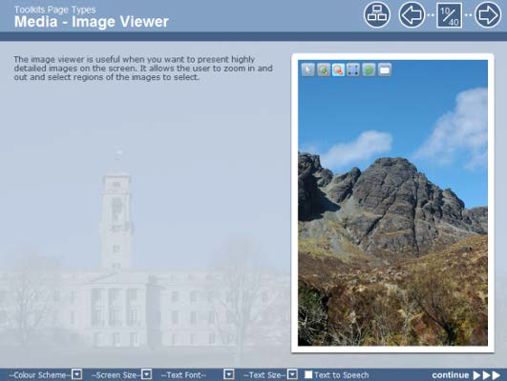

4.3.2. Audio slideshow

An audio slideshow is a slideshow which could be synchronised with an audio file. When a student starts playing the audio file, the pictures start changing. These pictures could be combined with text when wanted.

When you add an audio slideshow, you will firstly get to see the main page where you are able to add an audio file and edit the title and text. The panel width allows you to decide what width the slideshow will have.

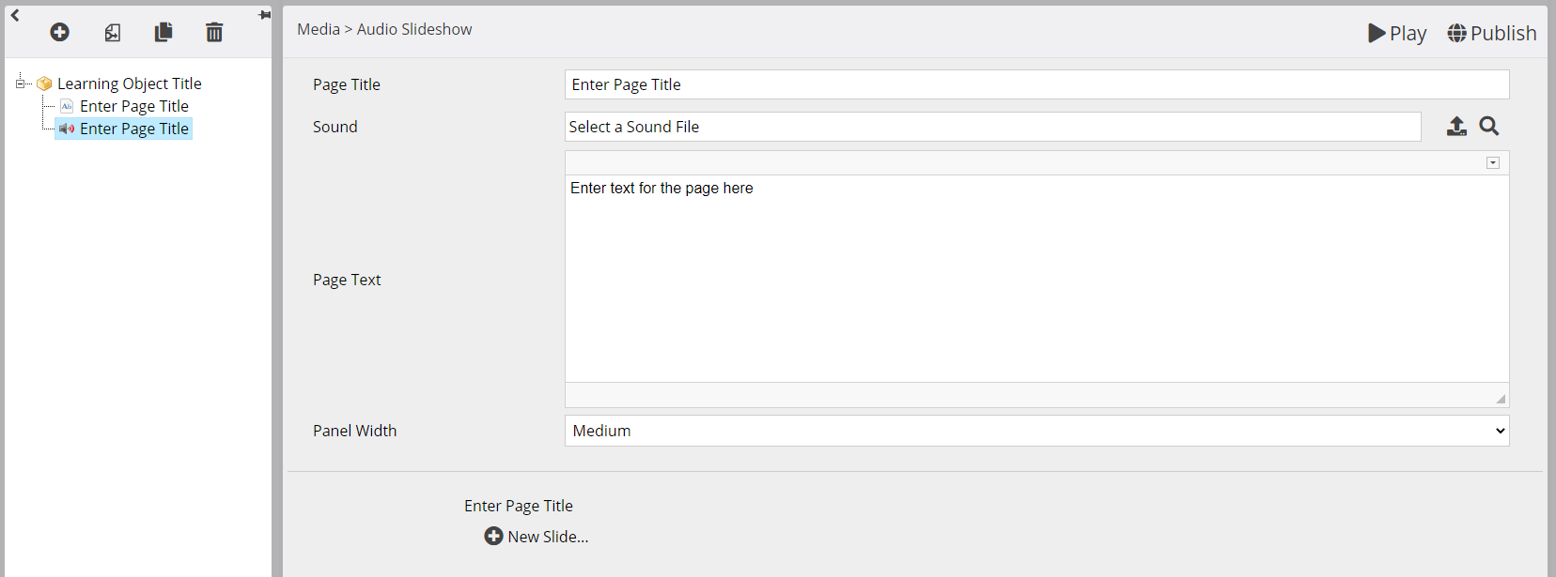

After you edited the main option, you are able to add a slide at the bottom of the screen. The first slide will appear in the left window.

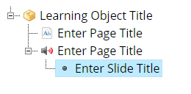

You can select this slide and edit the text and choose the right enlignment. By adjusting the ‘Synch Point’ you are able to adjust the time the slide is shown to the students.

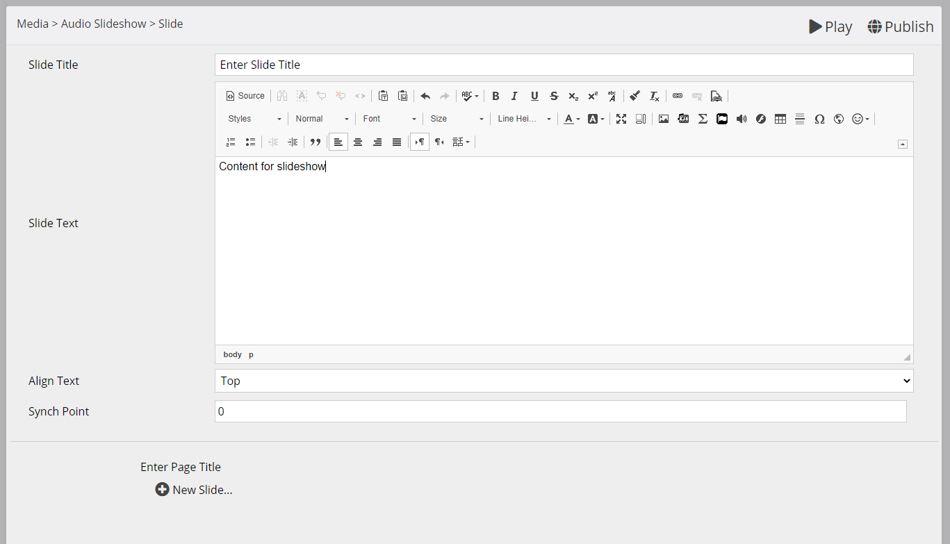

When you want to add a picture to the slideshow, you will have to add the optional proparty ‘image’ in the window at the right side of the screen. At the bottom, extra options will appear. Here you can your desired image. Also you are able to add an additional description of the picture.

Tip: A PowerPoint presentation could be used for a slideshow. It is than important to save the PowerPoint as JPEG. After doing this the slides can be added to the audio slideshow as images. It is important to check if the text is readable. Check this by selecting ‘Play’.

Check the slide by selecting ‘Play’. When you are satisfied and want to add another slide, select ‘New Slide’ at the bottom. A new slide will be added right after the slide you are currently on.

4.3.3. PDF-document

By using this page type you can add whole PDF files to your learning object. These PDF-files can be presented within the learning object. Students will be able to scroll through the file, zoom in and zoom out. By adding extra properties, you can adjust the width of the document.

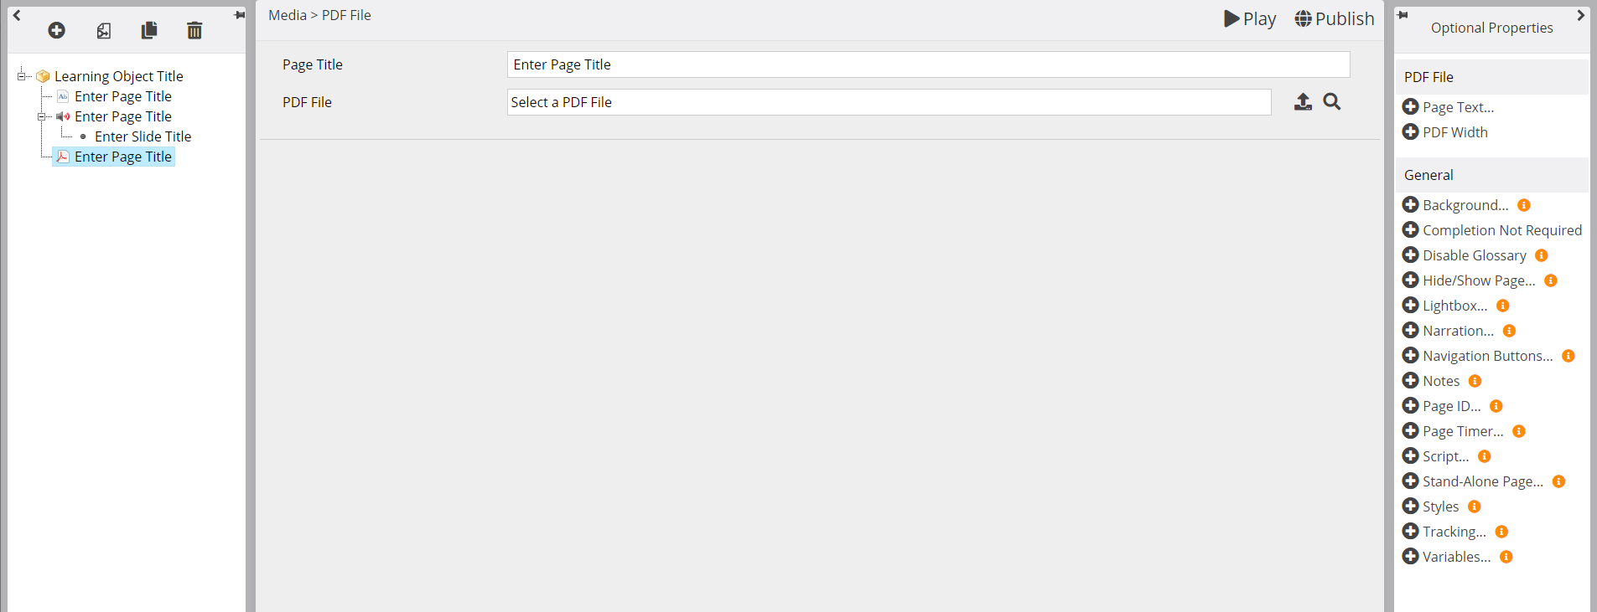

4.3.4. Video

By using this page type a video can be shown to students. Extra properties will let you set a starting moment and an ending to the video. Adding these properties enables you to show a specific part of a video. The file has to be uploaded as a MP4-file. By adding extra text you can provide extra information.

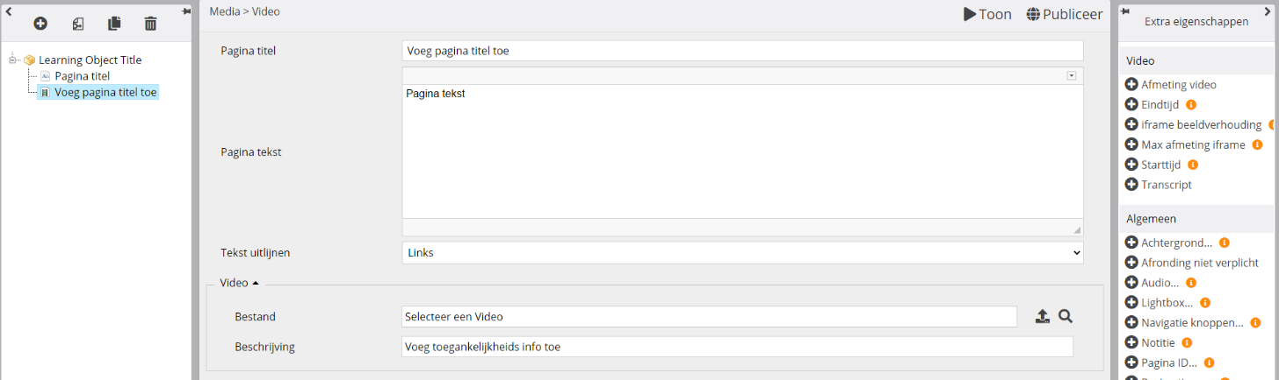

4.3.5. YouTube Video

You are able to add a video you have uploaded to YouTube to your learning object by following the next steps:

Add a YouTube Video-page in Xerte. Here you will get the option to embed a video.

Go to the video you prefer to embed at YouTube.

Select ‘Share’.

Select ‘Embed’.

Copy the entire code shown and paste this code in Xerte at the part which let you embed codes.

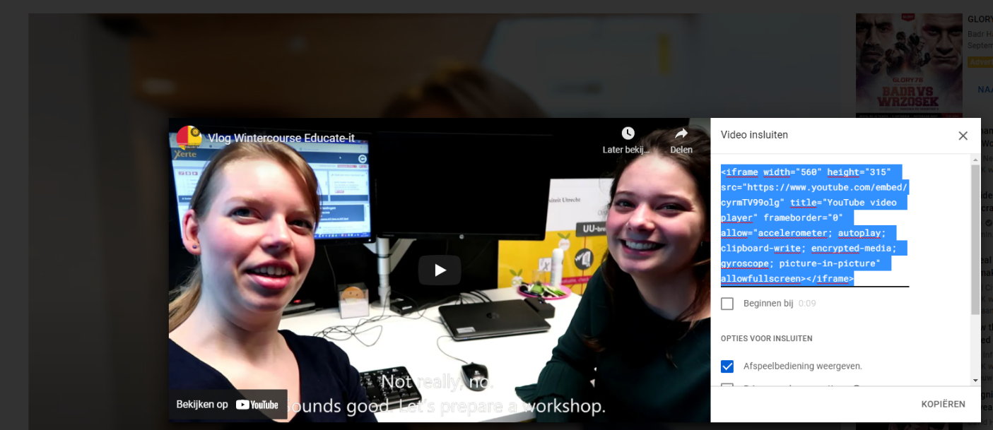

Import pages
Xerte allows its users to import pages from other projects which they own. For this permission you have to be an ‘owner’ of the project. To import pages, follow these steps:

Select on the left top ‘import pages’

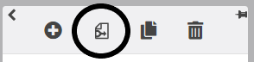

A page will pop up showing the other projects you have access to. Here you can select which pages you would like to import.

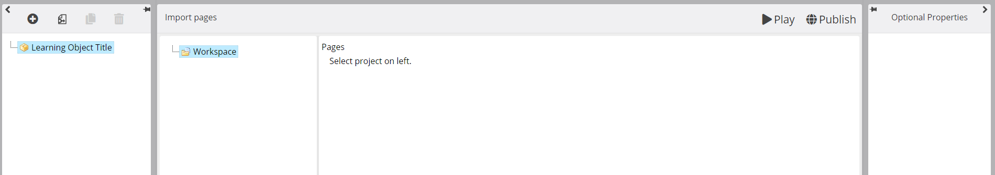

Select the pages you would like to import and press the button ‘import pages’. These pages will be added to your project and the window will be shut again.

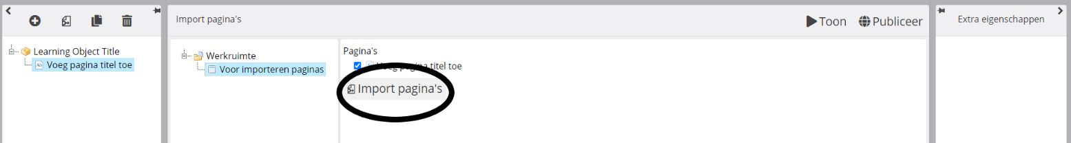

Adding scores to pages

Sometimes you would like to measure student achievements at certain pages and assignments. This is possible for specific pages by following these steps:

After editing your learning object, return to the main screen.

Select ‘edit’ at the left top.

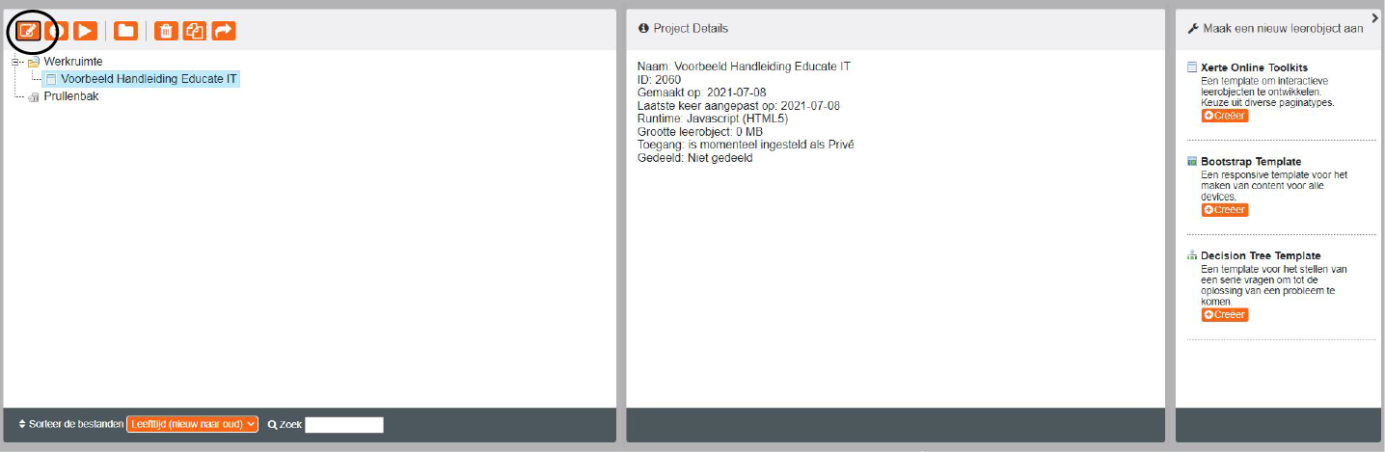

Open the ‘Extra Properties’ menu at the right side of the screen when you have the whole learning object selected as shown below.

Select ‘Tracking’ and add it to the learning object.

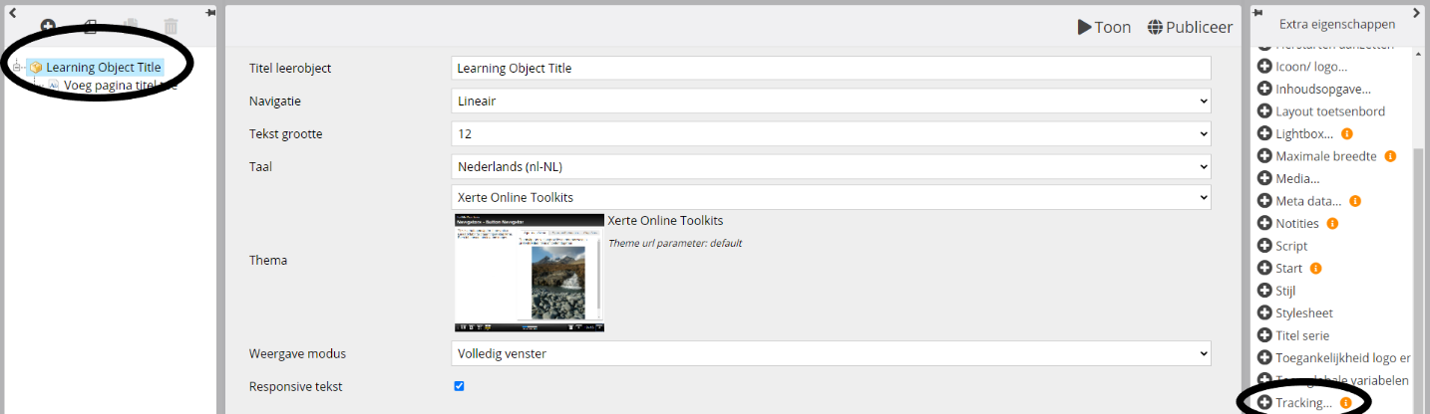

At the bottom an extra menu with options appears. Here you select the following options:

Mode: Full tracking of last pass

Passing score: leave this empty

Page timeout for completion: select 1

Force tracking mode behaviour: not selected

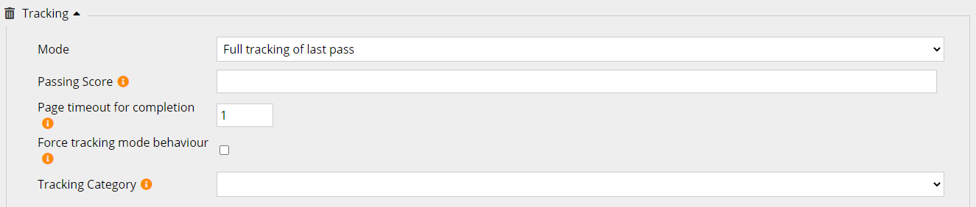When you don’t want certain pages to be scored and graded, than you have to select this individually per page by following these steps:

Go to the first page which shouldn’t be graded.

Open the menu ‘extra properties’ on the right side.

Select ‘completion not required’

A box will appear on the bottom. Select this option by ticking the box.

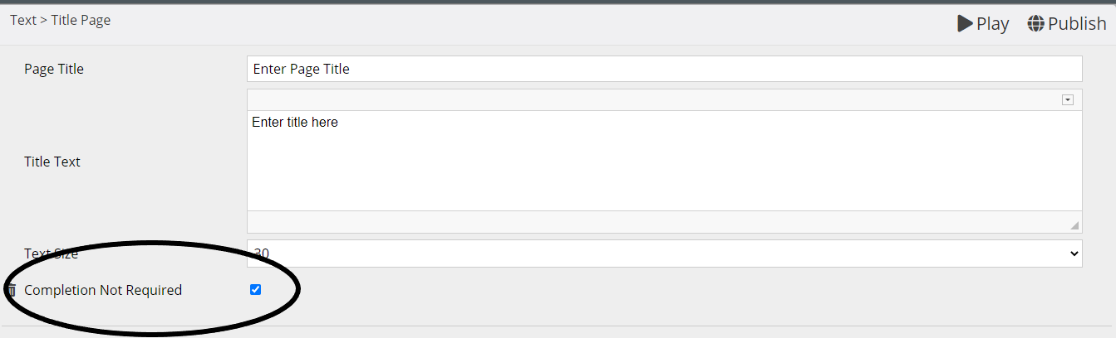

Repeat these steps for all pages not meant for grading.

Showing scores to your students

If you would like to show the students their grade, add a result page at the end by following these steps:

Go to ‘Add Page’ and select ‘Tracking/xAPI’. Add a result page.

Enter a page title.

Choose ‘minimal’ or ‘normal’ results.

Don’t forget to add the extra property ‘Completion Not Required’.

Sharing the course with students

After finishing the learning object, you can share it with students. Educate-it advices you to use the next method: integrate your learning object in BlackBoard, so every students immediately has access to the course.

Go to the mainpage and select de title of the project.

Select the button ‘properties’.

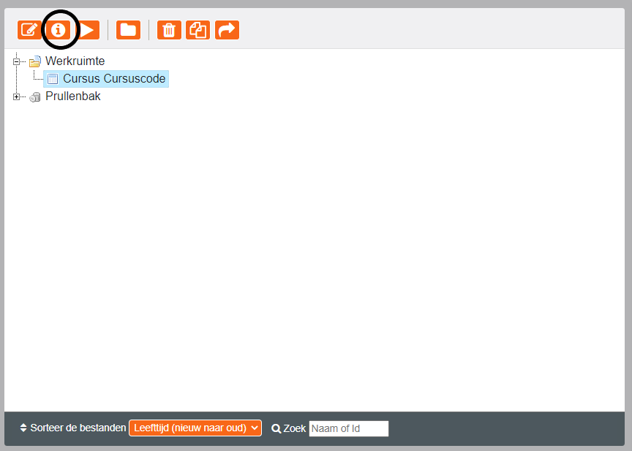

Select ‘export’.

Select ‘Get SCORM 1.2. package’.

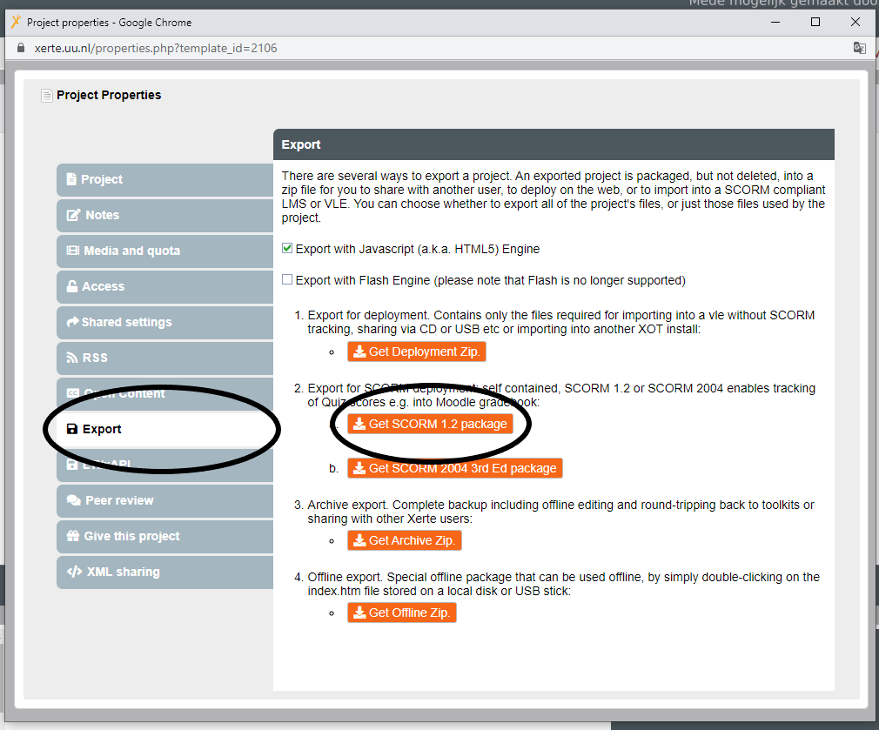

A zip-file will download on your computer. This is the learning object.

Important: After exporting the learning object, the adjustments you make in Xerte won’t be adjusted in BlackBoard. So export your learning object after everything is finished.

- Go to your Blackboard course and select ‘build content’.
- Select ‘content package (SCORM)’.
- Select ‘browse my computer’ and enter the het ZIP-file.
- Select ‘submit’.

The project is now shared with all the students added to the course in Blackboard. To what students will see select the ‘preview’ mode in Blackboard.

Adding a Co-author

When you are owner of the learning object you are able to add a co-author to the learning object to collaborate on it. To add a co-author follow these steps:

Go to ‘properties’ on the left top of the main screen.

Go to ‘Share Settings’.

Search the user you want to add.

Important: In order to add a teacher, this teacher must first have logged in to Xerte at least once.

Select the rights the teacher will get.

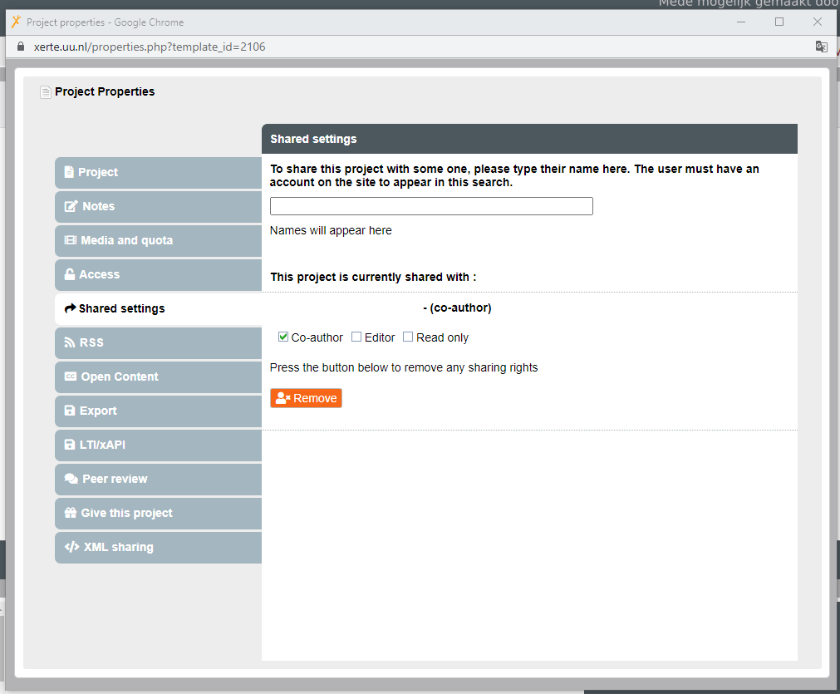

Important: The only right not allowed to share, is the right of ownership. This right allows you to share the project with other users. To pass on this ownership you have to get in contact with Educate-it (see 5. Contact).

Contact
Do you have any questions, are you in need of support or any feedback on this manual? Get in touch with us.

Didactic support

For didactic support get in touch with one of our faculty key-users.

Faculteit | Key-user | E-mail address
FSW | Annet van der Riet  Kim Mastwijk | a.c.vanderriet@uu.nl  c.j.mastwijk@uu.nl
GNK/UMCU | Geertje Agricola | g.h.agricola@uu.nl
DGK | Maryse Leloup  Minke Brinkman | m.d.leloup@uu.nl  m.brinkman@uu.nl
GEO | Laurien Jansen  Nanette Verhulst | l.k.jansen@uu.nl  j.e.verhulst@uu.nl
BETA | Mirthe Mangnus  Kim Mastwijk  Minke brinkman  Emma Bosman | Science.educate-it@uu.nl
REBO | Nanette Verhulst  Maryse Leloup | j.e.verhulst@uu.nl  m.d.leloup@uu.nl
GW | Michiel Fleerkate  Laurien Jansen | m.w.fleerkate@uu.nl  l.k.jansen@uu.nl
UCU | Minke Brinkman  Kim Mastwijk | m.brinkman@uu.nl  c.j.mastwijk@uu.nl
Faculteit overstijgend | Geertje Agricola | g.h.agricola@uu.nl
Practical Support

To get practical support, get in touch with the Teaching Support Helpdesk.
Address: Universiteitsbibliotheek Uithof, second floor, Red desk Opening hours: Monday - Friday 8.30u - 17.00u
Phone: 030 253 2197
E-mail: teachingsupport@uu.nl
Website: https://educate-it-uu.sites.uu.nl

